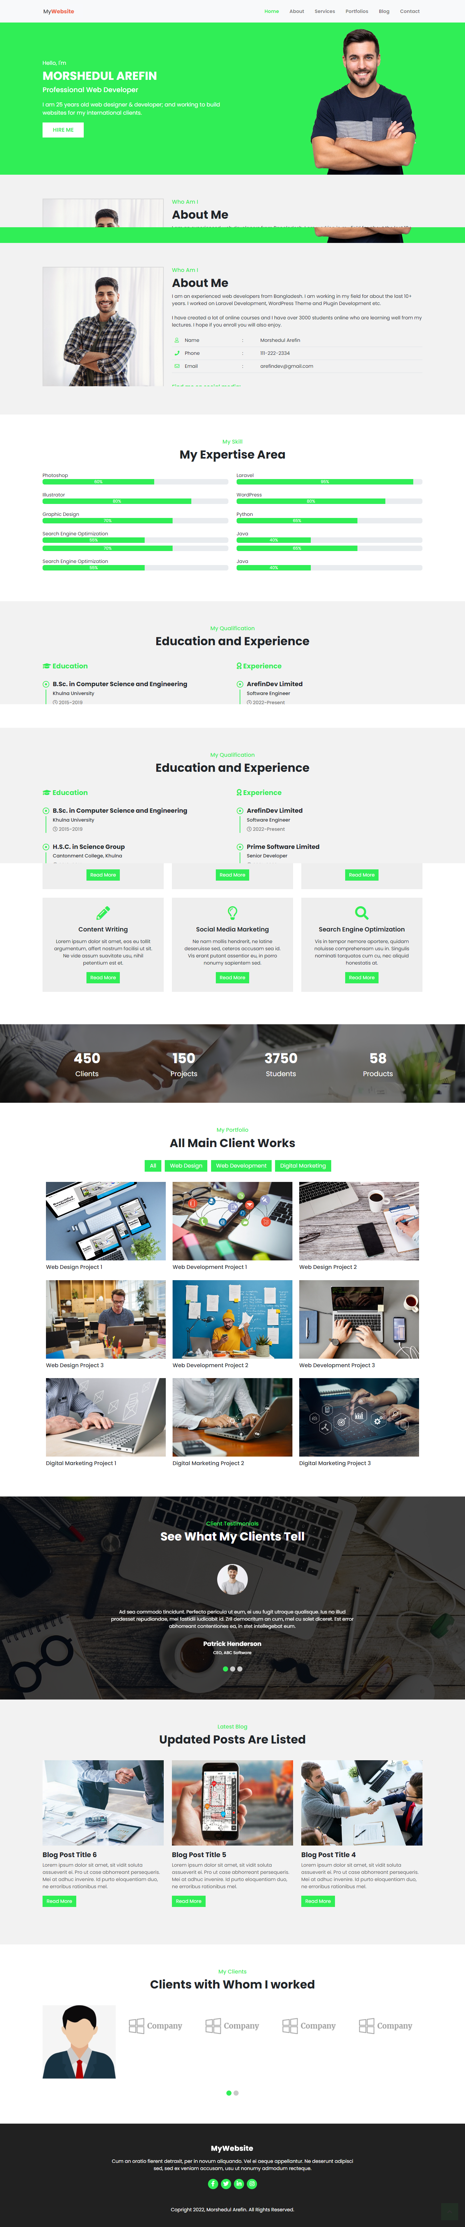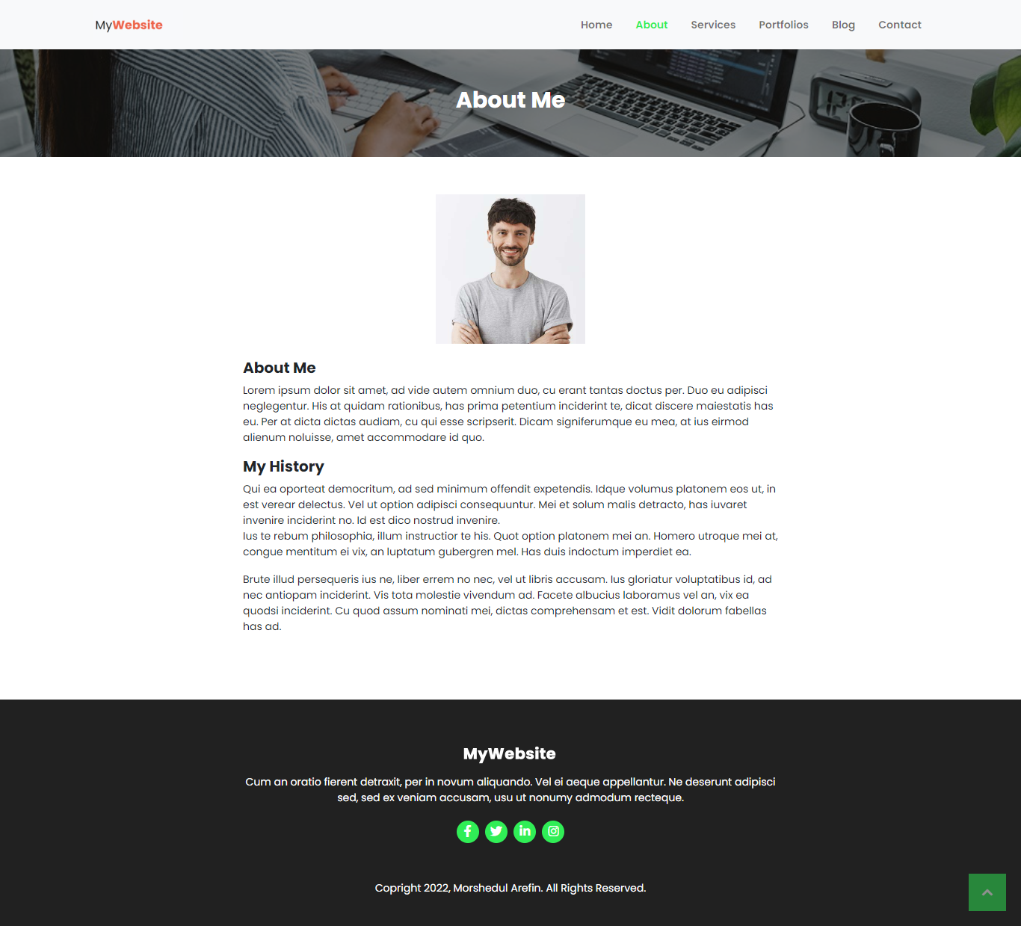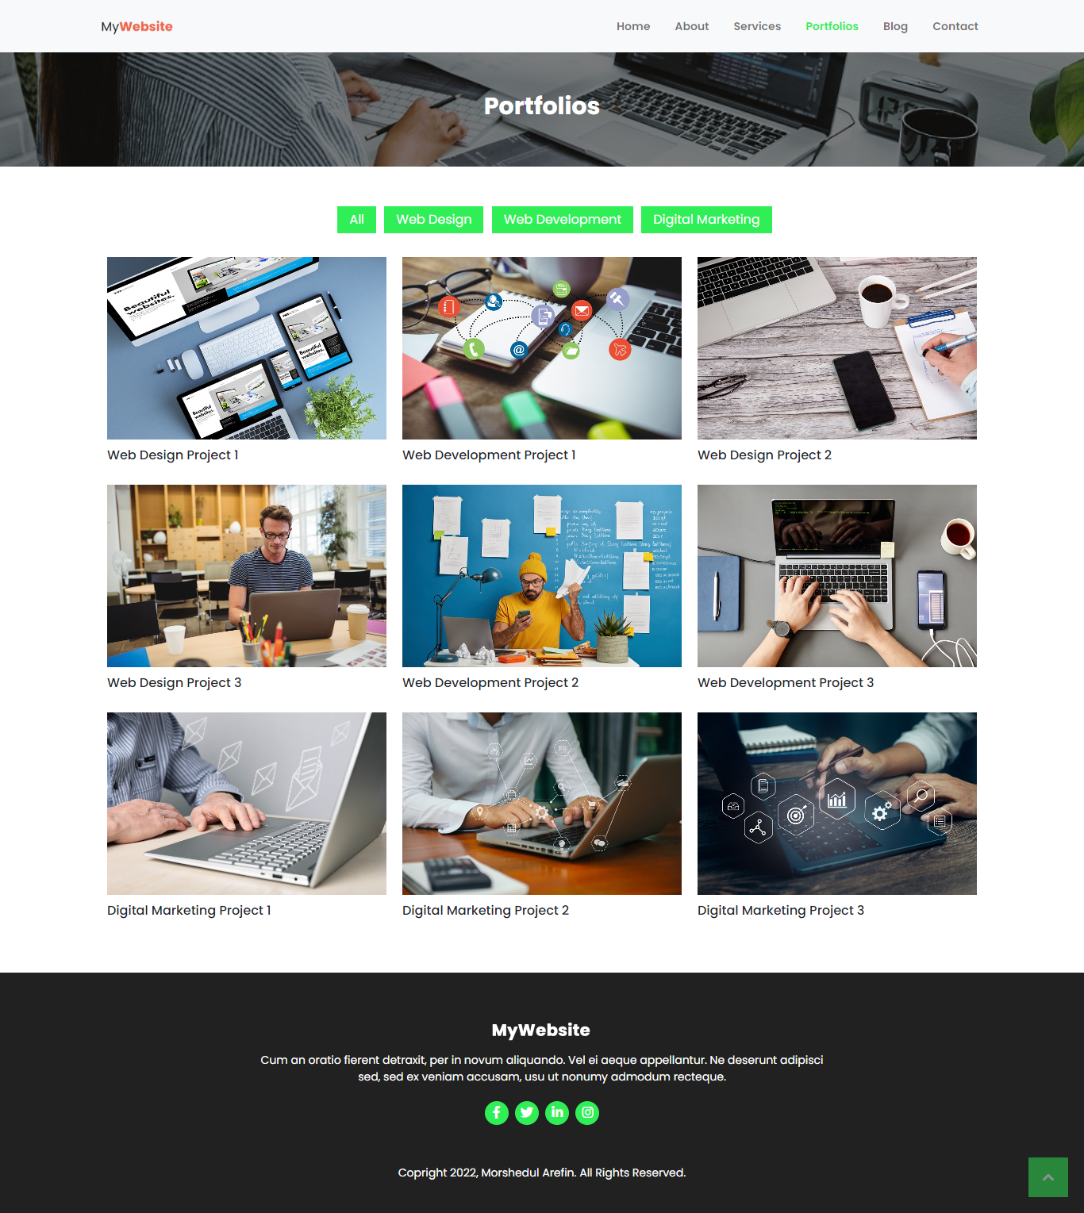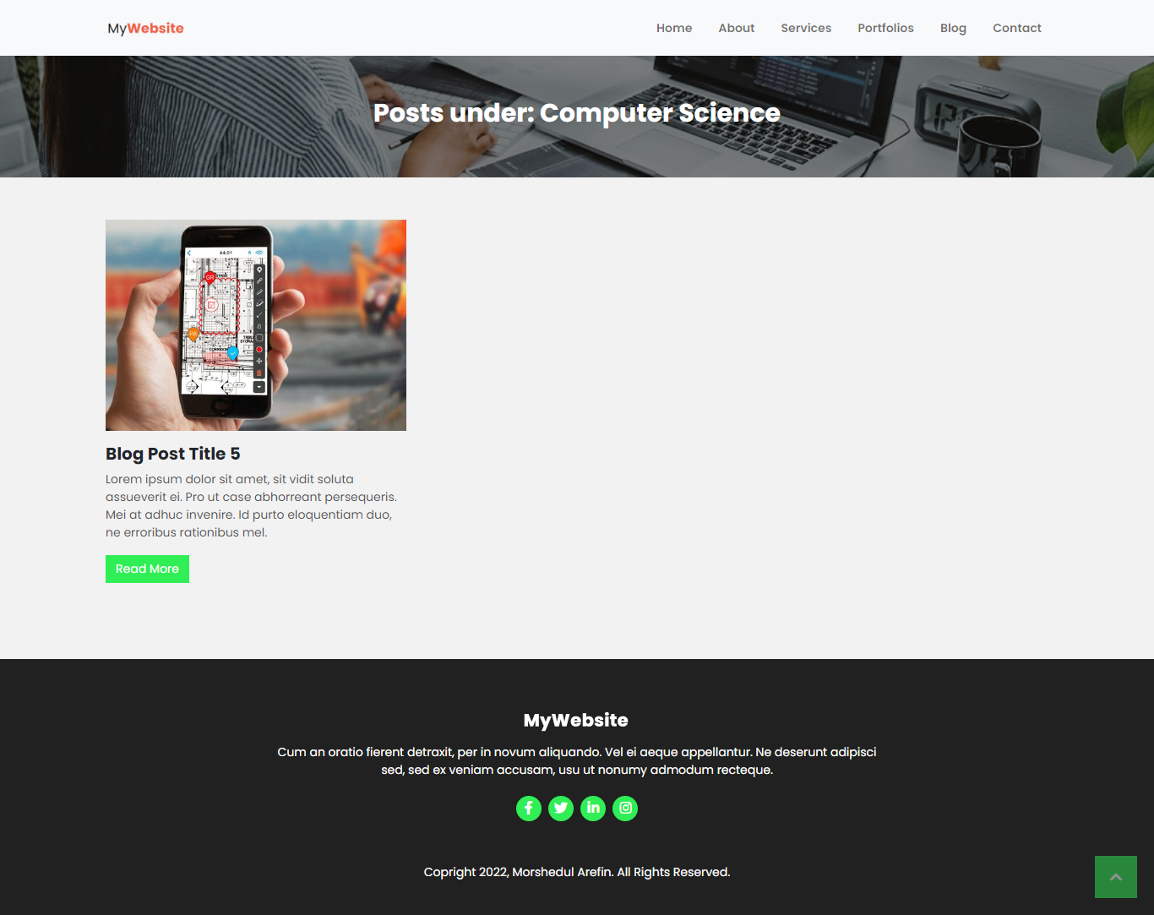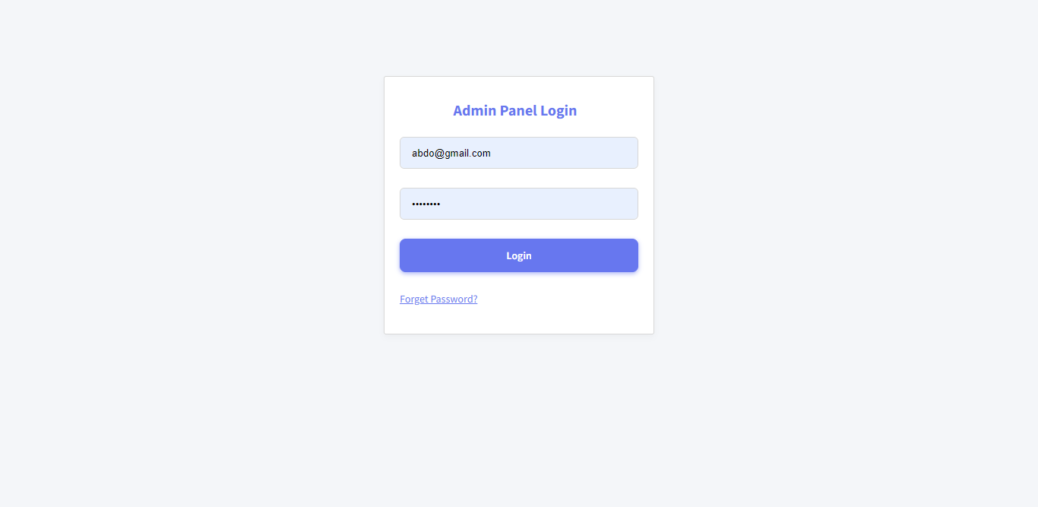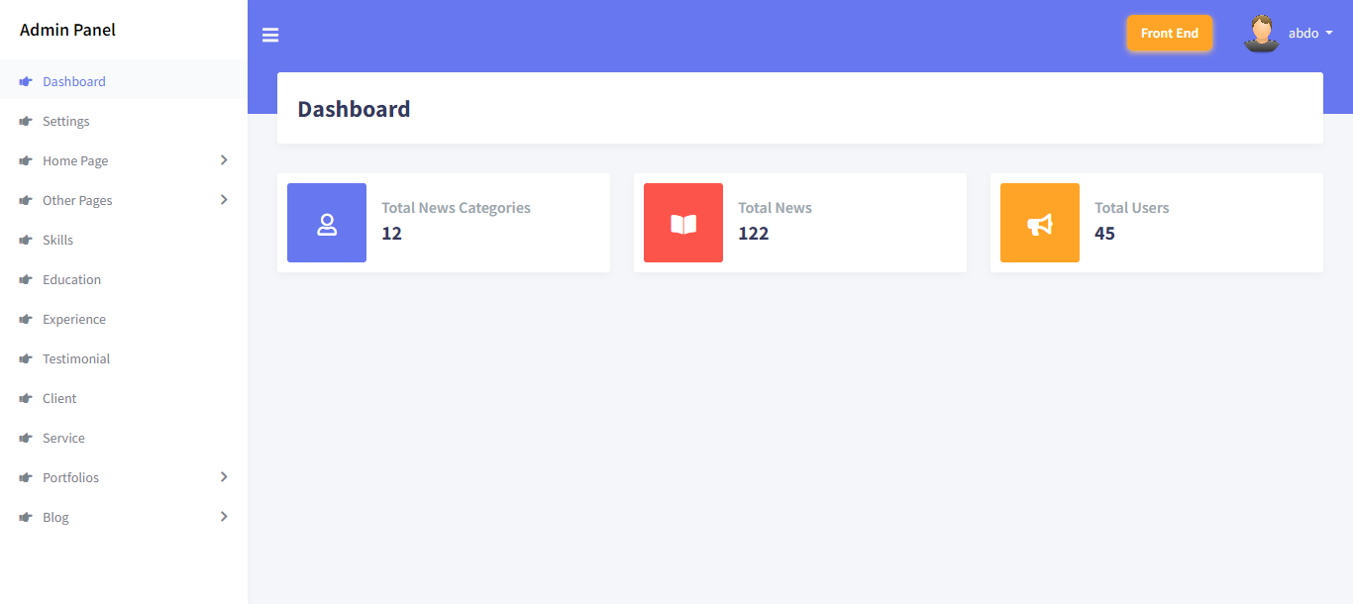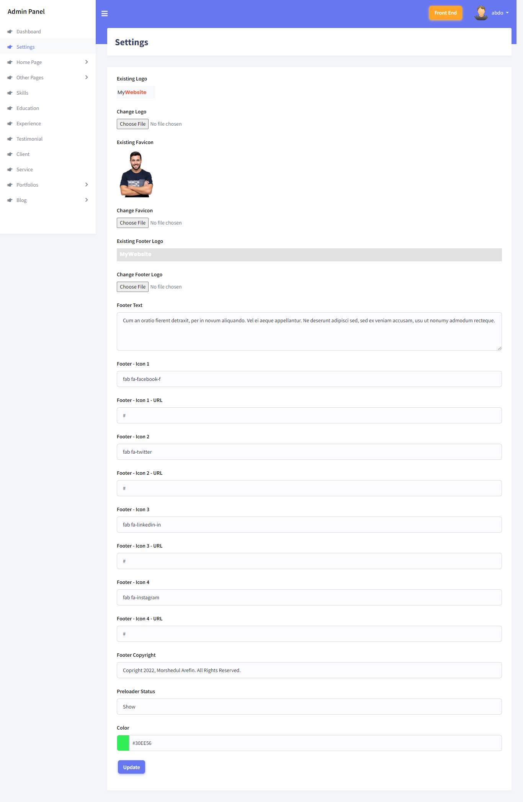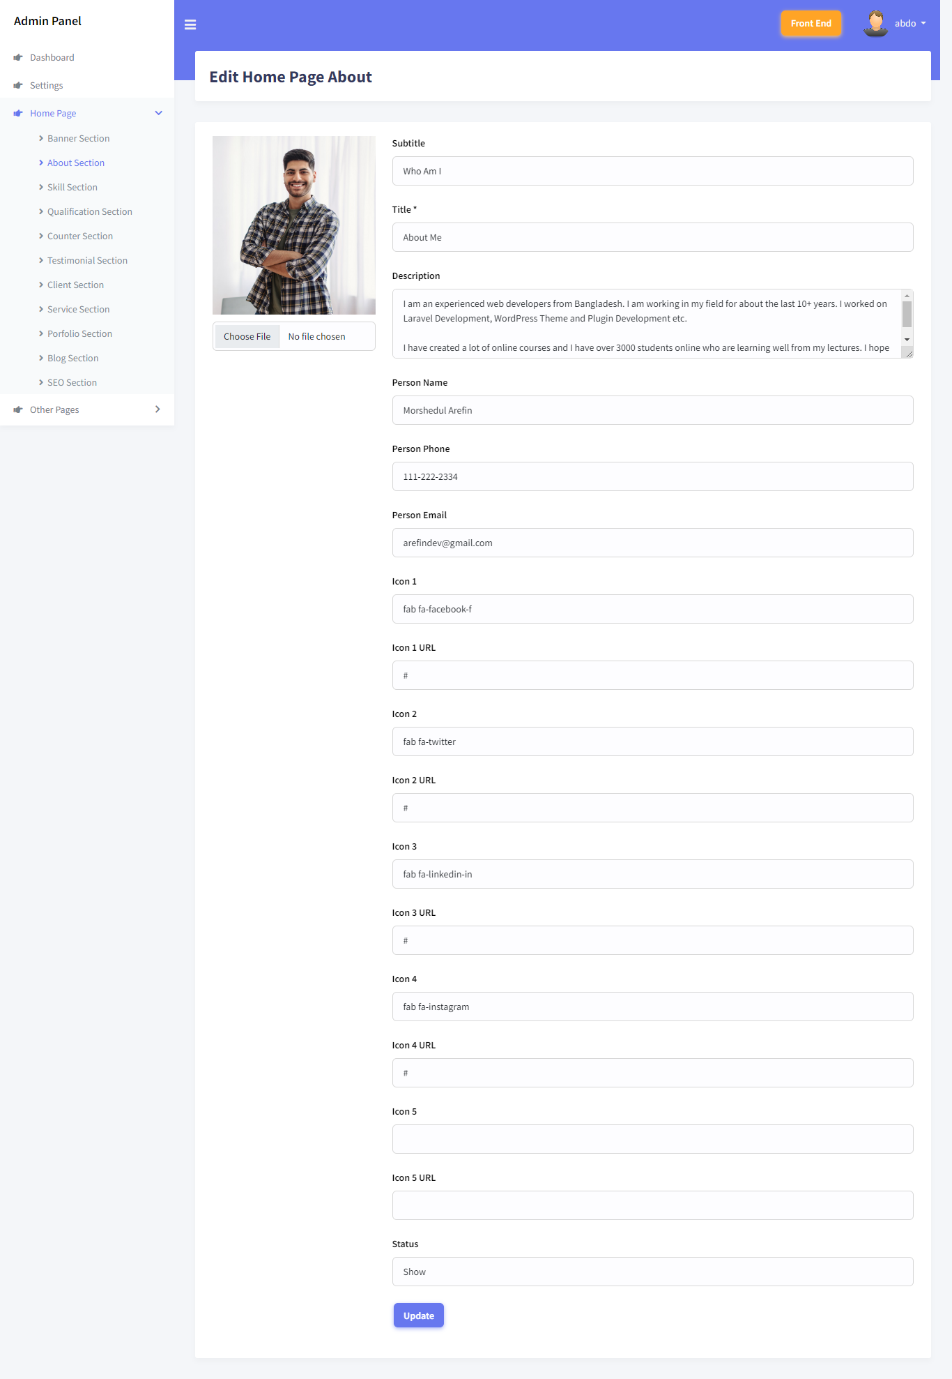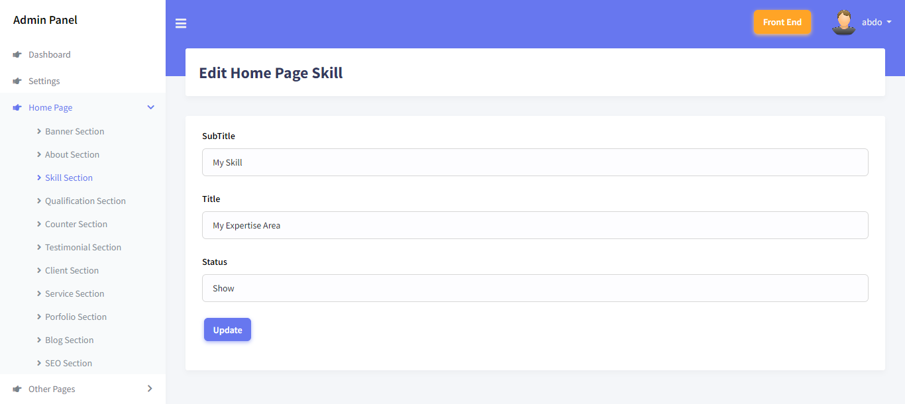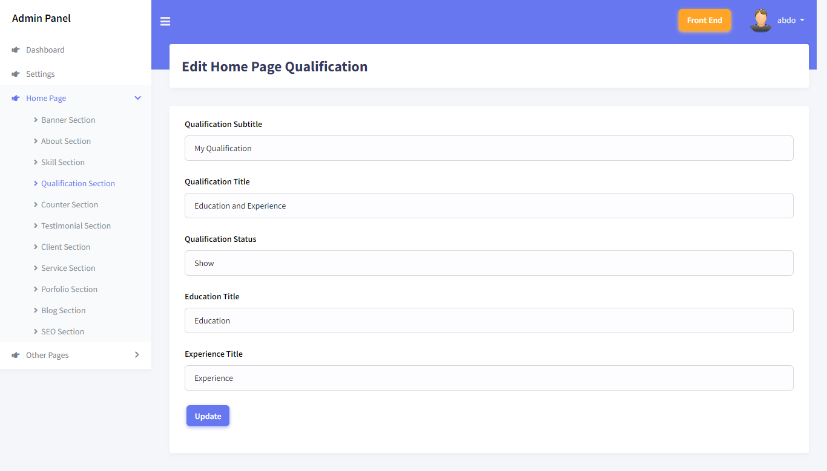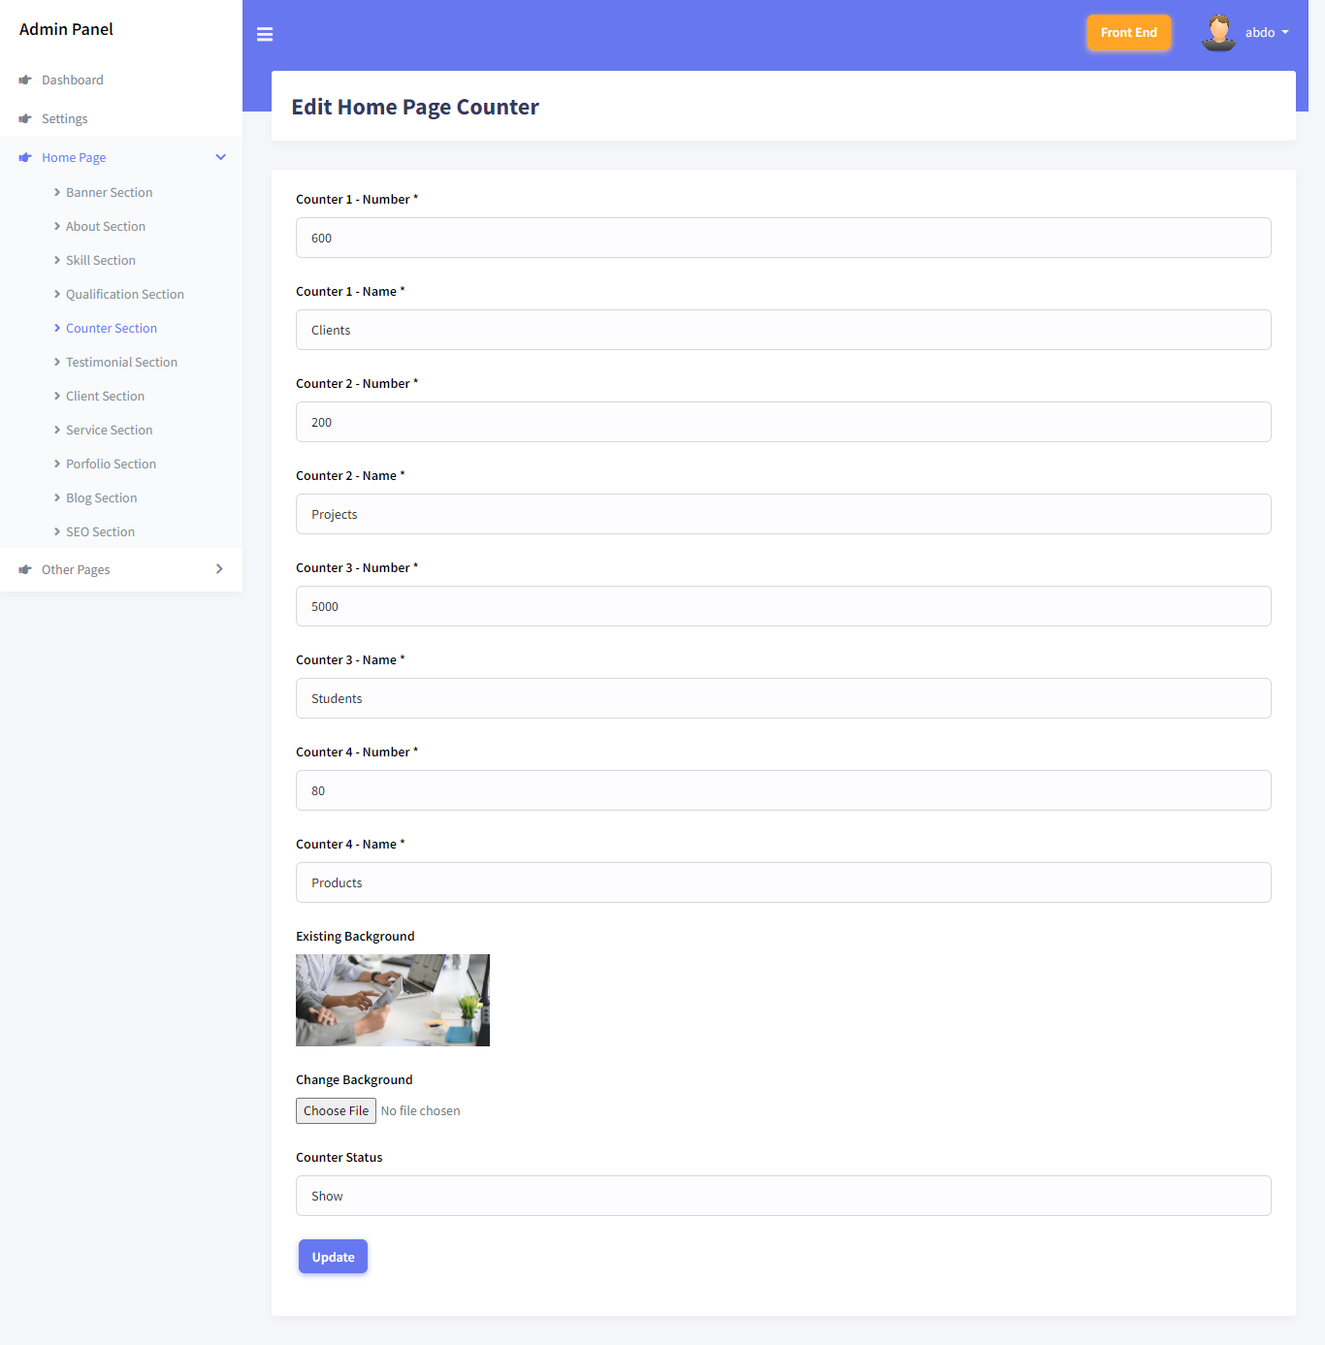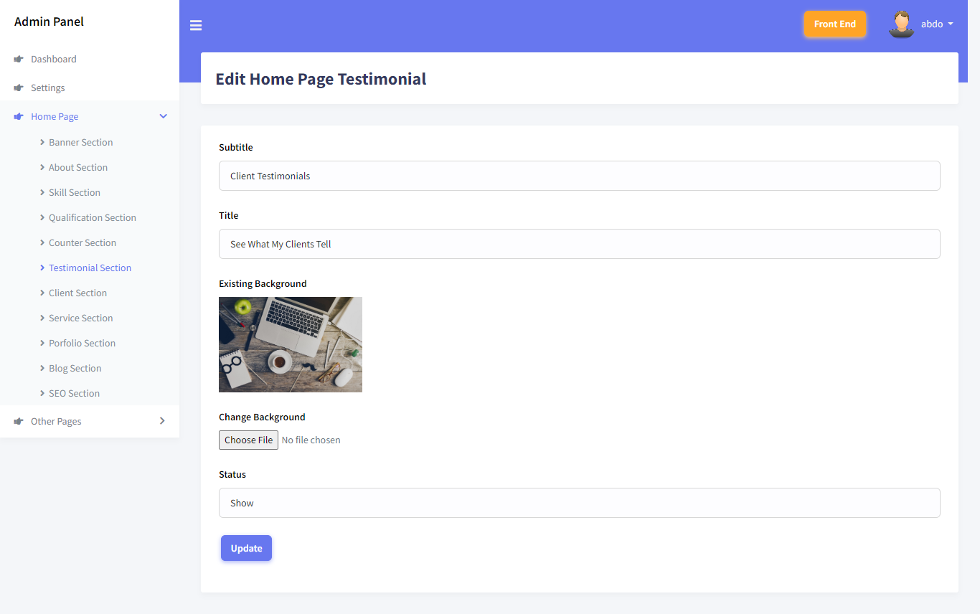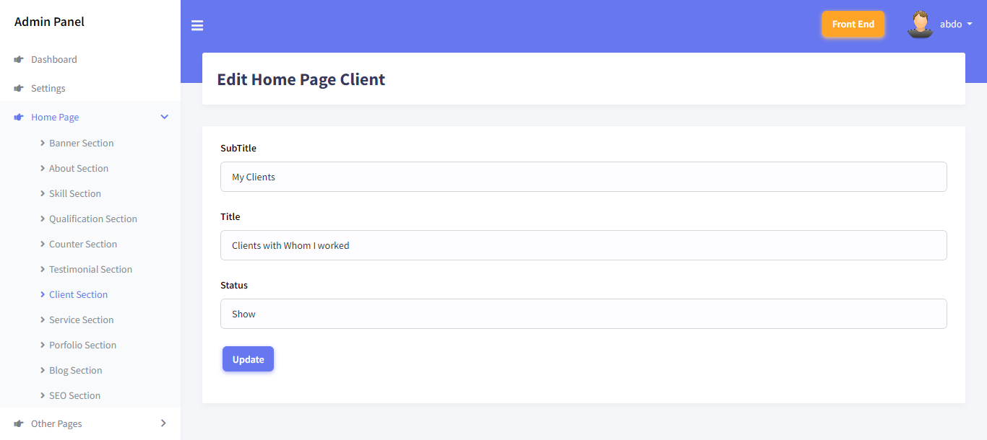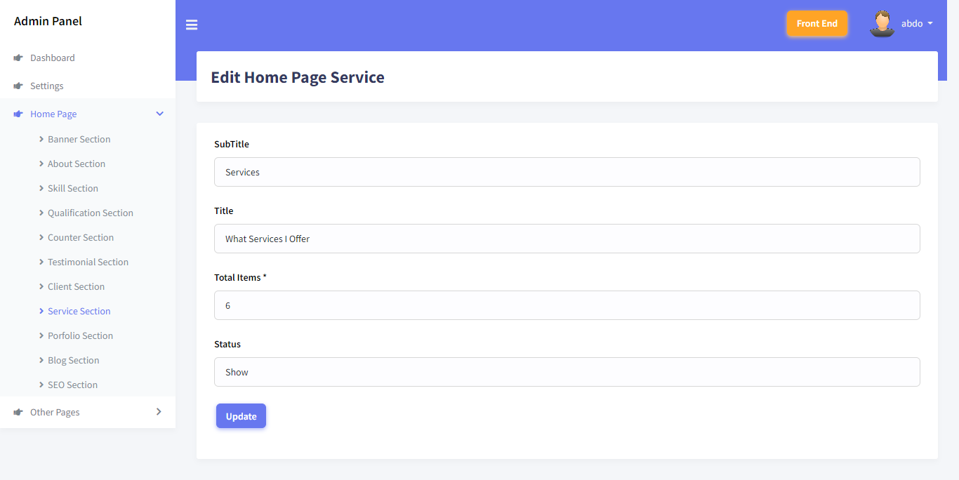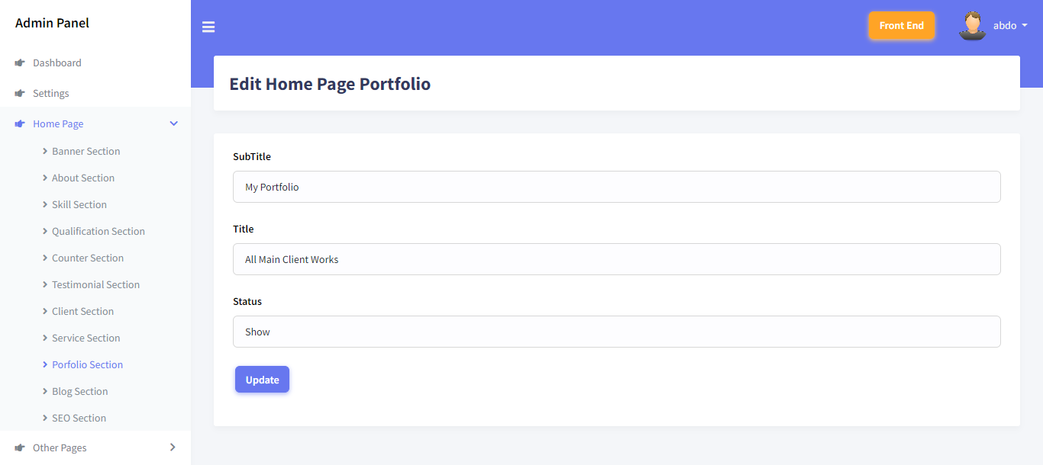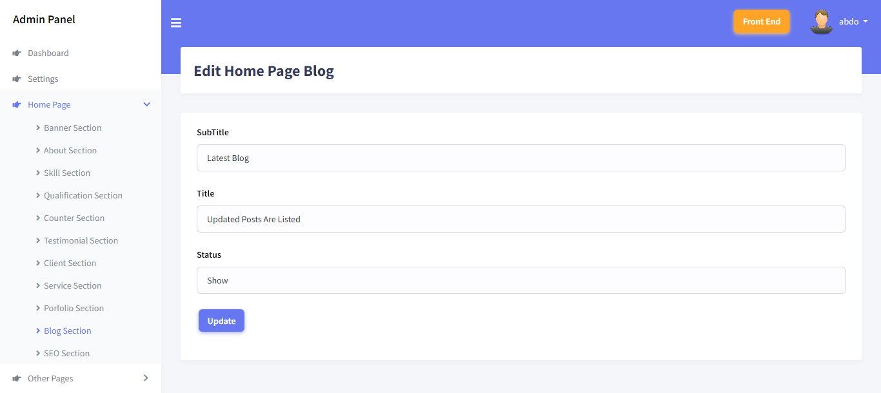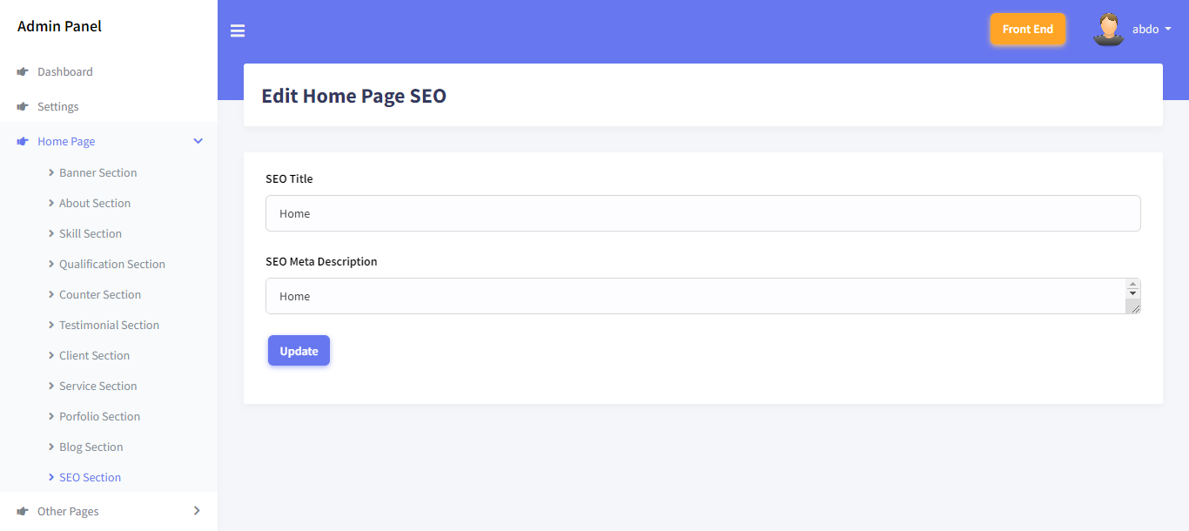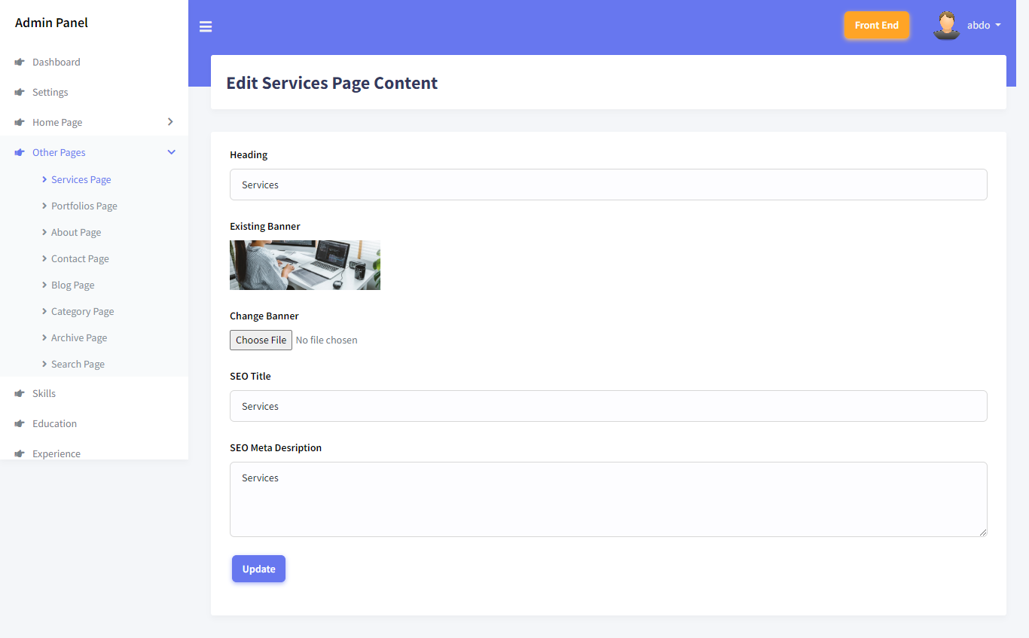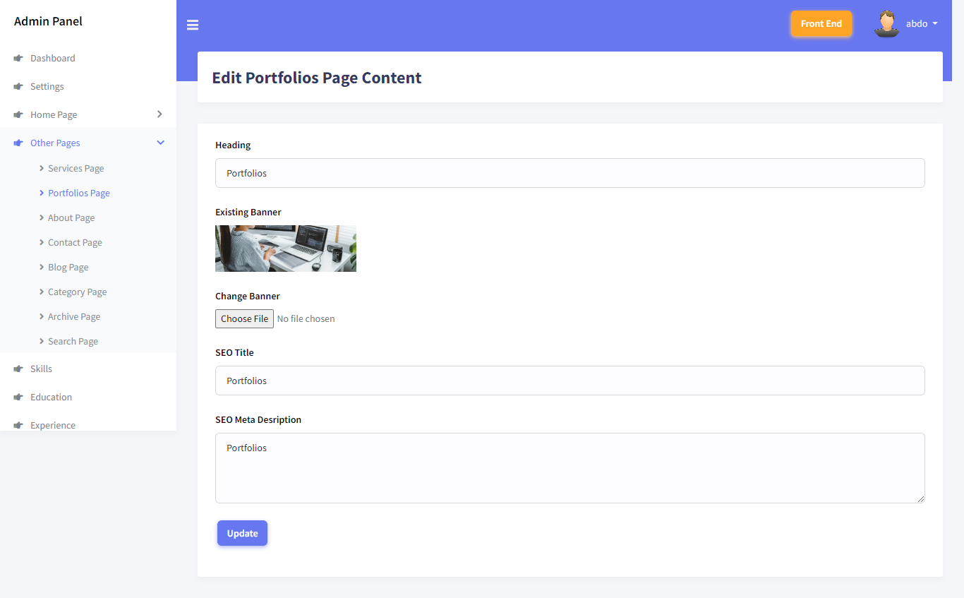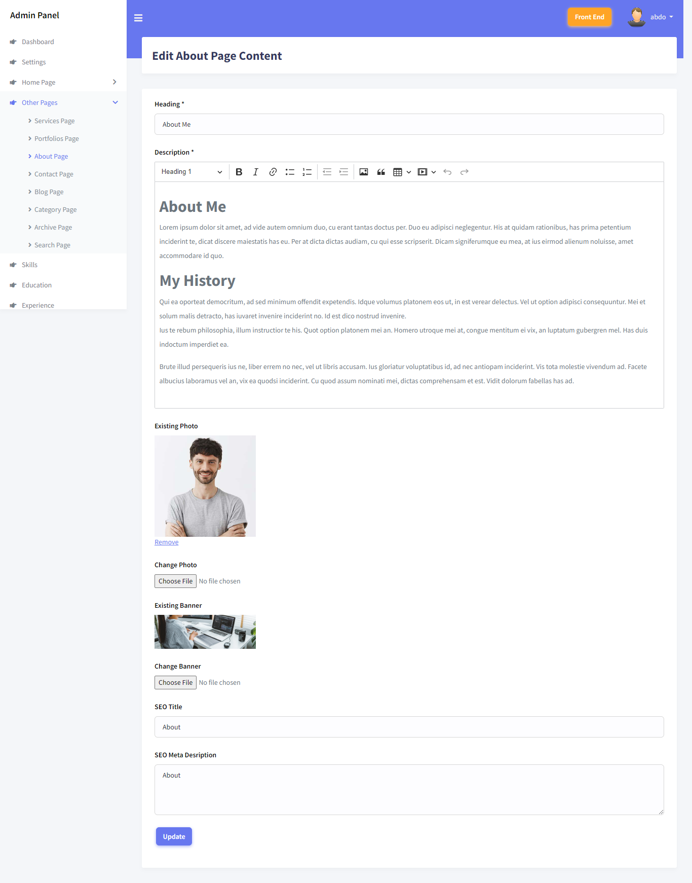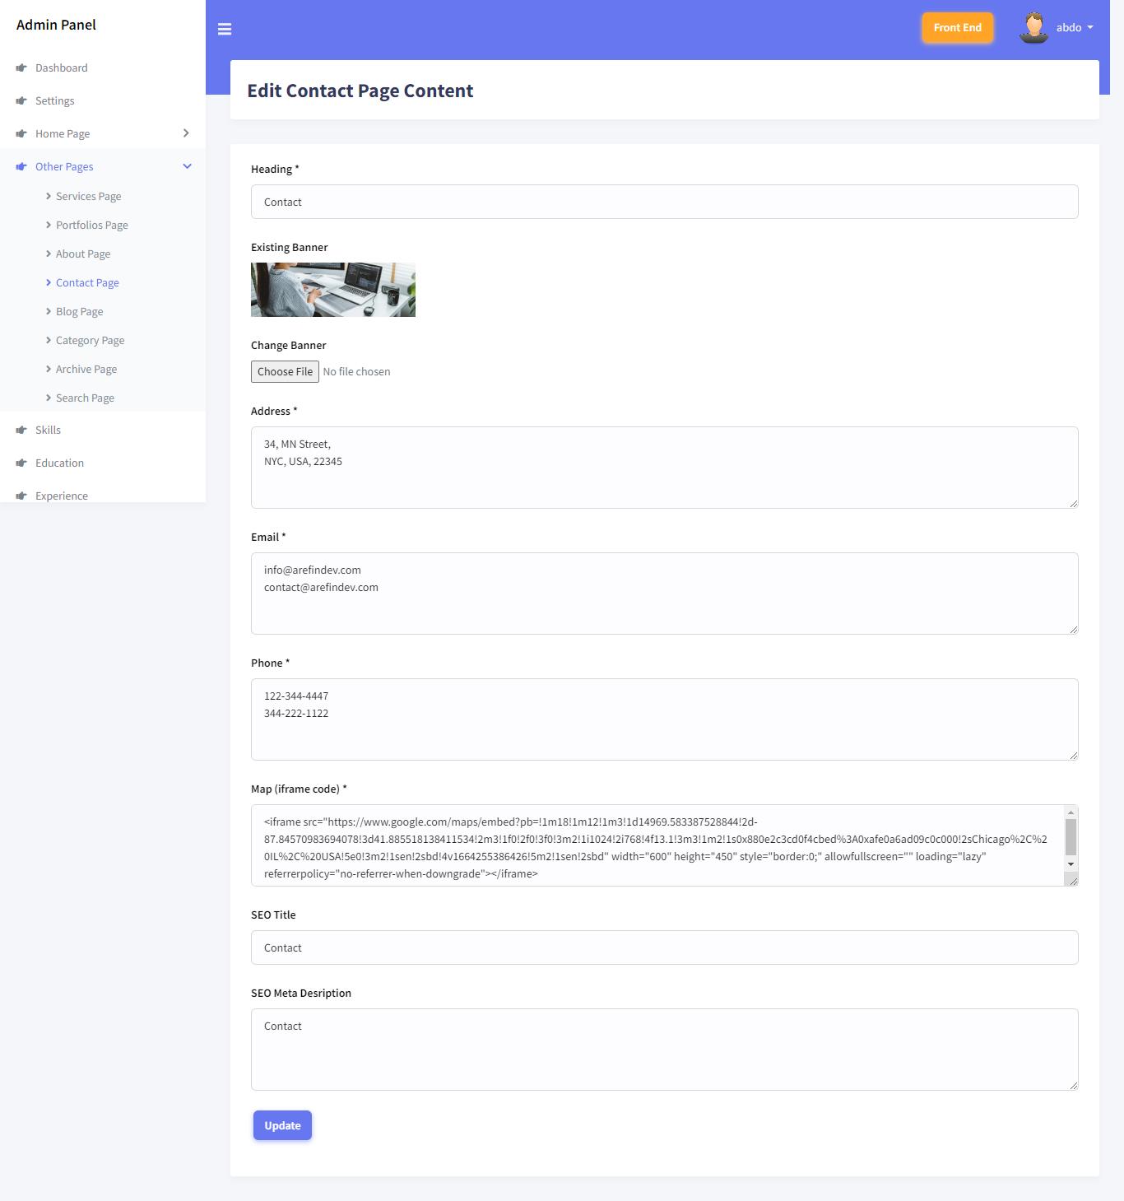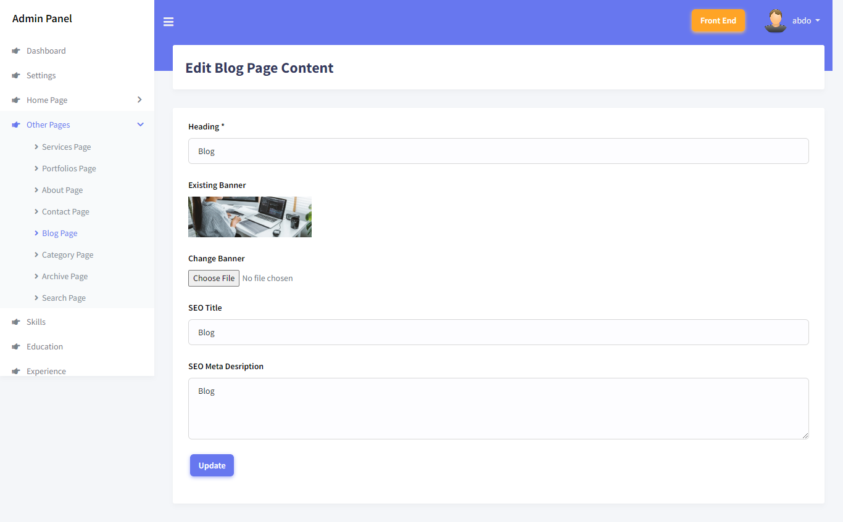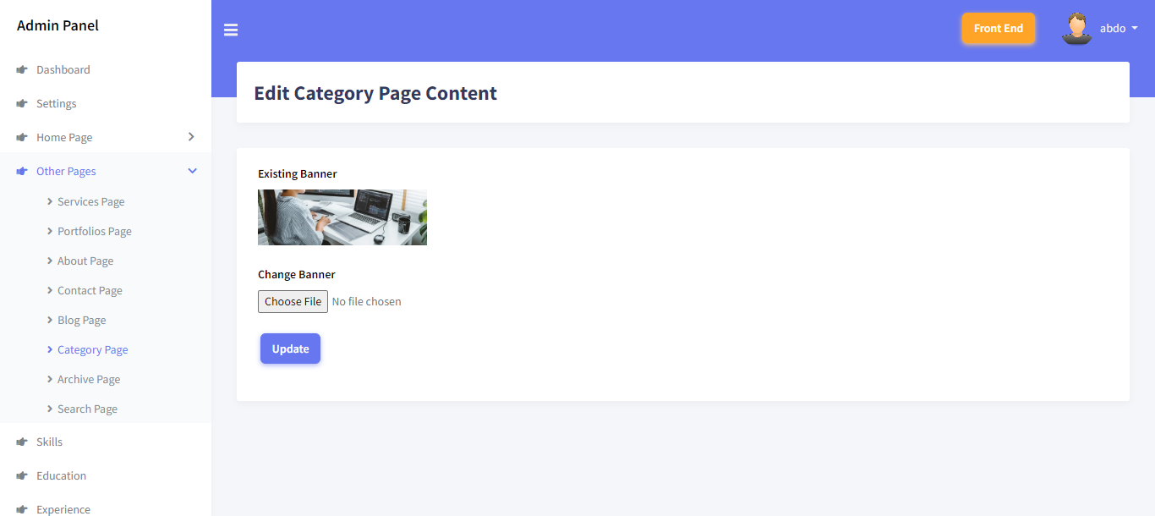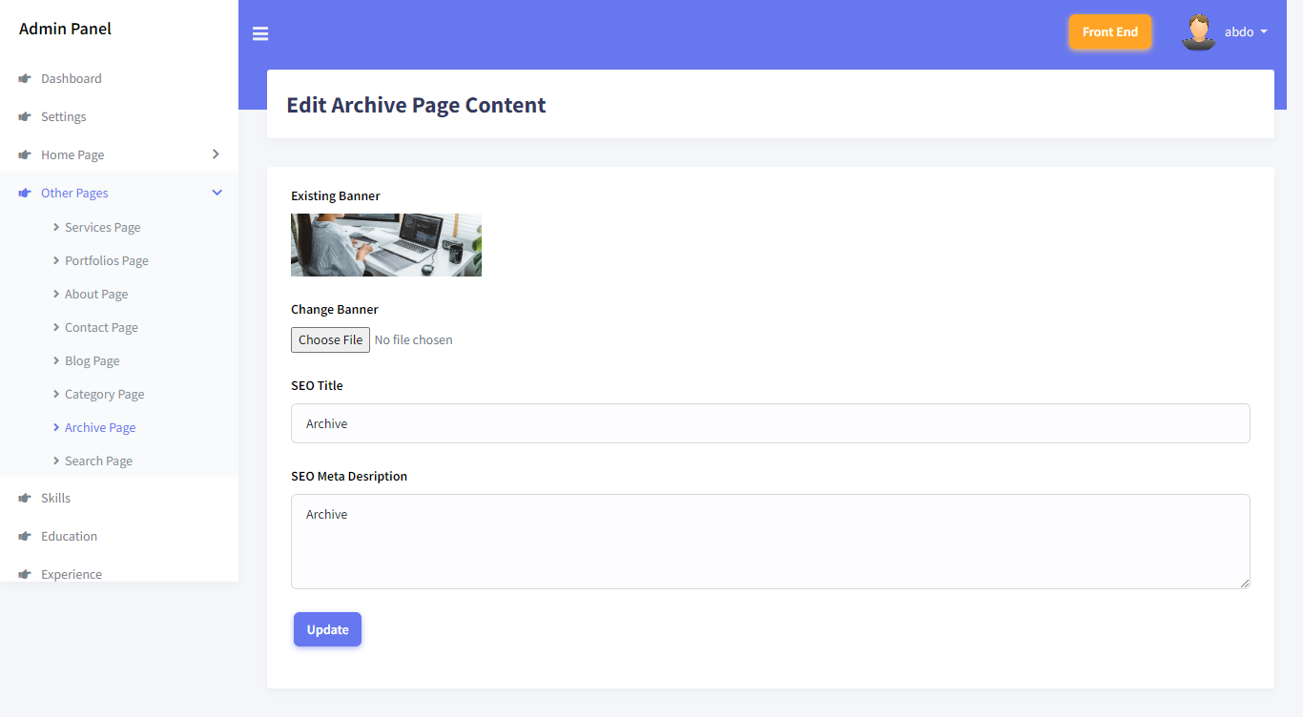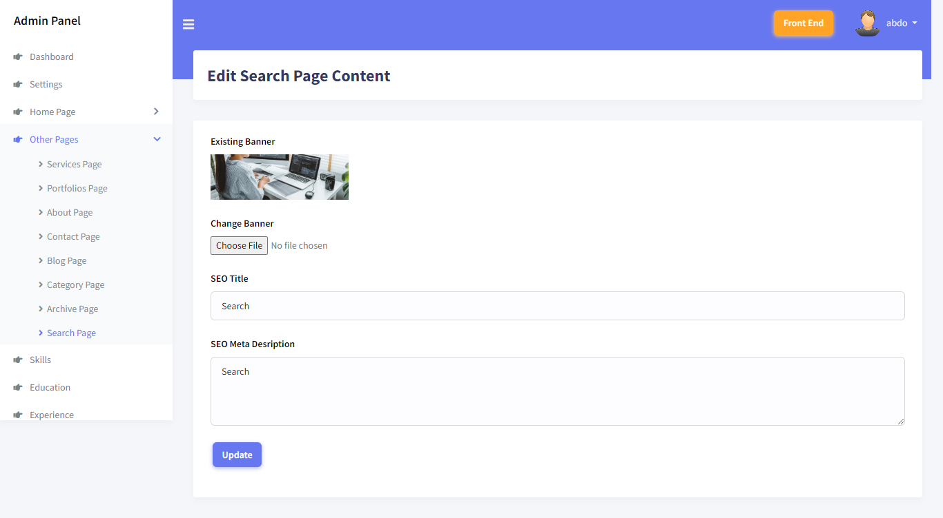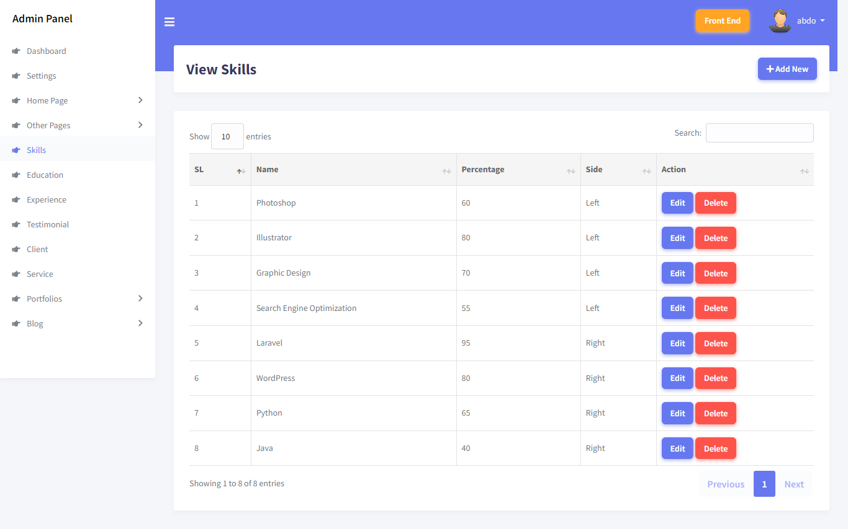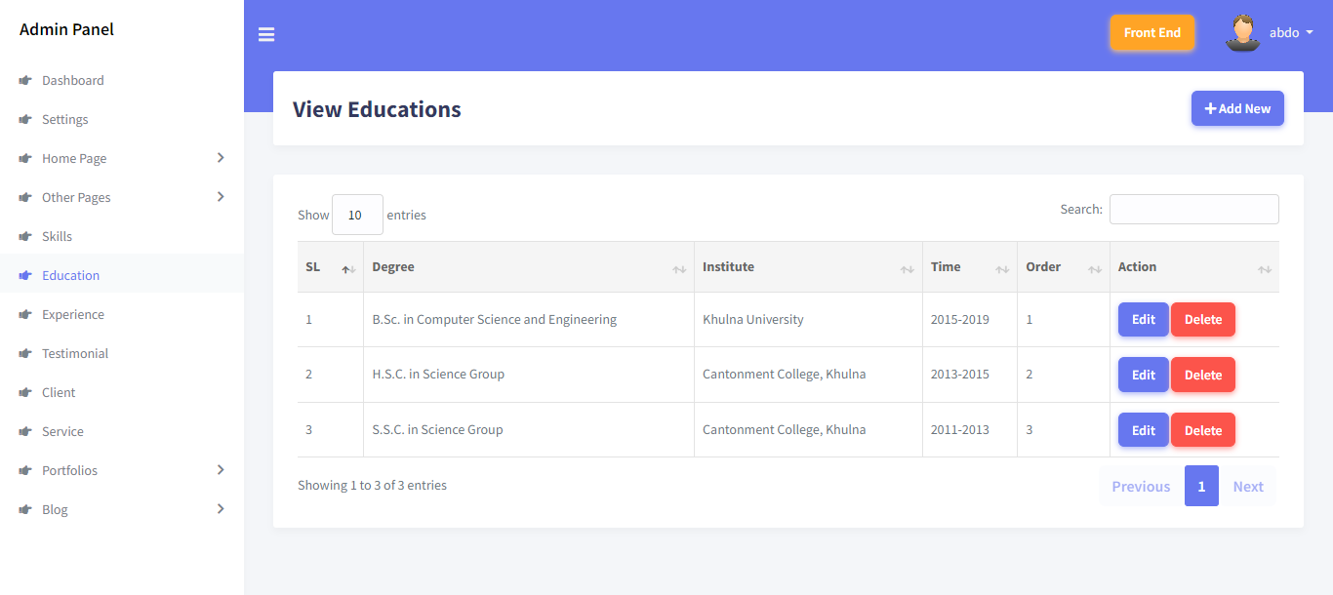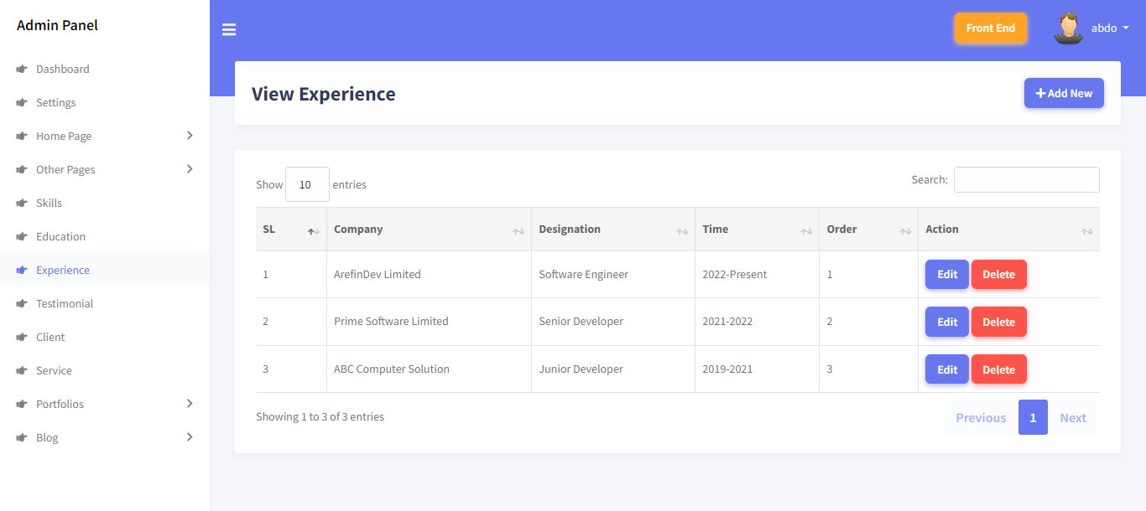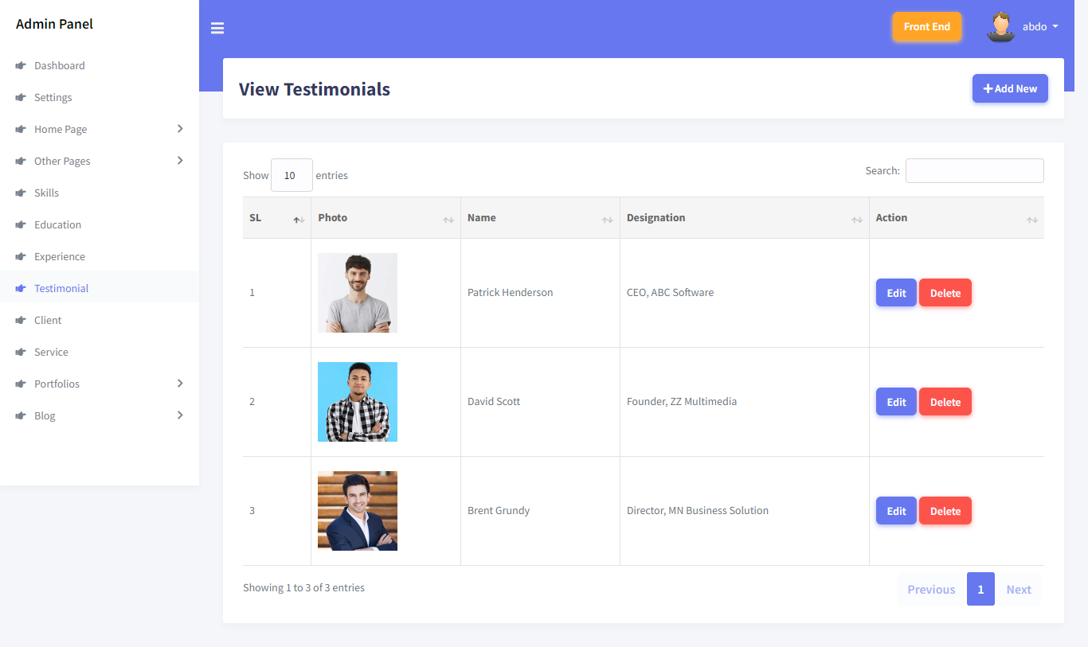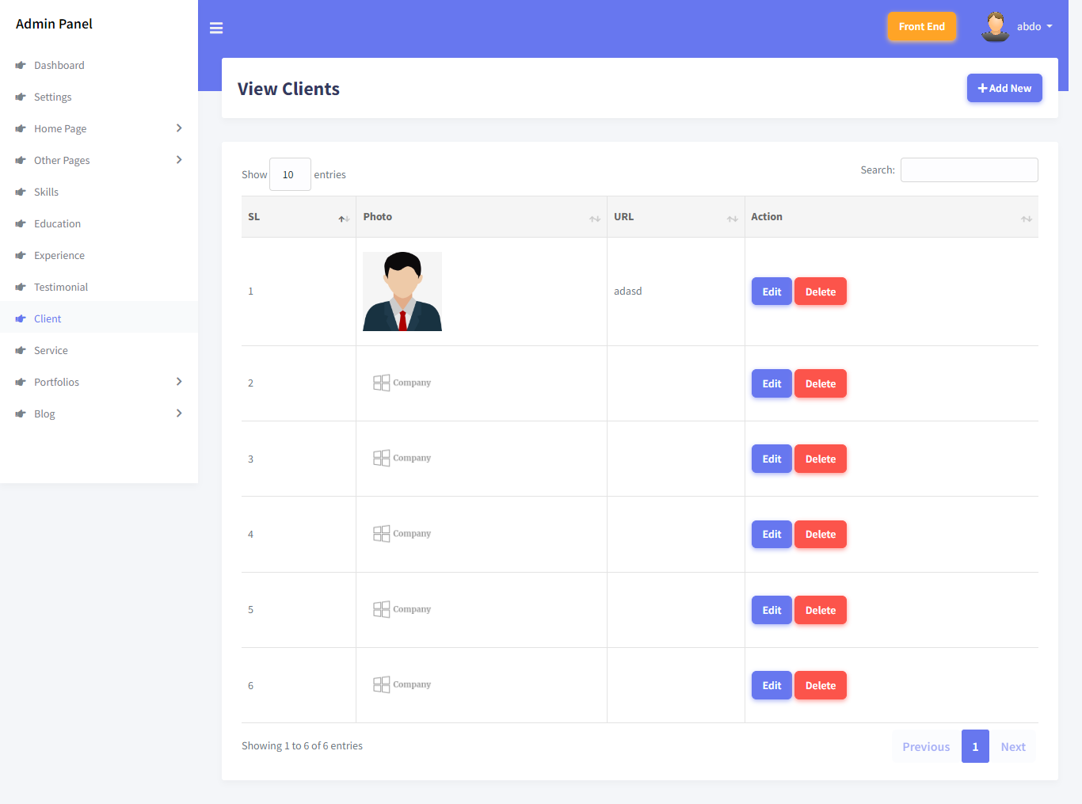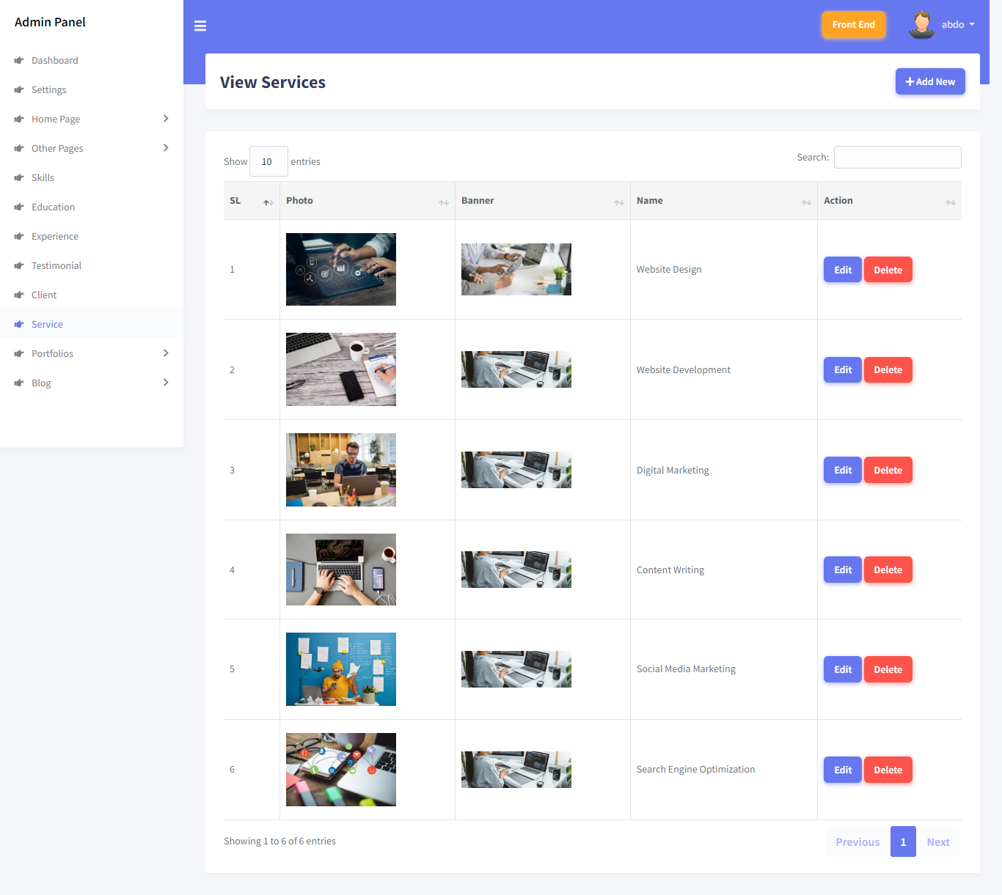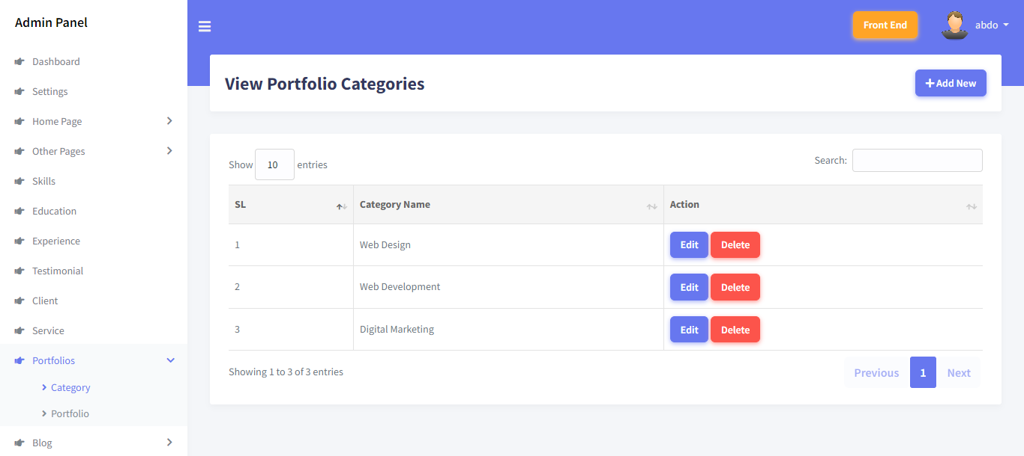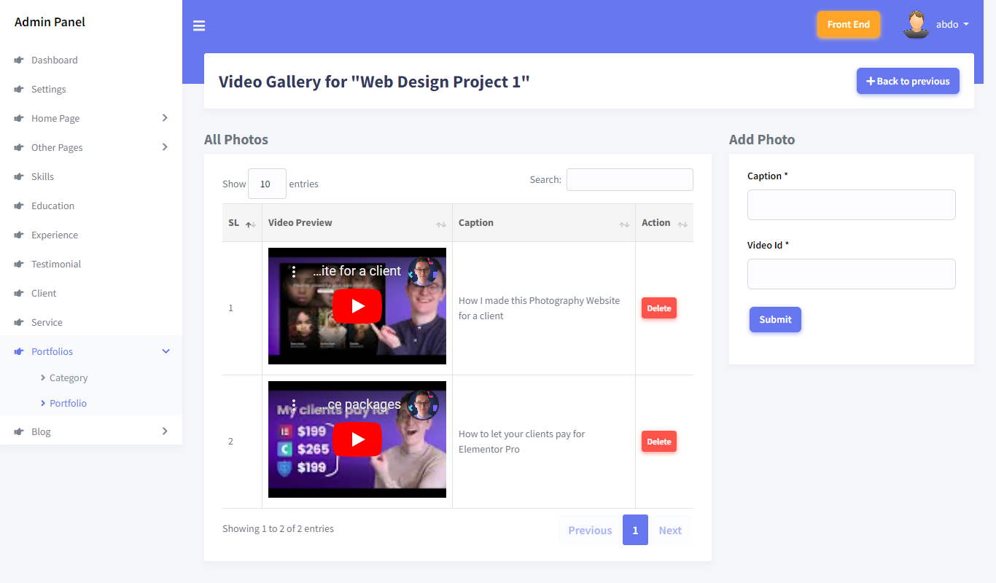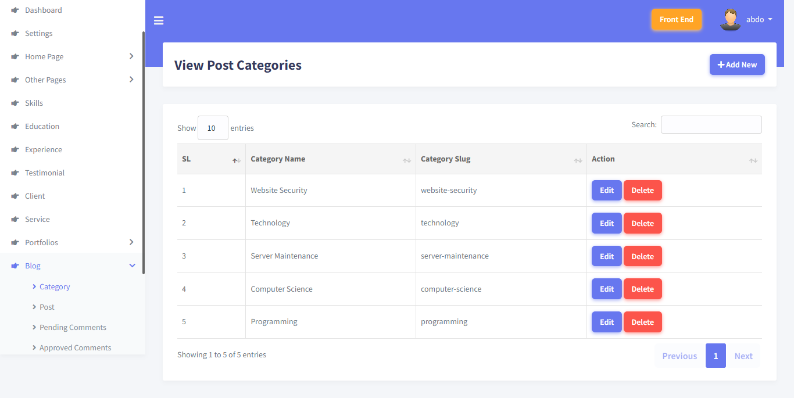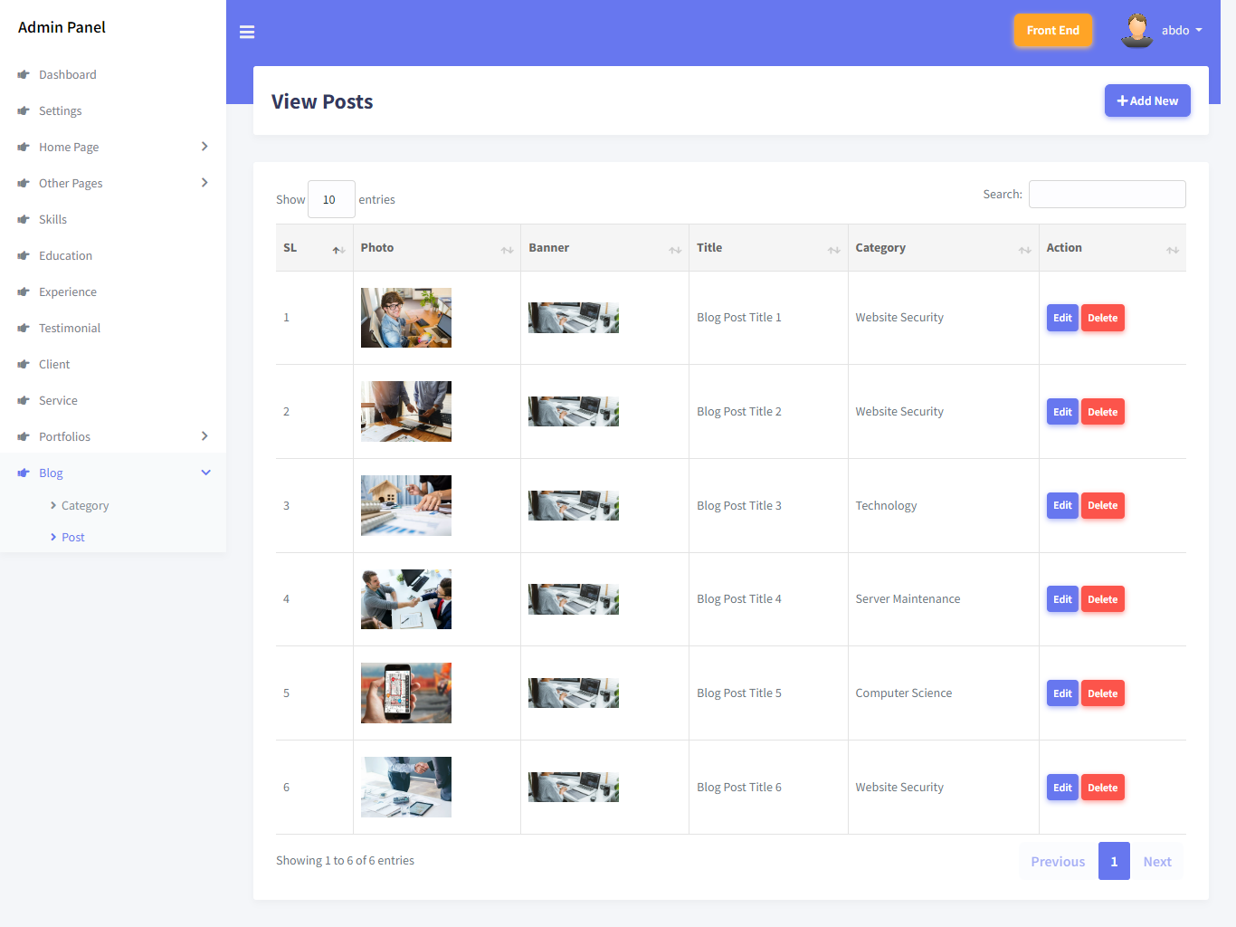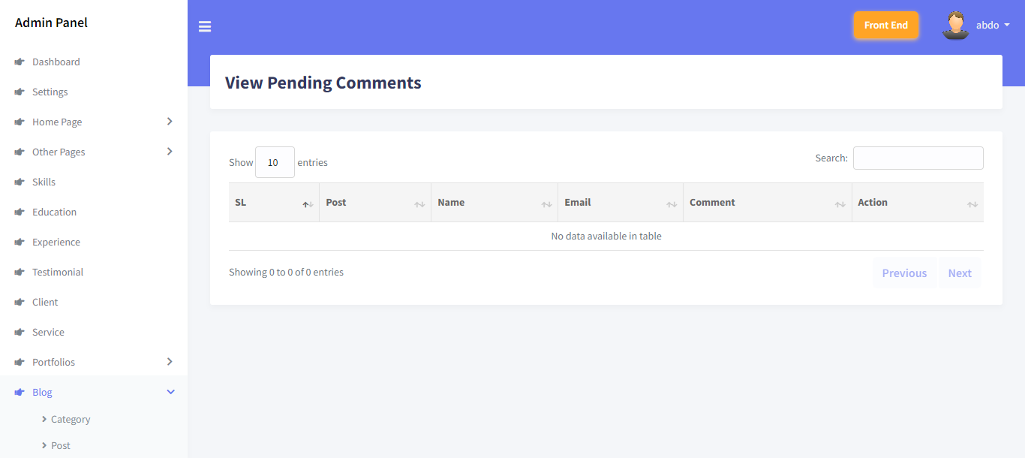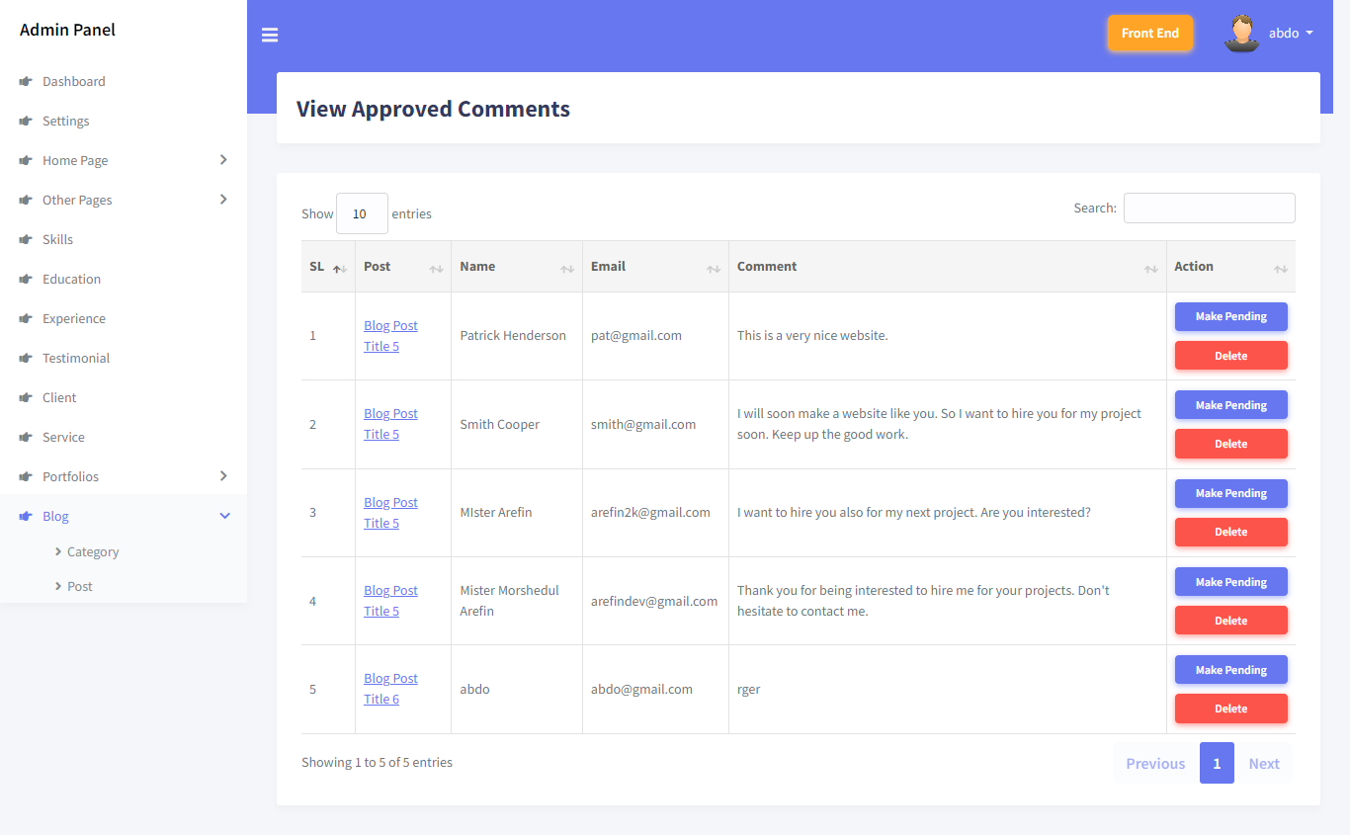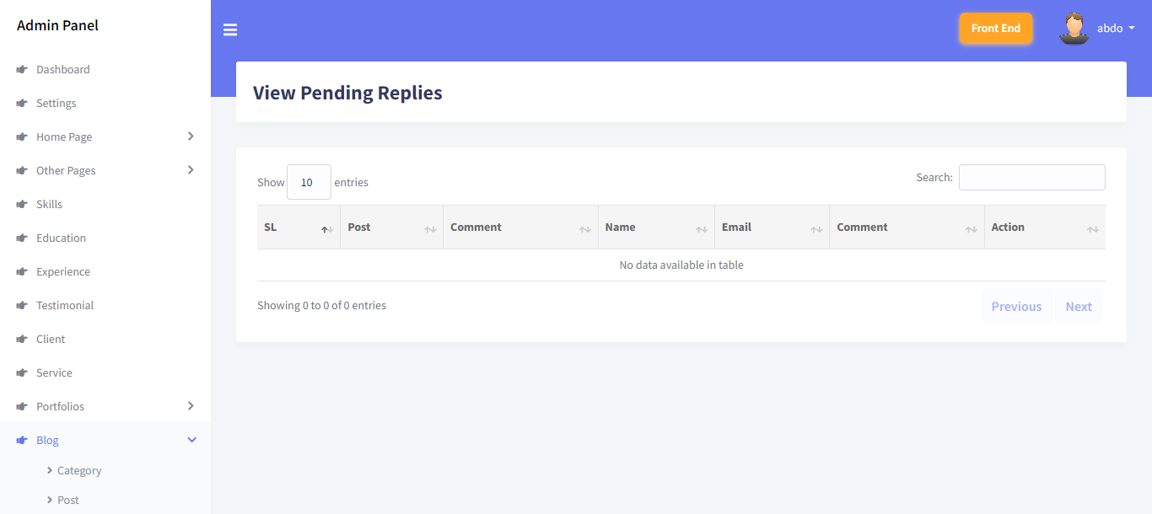

DB_CONNECTION=mysql

DB_HOST=127.0.0.1

DB_PORT=3306

DB_DATABASE=newblog

DB_USERNAME=root

DB_PASSWORD=

php artisan make:model Admin -m

Model created successfully.

Created Migration: 2022_11_23_185429_create_admins_table

PS C:\xampp\htdocs\newblog> php artisan make:model Archive -m

Model created successfully.

Created Migration: 2022_11_23_185451_create_archives_table

PS C:\xampp\htdocs\newblog> php artisan make:model Client -m

Model created successfully.

Created Migration: 2022_11_23_185503_create_clients_table

PS C:\xampp\htdocs\newblog> php artisan make:model Comment -m

Model created successfully.

Created Migration: 2022_11_23_185525_create_comments_table

PS C:\xampp\htdocs\newblog> php artisan make:model Education -m

Model created successfully.

Created Migration: 2022_11_23_185537_create_education_table

PS C:\xampp\htdocs\newblog> php artisan make:model Experience -m

Model created successfully.

Created Migration: 2022_11_23_185552_create_experiences_table

PS C:\xampp\htdocs\newblog> php artisan make:model HomePageItem -m

Model created successfully.

Created Migration: 2022_11_23_185603_create_home_page_items_table

PS C:\xampp\htdocs\newblog> php artisan make:model PageItem -m

Model created successfully.

Created Migration: 2022_11_23_185616_create_page_items_table

PS C:\xampp\htdocs\newblog> php artisan make:model Portfolio -m

Model created successfully.

Created Migration: 2022_11_23_185632_create_portfolios_table

PS C:\xampp\htdocs\newblog> php artisan make:model PortfolioCategory -m

Model created successfully.

Created Migration: 2022_11_23_185646_create_portfolio_categories_table

PS C:\xampp\htdocs\newblog> php artisan make:model PortfolioPhoto -m

Model created successfully.

Created Migration: 2022_11_23_185714_create_portfolio_photos_table

PS C:\xampp\htdocs\newblog> php artisan make:model PortfolioVideo -m

Model created successfully.

Created Migration: 2022_11_23_185738_create_portfolio_videos_table

PS C:\xampp\htdocs\newblog> php artisan make:model Post -m

Model created successfully.

Created Migration: 2022_11_23_185750_create_posts_table

PS C:\xampp\htdocs\newblog> php artisan make:model Service -m

Model created successfully.

Created Migration: 2022_11_23_185801_create_services_table

PS C:\xampp\htdocs\newblog> php artisan make:model Setting -m

Model created successfully.

Created Migration: 2022_11_23_185813_create_settings_table

PS C:\xampp\htdocs\newblog> php artisan make:model Skill -m

Model created successfully.

Created Migration: 2022_11_23_185826_create_skills_table

PS C:\xampp\htdocs\newblog> php artisan make:model Testimonial -m

Model created successfully.

Created Migration: 2022_11_23_185838_create_testimonials_table

PS C:\xampp\htdocs\newblog

php artisan make:model Reply -m

Model created successfully.

Created Migration: 2022_11_23_201639_create_replies_table

C:\xampp\htdocs\newblog> php artisan make:model PostCategory -m

Model created successfully.

Created Migration: 2022_11_23_201714_create_post_categories_table

public function up()

{

Schema::create('admins', function (Blueprint $table) {

$table->id();

$table->string('name');

$table->string('email');

$table->string('password');

$table->string('photo');

$table->string('token');

$table->timestamps();

});

}

public function up()

{

Schema::create('archives', function (Blueprint $table) {

$table->id();

$table->text('month');

$table->text('year');

$table->integer('total_post');

$table->timestamps();

});

}

public function up()

{

Schema::create('clients', function (Blueprint $table) {

$table->id();

$table->text('photo');

$table->text('url')->nullable();

$table->timestamps();

});

}

public function up()

{

Schema::create('comments', function (Blueprint $table) {

$table->id();

$table->integer('post_id');

$table->text('person_name');

$table->text('person_email');

$table->text('person_comment');

$table->text('person_type');

$table->integer('status');

$table->timestamps();

});

}

public function up()

{

Schema::create('education', function (Blueprint $table) {

$table->id();

$table->text('degree');

$table->text('institute');

$table->text('time');

$table->integer('item_order');

$table->timestamps();

});

}

public function up()

{

Schema::create('experiences', function (Blueprint $table) {

$table->id();

$table->text('company');

$table->text('designation');

$table->text('time');

$table->integer('item_order');

$table->timestamps();

});

}

public function up()

{

Schema::create('home_page_items', function (Blueprint $table) {

$table->id();

$table->text('banner_title')->nullable();

$table->text('banner_person_name');

$table->text('banner_person_designation')->nullable();

$table->text('banner_description')->nullable();

$table->text('banner_button_text')->nullable();

$table->text('banner_button_url')->nullable();

$table->text('banner_photo');

$table->text('about_subtitle')->nullable();

$table->text('about_title');

$table->text('about_description')->nullable();

$table->text('about_person_name')->nullable();

$table->text('about_person_phone')->nullable();

$table->text('about_person_email')->nullable();

$table->text('about_icon1')->nullable();

$table->text('about_icon1_url')->nullable();

$table->text('about_icon2')->nullable();

$table->text('about_icon2_url')->nullable();

$table->text('about_icon3')->nullable();

$table->text('about_icon3_url')->nullable();

$table->text('about_icon4')->nullable();

$table->text('about_icon4_url')->nullable();

$table->text('about_icon5')->nullable();

$table->text('about_icon5_url')->nullable();

$table->text('about_photo');

$table->text('about_status');

$table->text('skill_subtitle')->nullable();

$table->text('skill_title')->nullable();

$table->text('skill_status');

$table->text('qualification_subtitle')->nullable();

$table->text('qualification_title')->nullable();

$table->text('education_title')->nullable();

$table->text('experience_title')->nullable();

$table->text('qualification_status');

$table->text('counter1_number');

$table->text('counter1_name');

$table->text('counter2_number');

$table->text('counter2_name');

$table->text('counter3_number');

$table->text('counter3_name');

$table->text('counter4_number');

$table->text('counter4_name');

$table->text('counter_background');

$table->text('counter_status');

$table->text('testimonial_subtitle')->nullable();

$table->text('testimonial_title')->nullable();

$table->text('testimonial_background');

$table->text('testimonial_status');

$table->text('client_subtitle')->nullable();

$table->text('client_title')->nullable();

$table->text('client_status');

$table->text('service_subtitle')->nullable();

$table->text('service_title')->nullable();

$table->text('service_total');

$table->text('service_status');

$table->text('portfolio_subtitle')->nullable();

$table->text('portfolio_title')->nullable();

$table->text('portfolio_status');

$table->text('blog_subtitle')->nullable();

$table->text('blog_title')->nullable();

$table->text('blog_status');

$table->text('seo_title')->nullable();

$table->text('seo_meta_description')->nullable();

$table->timestamps();

});

public function up()

{

Schema::create('page_items', function (Blueprint $table) {

$table->id();

$table->text('services_heading');

$table->text('services_banner');

$table->text('services_seo_title')->nullable();

$table->text('services_seo_meta_description')->nullable();

$table->text('portfolio_heading');

$table->text('portfolio_banner');

$table->text('portfolio_seo_title')->nullable();

$table->text('portfolio_seo_meta_description')->nullable();

$table->text('about_heading');

$table->text('about_banner');

$table->text('about_photo')->nullable();

$table->text('about_description');

$table->text('about_seo_title')->nullable();

$table->text('about_seo_meta_description')->nullable();

$table->text('contact_heading');

$table->text('contact_banner');

$table->text('contact_address');

$table->text('contact_email');

$table->text('contact_phone');

$table->text('contact_map_iframe');

$table->text('contact_seo_title')->nullable();

$table->text('contact_seo_meta_description')->nullable();

$table->text('blog_heading');

$table->text('blog_banner');

$table->text('blog_seo_title')->nullable();

$table->text('blog_seo_meta_description')->nullable();

$table->text('category_banner')->nullable();

$table->text('archive_banner');

$table->text('archive_seo_title')->nullable();

$table->text('archive_seo_meta_description')->nullable();

$table->text('search_banner');

$table->text('search_seo_title')->nullable();

$table->text('search_seo_meta_description')->nullable();

$table->timestamps();

});

public function up()

{

Schema::create('portfolios', function (Blueprint $table) {

$table->id();

$table->integer('portfolio_category_id');

$table->text('name');

$table->text('slug');

$table->text('description');

$table->text('photo');

$table->text('banner');

$table->text('project_client')->nullable();

$table->text('project_company')->nullable();

$table->text('project_start_date')->nullable();

$table->text('project_end_date')->nullable();

$table->text('project_cost')->nullable();

$table->text('project_website')->nullable();

$table->text('seo_title')->nullable();

$table->text('seo_meta_description')->nullable();

$table->timestamps();

});

}

public function up()

{

Schema::create('portfolio_categories', function (Blueprint $table) {

$table->id();

$table->text('category_name');

$table->text('category_slug');

$table->text('category_seo_title')->nullable();

$table->text('category_seo_meta_description')->nullable();

$table->timestamps();

});

}

public function up()

{

Schema::create('portfolio_photos', function (Blueprint $table) {

$table->id();

$table->integer('portfolio_id');

$table->text('photo');

$table->timestamps();

});

}

public function up()

{

Schema::create('portfolio_videos', function (Blueprint $table) {

$table->id();

$table->integer('portfolio_id');

$table->text('caption');

$table->text('video_id');

$table->timestamps();

});

}

public function up()

{

Schema::create('posts', function (Blueprint $table) {

$table->id();

$table->integer('post_category_id');

$table->text('title');

$table->text('slug');

$table->text('short_description');

$table->text('description');

$table->text('photo');

$table->text('banner');

$table->text('show_comment');

$table->text('seo_title')->nullable();

$table->text('seo_meta_description')->nullable();

$table->timestamps();

});

}

public function up()

{

Schema::create('services', function (Blueprint $table) {

$table->id();

$table->text('name');

$table->text('slug');

$table->text('short_description');

$table->text('description');

$table->text('icon');

$table->text('photo');

$table->text('banner');

$table->text('seo_title')->nullable();

$table->text('seo_meta_description')->nullable();

$table->integer('item_order');

$table->timestamps();

});

}

public function up()

{

Schema::create('settings', function (Blueprint $table) {

$table->id();

$table->text('logo');

$table->text('favicon');

$table->text('logo_footer');

$table->text('footer_text')->nullable();

$table->text('footer_icon_1')->nullable();

$table->text('footer_icon_1_url')->nullable();

$table->text('footer_icon_2')->nullable();

$table->text('footer_icon_2_url')->nullable();

$table->text('footer_icon_3')->nullable();

$table->text('footer_icon_3_url')->nullable();

$table->text('footer_icon_4')->nullable();

$table->text('footer_icon_4_url')->nullable();

$table->text('footer_copyright');

$table->text('preloader_status');

$table->text('theme_color');

$table->timestamps();

});

}

public function up()

{

Schema::create('skills', function (Blueprint $table) {

$table->id();

$table->text('name');

$table->text('percentage');

$table->text('side');

$table->timestamps();

});

}

public function up()

{

Schema::create('testimonials', function (Blueprint $table) {

$table->id();

$table->text('name');

$table->text('designation');

$table->text('comment');

$table->text('photo');

$table->timestamps();

});

}

public function up()

{

Schema::create('post_categories', function (Blueprint $table) {

$table->id();

$table->text('category_name');

$table->text('category_slug');

$table->text('category_seo_title')->nullable();

$table->text('category_seo_meta_description')->nullable();

$table->timestamps();

});

}

public function up()

{

Schema::create('replies', function (Blueprint $table) {

$table->id();

$table->integer('post_id');

$table->integer('comment_id');

$table->text('person_name');

$table->text('person_email');

$table->text('person_comment');

$table->text('person_type');

$table->integer('status');

$table->timestamps();

});

}

Portfolio.php

<?php

namespace App\Models;

use Illuminate\Database\Eloquent\Factories\HasFactory;

use Illuminate\Database\Eloquent\Model;

class Portfolio extends Model

{

use HasFactory;

public function rPortfolioCategory()

{

return $this->belongsTo(PortfolioCategory::class, 'portfolio_category_id');

}

}

Comment.php

<?php

namespace App\Models;

use Illuminate\Database\Eloquent\Factories\HasFactory;

use Illuminate\Database\Eloquent\Model;

class Comment extends Model

{

use HasFactory;

public function rPost()

{

return $this->belongsTo(Post::class, 'post_id');

}

public function rReply()

{

return $this->hasMany(Reply::class);

}

}

Post.php

<?php

namespace App\Models;

use Illuminate\Database\Eloquent\Factories\HasFactory;

use Illuminate\Database\Eloquent\Model;

class Post extends Model

{

use HasFactory;

public function rPostCategory()

{

return $this->belongsTo(PostCategory::class, 'post_category_id');

}

}

Reply.php

<?php

namespace App\Models;

use Illuminate\Database\Eloquent\Factories\HasFactory;

use Illuminate\Database\Eloquent\Model;

class Reply extends Model

{

use HasFactory;

public function rPost()

{

return $this->belongsTo(Post::class, 'post_id');

}

public function rComment()

{

return $this->belongsTo(Comment::class, 'comment_id');

}

}

php artisan make:middleware Admin

<?php

namespace App\Http\Middleware;

use Illuminate\Auth\Middleware\Authenticate as Middleware;

class Admin extends Middleware

{

protected function redirectTo($request)

{

if (! $request->expectsJson()) {

return route('admin_login');

}

}

}

php artisan make:mail Websitemail

<?php

namespace App\Mail;

use Illuminate\Bus\Queueable;

use Illuminate\Contracts\Queue\ShouldQueue;

use Illuminate\Mail\Mailable;

use Illuminate\Queue\SerializesModels;

class Websitemail extends Mailable

{

use Queueable, SerializesModels;

public $subject, $body;

public function __construct($subject, $body)

{

$this->subject = $subject;

$this->body = $body;

}

public function build()

{

return $this->view('email.email')->with([

'subject' => $this->subject

]);

}

}

Config

auth.php

<?php

return [

/*

|--------------------------------------------------------------------------

| Authentication Defaults

|--------------------------------------------------------------------------

|

| This option controls the default authentication "guard" and password

| reset options for your application. You may change these defaults

| as required, but they're a perfect start for most applications.

|

*/

'defaults' => [

'guard' => 'web',

'passwords' => 'users',

],

/*

|--------------------------------------------------------------------------

| Authentication Guards

|--------------------------------------------------------------------------

|

| Next, you may define every authentication guard for your application.

| Of course, a great default configuration has been defined for you

| here which uses session storage and the Eloquent user provider.

|

| All authentication drivers have a user provider. This defines how the

| users are actually retrieved out of your database or other storage

| mechanisms used by this application to persist your user's data.

|

| Supported: "session"

|

*/

'guards' => [

'web' => [

'driver' => 'session',

'provider' => 'users',

],

'admin' => [

'driver' => 'session',

'provider' => 'admins',

],

],

/*

|--------------------------------------------------------------------------

| User Providers

|--------------------------------------------------------------------------

|

| All authentication drivers have a user provider. This defines how the

| users are actually retrieved out of your database or other storage

| mechanisms used by this application to persist your user's data.

|

| If you have multiple user tables or models you may configure multiple

| sources which represent each model / table. These sources may then

| be assigned to any extra authentication guards you have defined.

|

| Supported: "database", "eloquent"

|

*/

'providers' => [

'users' => [

'driver' => 'eloquent',

'model' => App\Models\User::class,

],

'admins' => [

'driver' => 'eloquent',

'model' => App\Models\Admin::class,

],

// 'users' => [

// 'driver' => 'database',

// 'table' => 'users',

// ],

],

/*

|--------------------------------------------------------------------------

| Resetting Passwords

|--------------------------------------------------------------------------

|

| You may specify multiple password reset configurations if you have more

| than one user table or model in the application and you want to have

| separate password reset settings based on the specific user types.

|

| The expire time is the number of minutes that each reset token will be

| considered valid. This security feature keeps tokens short-lived so

| they have less time to be guessed. You may change this as needed.

|

*/

'passwords' => [

'users' => [

'provider' => 'users',

'table' => 'password_resets',

'expire' => 60,

'throttle' => 60,

],

'admins' => [

'provider' => 'admins',

'table' => 'password_resets',

'expire' => 60,

'throttle' => 60,

],

],

/*

|--------------------------------------------------------------------------

| Password Confirmation Timeout

|--------------------------------------------------------------------------

|

| Here you may define the amount of seconds before a password confirmation

| times out and the user is prompted to re-enter their password via the

| confirmation screen. By default, the timeout lasts for three hours.

|

*/

'password_timeout' => 10800,

];

AppServiceProvider.php

<?php

namespace App\Providers;

use Illuminate\Support\ServiceProvider;

use Illuminate\Pagination\Paginator;

use App\Models\Setting;

class AppServiceProvider extends ServiceProvider

{

public function register()

{

//

}

public function boot()

{

Paginator::useBootstrap();

$setting_data = Setting::where('id',1)->first();

view()->share('global_setting_data', $setting_data);

}

}

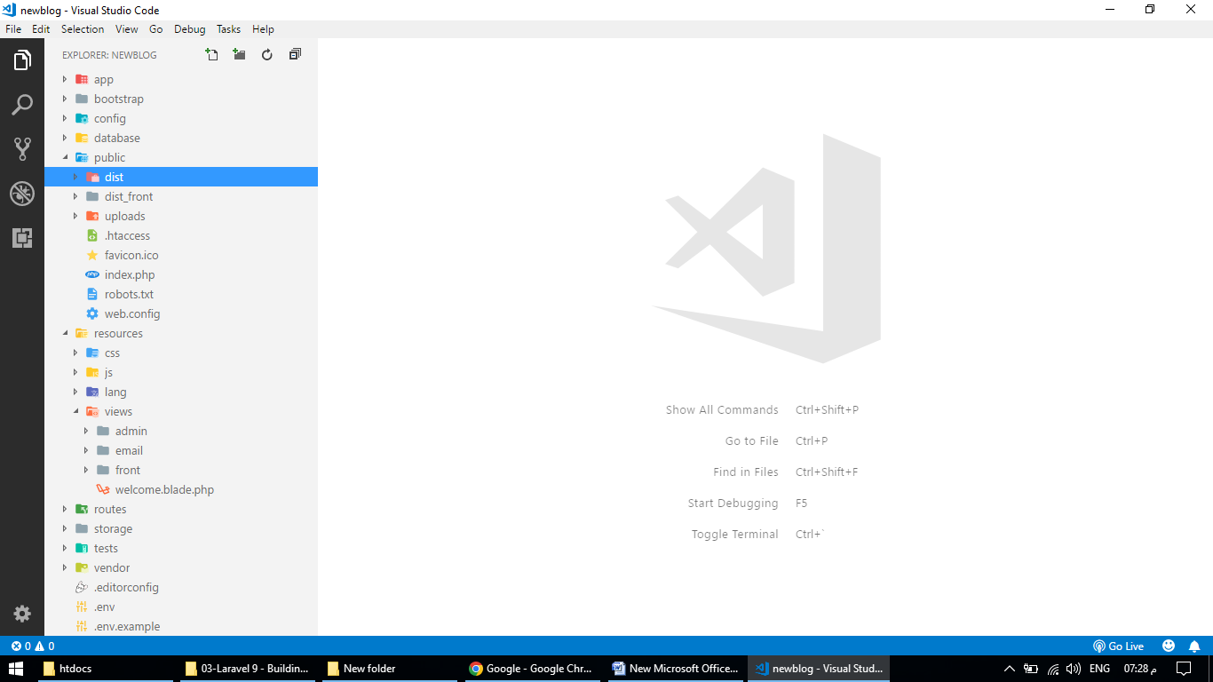

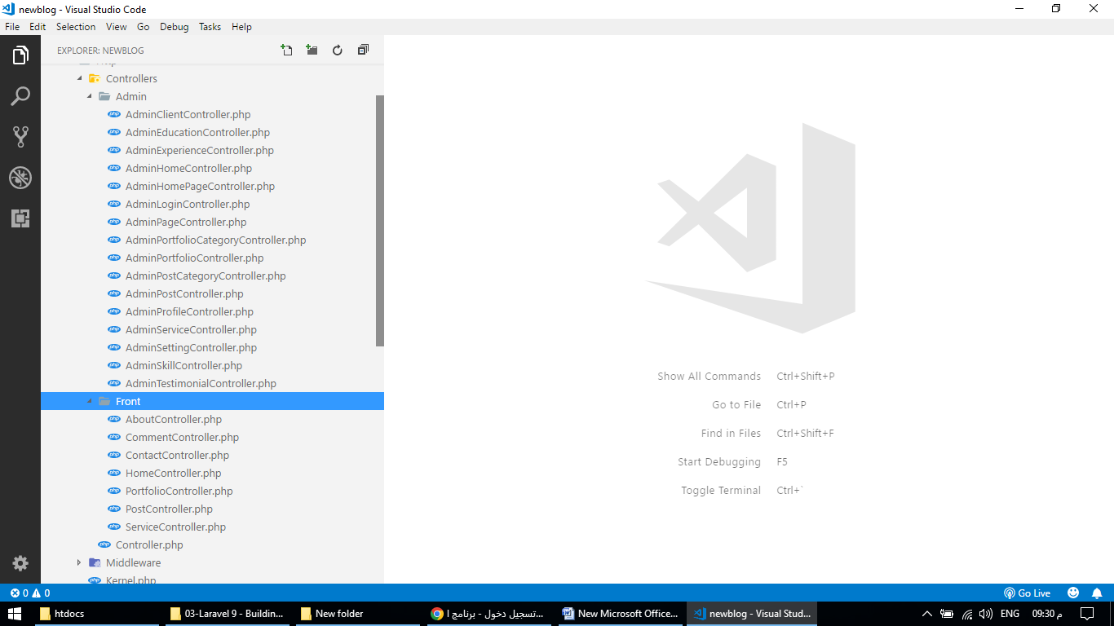

AdminClientController.php

<?php

namespace App\Http\Controllers\Admin;

use App\Http\Controllers\Controller;

use Illuminate\Http\Request;

use App\Models\Client;

class AdminClientController extends Controller

{

public function index()

{

$all_data = Client::orderBy('id','asc')->get();

return view('admin.client_show', compact('all_data'));

}

public function add()

{

return view('admin.client_add');

}

public function store(Request $request)

{

$request->validate([

'photo' => 'required|image|mimes:jpg,jpeg,png,gif'

]);

$obj = new Client();

$ext = $request->file('photo')->extension();

$final_name = 'client_'.time().'.'.$ext;

$request->file('photo')->move(public_path('uploads/'),$final_name);

$obj->photo = $final_name;

$obj->url = $request->url;

$obj->save();

return redirect()->route('admin_client_show')->with('success', 'Data is inserted successfully.');

}

public function edit($id)

{

$row_data = Client::where('id',$id)->first();

return view('admin.client_edit',compact('row_data'));

}

public function update(Request $request,$id)

{

$obj = Client::where('id',$id)->first();

if($request->hasFile('photo')) {

$request->validate([

'photo' => 'image|mimes:jpg,jpeg,png,gif'

]);

unlink(public_path('uploads/'.$obj->photo));

$ext = $request->file('photo')->extension();

$final_name = 'client_'.time().'.'.$ext;

$request->file('photo')->move(public_path('uploads/'),$final_name);

$obj->photo = $final_name;

}

$obj->url = $request->url;

$obj->update();

return redirect()->route('admin_client_show')->with('success', 'Data is updated successfully.');

}

public function delete($id)

{

$row_data = Client::where('id',$id)->first();

unlink(public_path('uploads/'.$row_data->photo));

$row_data->delete();

return redirect()->back()->with('success', 'Data is deleted successfully.');

}

}

AdminEducationController.php

<?php

namespace App\Http\Controllers\Admin;

use App\Http\Controllers\Controller;

use Illuminate\Http\Request;

use App\Models\Education;

class AdminEducationController extends Controller

{

public function index()

{

$all_data = Education::orderBy('item_order','asc')->get();

return view('admin.education_show', compact('all_data'));

}

public function add()

{

return view('admin.education_add');

}

public function store(Request $request)

{

$request->validate([

'degree' => 'required',

'institute' => 'required',

'time' => 'required',

'item_order' => 'required'

]);

$obj = new Education();

$obj->degree = $request->degree;

$obj->institute = $request->institute;

$obj->time = $request->time;

$obj->item_order = $request->item_order;

$obj->save();

return redirect()->route('admin_education_show')->with('success', 'Data is inserted successfully.');

}

public function edit($id)

{

$row_data = Education::where('id',$id)->first();

return view('admin.education_edit',compact('row_data'));

}

public function update(Request $request,$id)

{

$request->validate([

'degree' => 'required',

'institute' => 'required',

'time' => 'required',

'item_order' => 'required'

]);

$obj = Education::where('id',$id)->first();

$obj->degree = $request->degree;

$obj->institute = $request->institute;

$obj->time = $request->time;

$obj->item_order = $request->item_order;

$obj->update();

return redirect()->route('admin_education_show')->with('success', 'Data is updated successfully.');

}

public function delete($id)

{

$row_data = Education::where('id',$id)->first();

$row_data->delete();

return redirect()->back()->with('success', 'Data is deleted successfully.');

}

}

<?php

namespace App\Http\Controllers\Admin;

use App\Http\Controllers\Controller;

use Illuminate\Http\Request;

use App\Models\Experience;

class AdminExperienceController extends Controller

{

public function index()

{

$all_data = Experience::orderBy('item_order','asc')->get();

return view('admin.experience_show', compact('all_data'));

}

public function add()

{

return view('admin.experience_add');

}

public function store(Request $request)

{

$request->validate([

'company' => 'required',

'designation' => 'required',

'time' => 'required',

'item_order' => 'required'

]);

$obj = new Experience();

$obj->company = $request->company;

$obj->designation = $request->designation;

$obj->time = $request->time;

$obj->item_order = $request->item_order;

$obj->save();

return redirect()->route('admin_experience_show')->with('success', 'Data is inserted successfully.');

}

public function edit($id)

{

$row_data = Experience::where('id',$id)->first();

return view('admin.experience_edit',compact('row_data'));

}

public function update(Request $request,$id)

{

$request->validate([

'company' => 'required',

'designation' => 'required',

'time' => 'required',

'item_order' => 'required'

]);

$obj = Experience::where('id',$id)->first();

$obj->company = $request->company;

$obj->designation = $request->designation;

$obj->time = $request->time;

$obj->item_order = $request->item_order;

$obj->update();

return redirect()->route('admin_experience_show')->with('success', 'Data is updated successfully.');

}

public function delete($id)

{

$row_data = Experience::where('id',$id)->first();

$row_data->delete();

return redirect()->back()->with('success', 'Data is deleted successfully.');

}

}

AdminHomeController.php

<?php

namespace App\Http\Controllers\Admin;

use App\Http\Controllers\Controller;

use Illuminate\Http\Request;

class AdminHomeController extends Controller

{

public function index()

{

return view('admin.home');

}

}

AdminHomePageController.php

<?php

namespace App\Http\Controllers\Admin;

use App\Http\Controllers\Controller;

use Illuminate\Http\Request;

use App\Models\HomePageItem;

class AdminHomePageController extends Controller

{

public function banner()

{

$page_data = HomePageItem::where('id',1)->first();

return view('admin.home_banner_show', compact('page_data'));

}

public function banner_update(Request $request)

{

$page_data = HomePageItem::where('id',1)->first();

$request->validate([

'banner_person_name' => 'required'

]);

if($request->hasFile('banner_photo')) {

$request->validate([

'banner_photo' => 'image|mimes:jpg,jpeg,png,gif'

]);

unlink(public_path('uploads/'.$page_data->banner_photo));

$ext = $request->file('banner_photo')->extension();

$final_name = 'home_banner'.'.'.$ext;

$request->file('banner_photo')->move(public_path('uploads/'),$final_name);

$page_data->banner_photo = $final_name;

}

$page_data->banner_title = $request->banner_title;

$page_data->banner_person_name = $request->banner_person_name;

$page_data->banner_person_designation = $request->banner_person_designation;

$page_data->banner_description = $request->banner_description;

$page_data->banner_button_text = $request->banner_button_text;

$page_data->banner_button_url = $request->banner_button_url;

$page_data->update();

return redirect()->back()->with('success', 'Data is updated successfully.');

}

public function about()

{

$page_data = HomePageItem::where('id',1)->first();

return view('admin.home_about_show', compact('page_data'));

}

public function about_update(Request $request)

{

$page_data = HomePageItem::where('id',1)->first();

$request->validate([

'about_title' => 'required'

]);

if($request->hasFile('about_photo')) {

$request->validate([

'about_photo' => 'image|mimes:jpg,jpeg,png,gif'

]);

unlink(public_path('uploads/'.$page_data->about_photo));

$ext = $request->file('about_photo')->extension();

$final_name = 'home_about'.'.'.$ext;

$request->file('about_photo')->move(public_path('uploads/'),$final_name);

$page_data->about_photo = $final_name;

}

$page_data->about_subtitle = $request->about_subtitle;

$page_data->about_title = $request->about_title;

$page_data->about_description = $request->about_description;

$page_data->about_person_name = $request->about_person_name;

$page_data->about_person_phone = $request->about_person_phone;

$page_data->about_person_email = $request->about_person_email;

$page_data->about_icon1 = $request->about_icon1;

$page_data->about_icon1_url = $request->about_icon1_url;

$page_data->about_icon2 = $request->about_icon2;

$page_data->about_icon2_url = $request->about_icon2_url;

$page_data->about_icon3 = $request->about_icon3;

$page_data->about_icon3_url = $request->about_icon3_url;

$page_data->about_icon4 = $request->about_icon4;

$page_data->about_icon4_url = $request->about_icon4_url;

$page_data->about_icon5 = $request->about_icon5;

$page_data->about_icon5_url = $request->about_icon5_url;

$page_data->about_status = $request->about_status;

$page_data->update();

return redirect()->back()->with('success', 'Data is updated successfully.');

}

public function skill()

{

$page_data = HomePageItem::where('id',1)->first();

return view('admin.home_skill_show', compact('page_data'));

}

public function skill_update(Request $request)

{

$page_data = HomePageItem::where('id',1)->first();

$page_data->skill_subtitle = $request->skill_subtitle;

$page_data->skill_title = $request->skill_title;

$page_data->skill_status = $request->skill_status;

$page_data->update();

return redirect()->back()->with('success', 'Data is updated successfully.');

}

public function qualification()

{

$page_data = HomePageItem::where('id',1)->first();

return view('admin.home_qualification_show', compact('page_data'));

}

public function qualification_update(Request $request)

{

$page_data = HomePageItem::where('id',1)->first();

$page_data->qualification_subtitle = $request->qualification_subtitle;

$page_data->qualification_title = $request->qualification_title;

$page_data->education_title = $request->education_title;

$page_data->experience_title = $request->experience_title;

$page_data->qualification_status = $request->qualification_status;

$page_data->update();

return redirect()->back()->with('success', 'Data is updated successfully.');

}

public function counter()

{

$page_data = HomePageItem::where('id',1)->first();

return view('admin.home_counter_show', compact('page_data'));

}

public function counter_update(Request $request)

{

$page_data = HomePageItem::where('id',1)->first();

$request->validate([

'counter1_number' => 'required',

'counter1_name' => 'required',

'counter2_number' => 'required',

'counter2_name' => 'required',

'counter3_number' => 'required',

'counter3_name' => 'required',

'counter4_number' => 'required',

'counter4_name' => 'required'

]);

if($request->hasFile('counter_background')) {

$request->validate([

'counter_background' => 'image|mimes:jpg,jpeg,png,gif'

]);

unlink(public_path('uploads/'.$page_data->counter_background));

$ext = $request->file('counter_background')->extension();

$final_name = 'counter_background'.'.'.$ext;

$request->file('counter_background')->move(public_path('uploads/'),$final_name);

$page_data->counter_background = $final_name;

}

$page_data->counter1_number = $request->counter1_number;

$page_data->counter1_name = $request->counter1_name;

$page_data->counter2_number = $request->counter2_number;

$page_data->counter2_name = $request->counter2_name;

$page_data->counter3_number = $request->counter3_number;

$page_data->counter3_name = $request->counter3_name;

$page_data->counter4_number = $request->counter4_number;

$page_data->counter4_name = $request->counter4_name;

$page_data->counter_status = $request->counter_status;

$page_data->update();

return redirect()->back()->with('success', 'Data is updated successfully.');

}

public function testimonial()

{

$page_data = HomePageItem::where('id',1)->first();

return view('admin.home_testimonial_show', compact('page_data'));

}

public function testimonial_update(Request $request)

{

$page_data = HomePageItem::where('id',1)->first();

if($request->hasFile('testimonial_background')) {

$request->validate([

'testimonial_background' => 'image|mimes:jpg,jpeg,png,gif'

]);

unlink(public_path('uploads/'.$page_data->testimonial_background));

$ext = $request->file('testimonial_background')->extension();

$final_name = 'testimonial_background'.'.'.$ext;

$request->file('testimonial_background')->move(public_path('uploads/'),$final_name);

$page_data->testimonial_background = $final_name;

}

$page_data->testimonial_subtitle = $request->testimonial_subtitle;

$page_data->testimonial_title = $request->testimonial_title;

$page_data->testimonial_status = $request->testimonial_status;

$page_data->update();

return redirect()->back()->with('success', 'Data is updated successfully.');

}

public function client()

{

$page_data = HomePageItem::where('id',1)->first();

return view('admin.home_client_show', compact('page_data'));

}

public function client_update(Request $request)

{

$page_data = HomePageItem::where('id',1)->first();

$page_data->client_subtitle = $request->client_subtitle;

$page_data->client_title = $request->client_title;

$page_data->client_status = $request->client_status;

$page_data->update();

return redirect()->back()->with('success', 'Data is updated successfully.');

}

public function service()

{

$page_data = HomePageItem::where('id',1)->first();

return view('admin.home_service_show', compact('page_data'));

}

public function service_update(Request $request)

{

$page_data = HomePageItem::where('id',1)->first();

$request->validate([

'service_total' => 'required'

]);

$page_data->service_subtitle = $request->service_subtitle;

$page_data->service_title = $request->service_title;

$page_data->service_total = $request->service_total;

$page_data->service_status = $request->service_status;

$page_data->update();

return redirect()->back()->with('success', 'Data is updated successfully.');

}

public function portfolio()

{

$page_data = HomePageItem::where('id',1)->first();

return view('admin.home_portfolio_show', compact('page_data'));

}

public function portfolio_update(Request $request)

{

$page_data = HomePageItem::where('id',1)->first();

$page_data->portfolio_subtitle = $request->portfolio_subtitle;

$page_data->portfolio_title = $request->portfolio_title;

$page_data->portfolio_status = $request->portfolio_status;

$page_data->update();

return redirect()->back()->with('success', 'Data is updated successfully.');

}

public function blog()

{

$page_data = HomePageItem::where('id',1)->first();

return view('admin.home_blog_show', compact('page_data'));

}

public function blog_update(Request $request)

{

$page_data = HomePageItem::where('id',1)->first();

$page_data->blog_subtitle = $request->blog_subtitle;

$page_data->blog_title = $request->blog_title;

$page_data->blog_status = $request->blog_status;

$page_data->update();

return redirect()->back()->with('success', 'Data is updated successfully.');

}

public function seo()

{

$page_data = HomePageItem::where('id',1)->first();

return view('admin.home_seo_show', compact('page_data'));

}

public function seo_update(Request $request)

{

$page_data = HomePageItem::where('id',1)->first();

$page_data->seo_title = $request->seo_title;

$page_data->seo_meta_description = $request->seo_meta_description;

$page_data->update();

return redirect()->back()->with('success', 'Data is updated successfully.');

}

}

AdminLoginController.php

<?php

namespace App\Http\Controllers\Admin;

use App\Http\Controllers\Controller;

use Illuminate\Http\Request;

use App\Models\Admin;

use App\Mail\Websitemail;

use Hash;

use Auth;

class AdminLoginController extends Controller

{

public function index()

{

return view('admin.login');

}

public function forget_password()

{

return view('admin.forget_password');

}

public function forget_password_submit(Request $request)

{

$request->validate([

'email' => 'required|email'

]);

$admin_data = Admin::where('email',$request->email)->first();

if(!$admin_data) {

return redirect()->back()->with('error','Email address not found!');

}

$token = hash('sha256',time());

$admin_data->token = $token;

$admin_data->update();

$reset_link = url('admin/reset-password/'.$token.'/'.$request->email);

$subject = 'Reset Password';

$message = 'Please click on the following link: <br>';

$message .= '<a href="'.$reset_link.'">Click here</a>';

\Mail::to($request->email)->send(new Websitemail($subject,$message));

return redirect()->route('admin_login')->with('success','Please check your email and follow the steps there');

}

public function login_submit(Request $request)

{

$request->validate([

'email' => 'required|email',

'password' => 'required'

]);

$credential = [

'email' => $request->email,

'password' => $request->password

];

if(Auth::guard('admin')->attempt($credential)) {

return redirect()->route('admin_home');

} else {

return redirect()->route('admin_login')->with('error', 'Information is not correct!');

}

}

public function logout()

{

Auth::guard('admin')->logout();

return redirect()->route('admin_login');

}

public function reset_password($token,$email)

{

$admin_data = Admin::where('token',$token)->where('email',$email)->first();

if(!$admin_data) {

return redirect()->route('admin_login');

}

return view('admin.reset_password', compact('token','email'));

}

public function reset_password_submit(Request $request)

{

$request->validate([

'password' => 'required',

'retype_password' => 'required|same:password'

]);

$admin_data = Admin::where('token',$request->token)->where('email',$request->email)->first();

$admin_data->password = Hash::make($request->password);

$admin_data->token = '';

$admin_data->update();

return redirect()->route('admin_login')->with('success', 'Password is reset successfully');

}

}

AdminPageController.php

<?php

namespace App\Http\Controllers\Admin;

use App\Http\Controllers\Controller;

use Illuminate\Http\Request;

use App\Models\PageItem;

class AdminPageController extends Controller

{

public function services()

{

$page_data = PageItem::where('id',1)->first();

return view('admin.page_services', compact('page_data'));

}

public function services_update(Request $request)

{

$page_data = PageItem::where('id',1)->first();

$request->validate([

'services_heading' => 'required'

]);

if($request->hasFile('services_banner')) {

$request->validate([

'services_banner' => 'image|mimes:jpg,jpeg,png,gif'

]);

unlink(public_path('uploads/'.$page_data->services_banner));

$ext = $request->file('services_banner')->extension();

$final_name = 'banner_services_'.time().'.'.$ext;

$request->file('services_banner')->move(public_path('uploads/'),$final_name);

$page_data->services_banner = $final_name;

}

$page_data->services_heading = $request->services_heading;

$page_data->services_seo_title = $request->services_seo_title;

$page_data->services_seo_meta_description = $request->services_seo_meta_description;

$page_data->update();

return redirect()->back()->with('success', 'Data is updated successfully.');

}

public function portfolios()

{

$page_data = PageItem::where('id',1)->first();

return view('admin.page_portfolios', compact('page_data'));

}

public function portfolios_update(Request $request)

{

$page_data = PageItem::where('id',1)->first();

$request->validate([

'portfolios_heading' => 'required'

]);

if($request->hasFile('portfolios_banner')) {

$request->validate([

'portfolios_banner' => 'image|mimes:jpg,jpeg,png,gif'

]);

unlink(public_path('uploads/'.$page_data->portfolios_banner));

$ext = $request->file('portfolios_banner')->extension();

$final_name = 'banner_portfolios_'.time().'.'.$ext;

$request->file('portfolios_banner')->move(public_path('uploads/'),$final_name);

$page_data->portfolios_banner = $final_name;

}

$page_data->portfolios_heading = $request->portfolios_heading;

$page_data->portfolios_seo_title = $request->portfolios_seo_title;

$page_data->portfolios_seo_meta_description = $request->portfolios_seo_meta_description;

$page_data->update();

return redirect()->back()->with('success', 'Data is updated successfully.');

}

public function about()

{

$page_data = PageItem::where('id',1)->first();

return view('admin.page_about', compact('page_data'));

}

public function about_update(Request $request)

{

$page_data = PageItem::where('id',1)->first();

$request->validate([

'about_heading' => 'required',

'about_description' => 'required'

]);

if($request->hasFile('about_photo')) {

$request->validate([

'about_photo' => 'image|mimes:jpg,jpeg,png,gif'

]);

if($page_data->about_photo!='') {

unlink(public_path('uploads/'.$page_data->about_photo));

}

$ext = $request->file('about_photo')->extension();

$final_name = 'photo_about_'.time().'.'.$ext;

$request->file('about_photo')->move(public_path('uploads/'),$final_name);

$page_data->about_photo = $final_name;

}

if($request->hasFile('about_banner')) {

$request->validate([

'about_banner' => 'image|mimes:jpg,jpeg,png,gif'

]);

unlink(public_path('uploads/'.$page_data->about_banner));

$ext = $request->file('about_banner')->extension();

$final_name = 'banner_about_'.time().'.'.$ext;

$request->file('about_banner')->move(public_path('uploads/'),$final_name);

$page_data->about_banner = $final_name;

}

$page_data->about_heading = $request->about_heading;

$page_data->about_description = $request->about_description;

$page_data->about_seo_title = $request->about_seo_title;

$page_data->about_seo_meta_description = $request->about_seo_meta_description;

$page_data->update();

return redirect()->back()->with('success', 'Data is updated successfully.');

}

public function about_photo_delete()

{

$row_data = PageItem::where('id',1)->first();

unlink(public_path('uploads/'.$row_data->about_photo));

$row_data->about_photo = '';

$row_data->update();

return redirect()->back()->with('success', 'Photo is deleted successfully.');

}

public function contact()

{

$page_data = PageItem::where('id',1)->first();

return view('admin.page_contact', compact('page_data'));

}

public function contact_update(Request $request)

{

$page_data = PageItem::where('id',1)->first();

$request->validate([

'contact_heading' => 'required',

'contact_address' => 'required',

'contact_email' => 'required',

'contact_phone' => 'required',

'contact_map_iframe' => 'required'

]);

if($request->hasFile('contact_banner')) {

$request->validate([

'contact_banner' => 'image|mimes:jpg,jpeg,png,gif'

]);

unlink(public_path('uploads/'.$page_data->contact_banner));

$ext = $request->file('contact_banner')->extension();

$final_name = 'banner_contact_'.time().'.'.$ext;

$request->file('contact_banner')->move(public_path('uploads/'),$final_name);

$page_data->contact_banner = $final_name;

}

$page_data->contact_heading = $request->contact_heading;

$page_data->contact_address = $request->contact_address;

$page_data->contact_email = $request->contact_email;

$page_data->contact_phone = $request->contact_phone;

$page_data->contact_map_iframe = $request->contact_map_iframe;

$page_data->contact_seo_title = $request->contact_seo_title;

$page_data->contact_seo_meta_description = $request->contact_seo_meta_description;

$page_data->update();

return redirect()->back()->with('success', 'Data is updated successfully.');

}

public function blog()

{

$page_data = PageItem::where('id',1)->first();

return view('admin.page_blog', compact('page_data'));

}

public function blog_update(Request $request)

{

$page_data = PageItem::where('id',1)->first();

$request->validate([

'blog_heading' => 'required'

]);

if($request->hasFile('blog_banner')) {

$request->validate([

'blog_banner' => 'image|mimes:jpg,jpeg,png,gif'

]);

unlink(public_path('uploads/'.$page_data->blog_banner));

$ext = $request->file('blog_banner')->extension();

$final_name = 'banner_blog_'.time().'.'.$ext;

$request->file('blog_banner')->move(public_path('uploads/'),$final_name);

$page_data->blog_banner = $final_name;

}

$page_data->blog_heading = $request->blog_heading;

$page_data->blog_seo_title = $request->blog_seo_title;

$page_data->blog_seo_meta_description = $request->blog_seo_meta_description;

$page_data->update();

return redirect()->back()->with('success', 'Data is updated successfully.');

}

public function category()

{

$page_data = PageItem::where('id',1)->first();

return view('admin.page_category', compact('page_data'));

}

public function category_update(Request $request)

{

$page_data = PageItem::where('id',1)->first();

$request->validate([

'category_banner' => 'image|mimes:jpg,jpeg,png,gif'

]);

unlink(public_path('uploads/'.$page_data->category_banner));

$ext = $request->file('category_banner')->extension();

$final_name = 'banner_category_'.time().'.'.$ext;

$request->file('category_banner')->move(public_path('uploads/'),$final_name);

$page_data->category_banner = $final_name;

$page_data->update();

return redirect()->back()->with('success', 'Data is updated successfully.');

}

public function archive()

{

$page_data = PageItem::where('id',1)->first();

return view('admin.page_archive', compact('page_data'));

}

public function archive_update(Request $request)

{

$page_data = PageItem::where('id',1)->first();

if($request->hasFile('archive_banner')) {

$request->validate([

'archive_banner' => 'image|mimes:jpg,jpeg,png,gif'

]);

unlink(public_path('uploads/'.$page_data->archive_banner));

$ext = $request->file('archive_banner')->extension();

$final_name = 'banner_archive_'.time().'.'.$ext;

$request->file('archive_banner')->move(public_path('uploads/'),$final_name);

$page_data->archive_banner = $final_name;

}

$page_data->archive_seo_title = $request->archive_seo_title;

$page_data->archive_seo_meta_description = $request->archive_seo_meta_description;

$page_data->update();

return redirect()->back()->with('success', 'Data is updated successfully.');

}

public function search()

{

$page_data = PageItem::where('id',1)->first();

return view('admin.page_search', compact('page_data'));

}

public function search_update(Request $request)

{

$page_data = PageItem::where('id',1)->first();

if($request->hasFile('search_banner')) {

$request->validate([

'search_banner' => 'image|mimes:jpg,jpeg,png,gif'

]);

unlink(public_path('uploads/'.$page_data->search_banner));

$ext = $request->file('search_banner')->extension();

$final_name = 'banner_search_'.time().'.'.$ext;

$request->file('search_banner')->move(public_path('uploads/'),$final_name);

$page_data->search_banner = $final_name;

}

$page_data->search_seo_title = $request->search_seo_title;

$page_data->search_seo_meta_description = $request->search_seo_meta_description;

$page_data->update();

return redirect()->back()->with('success', 'Data is updated successfully.');

}

}

AdminPortfolioCategoryController.php

<?php

namespace App\Http\Controllers\Admin;

use App\Http\Controllers\Controller;

use Illuminate\Http\Request;

use App\Models\PortfolioCategory;

use App\Models\Portfolio;

class AdminPortfolioCategoryController extends Controller

{

public function index()

{

$all_data = PortfolioCategory::orderBy('id','asc')->get();

return view('admin.portfolio_category_show', compact('all_data'));

}

public function add()

{

return view('admin.portfolio_category_add');

}

public function store(Request $request)

{

$request->validate([

'category_name' => 'required'

]);

$obj = new PortfolioCategory();

$obj->category_name = $request->category_name;

$obj->save();

return redirect()->route('admin_portfolio_category_show')->with('success', 'Data is inserted successfully.');

}

public function edit($id)

{

$row_data = PortfolioCategory::where('id',$id)->first();

return view('admin.portfolio_category_edit',compact('row_data'));

}

public function update(Request $request,$id)

{

$request->validate([

'category_name' => 'required'

]);

$obj = PortfolioCategory::where('id',$id)->first();

$obj->category_name = $request->category_name;

$obj->update();

return redirect()->route('admin_portfolio_category_show')->with('success', 'Data is updated successfully.');

}

public function delete($id)

{

$row_data = PortfolioCategory::where('id',$id)->first();

$count = Portfolio::where('portfolio_category_id',$id)->count();

if($count==0) {

$row_data->delete();

} else {

return redirect()->back()->with('error', 'You can not delete this portfolio category, because there is one or more portfolio under this.');

}

return redirect()->back()->with('success', 'Data is deleted successfully.');

}

}

AdminPortfolioController.php

<?php

namespace App\Http\Controllers\Admin;

use App\Http\Controllers\Controller;

use Illuminate\Http\Request;

use Illuminate\Validation\Rule;

use App\Models\Portfolio;

use App\Models\PortfolioCategory;

use App\Models\PortfolioPhoto;

use App\Models\PortfolioVideo;

class AdminPortfolioController extends Controller

{

public function index()

{

$all_data = Portfolio::with('rPortfolioCategory')->orderBy('id','asc')->get();

return view('admin.portfolio_show', compact('all_data'));

}

public function add()

{

$portfolio_categories = PortfolioCategory::get();

return view('admin.portfolio_add', compact('portfolio_categories'));

}

public function store(Request $request)

{

$request->validate([

'name' => 'required',

'slug' => 'required|unique:portfolios',

'description' => 'required',

'photo' => 'required|image|mimes:jpg,jpeg,png,gif',

'banner' => 'required|image|mimes:jpg,jpeg,png,gif'

]);

$obj = new Portfolio();

$ext = $request->file('photo')->extension();

$final_name = 'portfolio_photo_'.time().'.'.$ext;

$request->file('photo')->move(public_path('uploads/'),$final_name);

$obj->photo = $final_name;

$ext1 = $request->file('banner')->extension();

$final_name1 = 'portfolio_banner_'.time().'.'.$ext1;

$request->file('banner')->move(public_path('uploads/'),$final_name1);

$obj->banner = $final_name1;

$obj->portfolio_category_id = $request->portfolio_category_id;

$obj->name = $request->name;

$obj->slug = $request->slug;

$obj->description = $request->description;

$obj->project_client = $request->project_client;

$obj->project_company = $request->project_company;

$obj->project_start_date = $request->project_start_date;

$obj->project_end_date = $request->project_end_date;

$obj->project_cost = $request->project_cost;

$obj->project_website = $request->project_website;

$obj->seo_title = $request->seo_title;

$obj->seo_meta_description = $request->seo_meta_description;

$obj->save();

return redirect()->route('admin_portfolio_show')->with('success', 'Data is inserted successfully.');

}

public function edit($id)

{

$portfolio_categories = PortfolioCategory::get();

$row_data = Portfolio::where('id',$id)->first();

return view('admin.portfolio_edit',compact('row_data','portfolio_categories'));

}

public function update(Request $request,$id)

{

$request->validate([

'name' => 'required',

'slug' => ['required','alpha_dash',Rule::unique('portfolios')->ignore($id)],

'description' => 'required'

]);

$obj = Portfolio::where('id',$id)->first();

if($request->hasFile('photo')) {

$request->validate([

'photo' => 'image|mimes:jpg,jpeg,png,gif'

]);

unlink(public_path('uploads/'.$obj->photo));

$ext = $request->file('photo')->extension();

$final_name = 'portfolio_photo_'.time().'.'.$ext;

$request->file('photo')->move(public_path('uploads/'),$final_name);

$obj->photo = $final_name;

}

if($request->hasFile('banner')) {

$request->validate([

'banner' => 'image|mimes:jpg,jpeg,png,gif'

]);

unlink(public_path('uploads/'.$obj->banner));

$ext = $request->file('banner')->extension();

$final_name = 'portfolio_banner_'.time().'.'.$ext;

$request->file('banner')->move(public_path('uploads/'),$final_name);

$obj->banner = $final_name;

}

$obj->portfolio_category_id = $request->portfolio_category_id;

$obj->name = $request->name;

$obj->slug = $request->slug;

$obj->description = $request->description;

$obj->project_client = $request->project_client;

$obj->project_company = $request->project_company;

$obj->project_start_date = $request->project_start_date;

$obj->project_end_date = $request->project_end_date;

$obj->project_cost = $request->project_cost;

$obj->project_website = $request->project_website;

$obj->seo_title = $request->seo_title;

$obj->seo_meta_description = $request->seo_meta_description;

$obj->update();

return redirect()->route('admin_portfolio_show')->with('success', 'Data is updated successfully.');

}

public function delete($id)

{

$row_data = Portfolio::where('id',$id)->first();

unlink(public_path('uploads/'.$row_data->photo));

unlink(public_path('uploads/'.$row_data->banner));

$row_data->delete();

// Delete photo gallery items

$photo_rows = PortfolioPhoto::where('portfolio_id',$id)->get();

foreach($photo_rows as $item) {

unlink(public_path('uploads/'.$item->photo));

$item->delete();

}

// Delete video gallery items

$video_rows = PortfolioVideo::where('portfolio_id',$id)->get();

foreach($video_rows as $item) {

$item->delete();

}

return redirect()->back()->with('success', 'Data is deleted successfully.');

}

public function photo_gallery($id)

{

$single_portfolio = Portfolio::where('id',$id)->first();

$photo_gallery_items = PortfolioPhoto::where('portfolio_id',$id)->get();

return view('admin.portfolio_photo_gallery_show', compact('photo_gallery_items','single_portfolio'));

}

public function photo_gallery_submit(Request $request)

{

$request->validate([

'photo' => 'required|image|mimes:jpg,jpeg,png,gif'

]);

$obj = new PortfolioPhoto();

$ext = $request->file('photo')->extension();

$final_name = 'portfolio_gallery_photo_'.time().'.'.$ext;

$request->file('photo')->move(public_path('uploads/'),$final_name);

$obj->photo = $final_name;

$obj->portfolio_id = $request->portfolio_id;

$obj->save();

return redirect()->back()->with('success', 'Data is inserted successfully.');

}

public function photo_gallery_delete($id)

{

$row_data = PortfolioPhoto::where('id',$id)->first();

unlink(public_path('uploads/'.$row_data->photo));

$row_data->delete();

return redirect()->back()->with('success', 'Data is deleted successfully.');

}

public function video_gallery($id)

{

$single_portfolio = Portfolio::where('id',$id)->first();

$video_gallery_items = PortfolioVideo::where('portfolio_id',$id)->get();

return view('admin.portfolio_video_gallery_show', compact('video_gallery_items','single_portfolio'));

}

public function video_gallery_submit(Request $request)

{

$request->validate([

'caption' => 'required',

'video_id' => 'required'

]);

$obj = new PortfolioVideo();

$obj->portfolio_id = $request->portfolio_id;

$obj->caption = $request->caption;

$obj->video_id = $request->video_id;

$obj->save();

return redirect()->back()->with('success', 'Data is inserted successfully.');

}

public function video_gallery_delete($id)

{

$row_data = PortfolioVideo::where('id',$id)->first();

$row_data->delete();

return redirect()->back()->with('success', 'Data is deleted successfully.');

}

}

AdminPostCategoryController.php

<?php

namespace App\Http\Controllers\Admin;

use App\Http\Controllers\Controller;

use Illuminate\Http\Request;

use Illuminate\Validation\Rule;

use App\Models\PostCategory;

use App\Models\Post;

class AdminPostCategoryController extends Controller

{

public function index()

{

$all_data = PostCategory::orderBy('id','asc')->get();

return view('admin.post_category_show', compact('all_data'));

}

public function add()

{

return view('admin.post_category_add');

}

public function store(Request $request)

{

$request->validate([

'category_name' => 'required',

'category_slug' => 'required|alpha_dash|unique:post_categories'

]);

$obj = new PostCategory();

$obj->category_name = $request->category_name;

$obj->category_slug = $request->category_slug;

$obj->category_seo_title = $request->category_seo_title;

$obj->category_seo_meta_description = $request->category_seo_meta_description;

$obj->save();

return redirect()->route('admin_post_category_show')->with('success', 'Data is inserted successfully.');

}

public function edit($id)

{

$row_data = PostCategory::where('id',$id)->first();

return view('admin.post_category_edit',compact('row_data'));

}

public function update(Request $request,$id)

{

$request->validate([

'category_name' => 'required',

'category_slug' => ['required','alpha_dash',Rule::unique('post_categories')->ignore($id)],

]);

$obj = PostCategory::where('id',$id)->first();

$obj->category_name = $request->category_name;

$obj->category_slug = $request->category_slug;

$obj->category_seo_title = $request->category_seo_title;

$obj->category_seo_meta_description = $request->category_seo_meta_description;

$obj->update();

return redirect()->route('admin_post_category_show')->with('success', 'Data is updated successfully.');

}

public function delete($id)

{

$row_data = PostCategory::where('id',$id)->first();

$count = Post::where('post_category_id',$id)->count();

if($count==0) {

$row_data->delete();

} else {

return redirect()->back()->with('error', 'You can not delete this post category, because there is one or more post under this.');

}

return redirect()->back()->with('success', 'Data is deleted successfully.');

}

}

AdminPostController.php

<?php

namespace App\Http\Controllers\Admin;

use App\Http\Controllers\Controller;

use Illuminate\Http\Request;

use Illuminate\Validation\Rule;

use App\Models\Post;

use App\Models\PostCategory;

use App\Models\Archive;

use App\Models\Comment;

use App\Models\Reply;

class AdminPostController extends Controller

{

public function index()

{

$all_data = Post::with('rPostCategory')->orderBy('id','asc')->get();

return view('admin.post_show', compact('all_data'));

}

public function add()

{

$post_categories = PostCategory::get();

return view('admin.post_add', compact('post_categories'));

}

public function store(Request $request)

{

$request->validate([

'title' => 'required',

'slug' => 'required|unique:posts',

'short_description' => 'required',

'description' => 'required',

'photo' => 'required|image|mimes:jpg,jpeg,png,gif',

'banner' => 'required|image|mimes:jpg,jpeg,png,gif'

]);

$obj = new Post();

$ext = $request->file('photo')->extension();

$final_name = 'post_photo_'.time().'.'.$ext;

$request->file('photo')->move(public_path('uploads/'),$final_name);

$obj->photo = $final_name;

$ext1 = $request->file('banner')->extension();

$final_name1 = 'post_banner_'.time().'.'.$ext1;

$request->file('banner')->move(public_path('uploads/'),$final_name1);

$obj->banner = $final_name1;

$obj->post_category_id = $request->post_category_id;

$obj->title = $request->title;

$obj->slug = $request->slug;

$obj->short_description = $request->short_description;

$obj->description = $request->description;

$obj->show_comment = $request->show_comment;

$obj->seo_title = $request->seo_title;

$obj->seo_meta_description = $request->seo_meta_description;

$obj->save();

$current_month = date('m');

$current_year = date('Y');

$total = Archive::where('month',$current_month)->where('year',$current_year)->count();

if($total>0) {

$archive_data = Archive::where('month',$current_month)->where('year',$current_year)->first();

$total_post = $archive_data->total_post;

$total_post = $total_post+1;

$archive_data->total_post = $total_post;

$archive_data->update();

} else {

$archive_data = new Archive();

$archive_data->month = $current_month;

$archive_data->year = $current_year;

$archive_data->total_post = 1;

$archive_data->save();

}

return redirect()->route('admin_post_show')->with('success', 'Data is inserted successfully.');

}

public function edit($id)

{

$post_categories = PostCategory::get();

$row_data = Post::where('id',$id)->first();

return view('admin.post_edit',compact('row_data','post_categories'));

}

public function update(Request $request,$id)

{

$request->validate([

'title' => 'required',

'slug' => ['required','alpha_dash',Rule::unique('posts')->ignore($id)],

'short_description' => 'required',

'description' => 'required'

]);

$obj = Post::where('id',$id)->first();

if($request->hasFile('photo')) {

$request->validate([

'photo' => 'image|mimes:jpg,jpeg,png,gif'

]);

unlink(public_path('uploads/'.$obj->photo));

$ext = $request->file('photo')->extension();

$final_name = 'post_photo_'.time().'.'.$ext;

$request->file('photo')->move(public_path('uploads/'),$final_name);

$obj->photo = $final_name;

}

if($request->hasFile('banner')) {

$request->validate([

'banner' => 'image|mimes:jpg,jpeg,png,gif'

]);

unlink(public_path('uploads/'.$obj->banner));

$ext = $request->file('banner')->extension();

$final_name = 'post_banner_'.time().'.'.$ext;

$request->file('banner')->move(public_path('uploads/'),$final_name);

$obj->banner = $final_name;

}

$obj->post_category_id = $request->post_category_id;

$obj->title = $request->title;

$obj->slug = $request->slug;

$obj->short_description = $request->short_description;

$obj->description = $request->description;

$obj->show_comment = $request->show_comment;

$obj->seo_title = $request->seo_title;

$obj->seo_meta_description = $request->seo_meta_description;

$obj->update();

return redirect()->route('admin_post_show')->with('success', 'Data is updated successfully.');

}

public function delete($id)

{

$row_data = Post::where('id',$id)->first();

$current_month = $row_data->created_at->format('m');

$current_year = $row_data->created_at->format('Y');

unlink(public_path('uploads/'.$row_data->photo));

unlink(public_path('uploads/'.$row_data->banner));

$row_data->delete();

$archive_data = Archive::where('month',$current_month)->where('year',$current_year)->first();

$total_post = $archive_data->total_post;

$total_post = $total_post-1;

$archive_data->total_post = $total_post;

$archive_data->update();

return redirect()->back()->with('success', 'Data is deleted successfully.');

}

public function comment_pending()

{

$pending_comments = Comment::with('rPost')->where('status',0)->get();

return view('admin.comment_pending', compact('pending_comments'));

}

public function comment_make_approved($id)

{

$obj = Comment::where('id',$id)->first();

$obj->status = 1;

$obj->update();

return redirect()->back()->with('success', 'Comment is approved successfully.');

}

public function comment_approved()

{

$approved_comments = Comment::with('rPost')->where('status',1)->get();

return view('admin.comment_approved', compact('approved_comments'));

}

public function comment_make_pending($id)

{

$obj = Comment::where('id',$id)->first();

$obj->status = 0;

$obj->update();

return redirect()->back()->with('success', 'Comment is pending successfully.');

}

public function comment_delete($id)

{

$row_data = Comment::where('id',$id)->first();

$row_data->delete();

return redirect()->back()->with('success', 'Data is deleted successfully.');

}

public function reply_pending()

{

$pending_replies = Reply::with('rPost')->where('status',0)->get();

return view('admin.reply_pending', compact('pending_replies'));

}

public function reply_make_approved($id)

{

$obj = Reply::where('id',$id)->first();

$obj->status = 1;

$obj->update();

return redirect()->back()->with('success', 'Reply is approved successfully.');

}

public function reply_approved()

{

$approved_replies = Reply::with('rPost')->where('status',1)->get();

return view('admin.reply_approved', compact('approved_replies'));

}

public function reply_make_pending($id)

{

$obj = Reply::where('id',$id)->first();

$obj->status = 0;

$obj->update();

return redirect()->back()->with('success', 'Reply is pending successfully.');

}

public function reply_delete($id)

{

$row_data = Reply::where('id',$id)->first();

$row_data->delete();

return redirect()->back()->with('success', 'Data is deleted successfully.');

}

}

<?php

namespace App\Http\Controllers\Admin;

use App\Http\Controllers\Controller;

use Illuminate\Http\Request;

use App\Models\Admin;

use Hash;

use Auth;

class AdminProfileController extends Controller

{

public function index()

{

return view('admin.profile');

}

public function profile_submit(Request $request)

{

$admin_data = Admin::where('email',Auth::guard('admin')->user()->email)->first();

$request->validate([

'name' => 'required',

'email' => 'required|email'

]);

if($request->password!='') {

$request->validate([

'password' => 'required',

'retype_password' => 'required|same:password'

]);

$admin_data->password = Hash::make($request->password);

}

if($request->hasFile('photo')) {

$request->validate([

'photo' => 'image|mimes:jpg,jpeg,png,gif'

]);

unlink(public_path('uploads/'.$admin_data->photo));

$ext = $request->file('photo')->extension();

$final_name = 'admin'.'.'.$ext;

$request->file('photo')->move(public_path('uploads/'),$final_name);

$admin_data->photo = $final_name;

}

$admin_data->name = $request->name;

$admin_data->email = $request->email;

$admin_data->update();

return redirect()->back()->with('success', 'Profile information is saved successfully.');

}

}

<?php

namespace App\Http\Controllers\Admin;

use App\Http\Controllers\Controller;

use Illuminate\Http\Request;

use Illuminate\Validation\Rule;

use App\Models\Service;

class AdminServiceController extends Controller

{

public function index()

{

$all_data = Service::orderBy('item_order','asc')->get();

return view('admin.service_show', compact('all_data'));

}

public function add()

{

return view('admin.service_add');

}

public function store(Request $request)

{

$request->validate([

'name' => 'required',

'slug' => 'required|unique:services',

'short_description' => 'required',

'description' => 'required',

'icon' => 'required',

'item_order' => 'required',

'photo' => 'required|image|mimes:jpg,jpeg,png,gif',

'banner' => 'required|image|mimes:jpg,jpeg,png,gif'

]);

$obj = new Service();

$ext = $request->file('photo')->extension();

$final_name = 'service_photo_'.time().'.'.$ext;

$request->file('photo')->move(public_path('uploads/'),$final_name);

$obj->photo = $final_name;

$ext1 = $request->file('banner')->extension();

$final_name1 = 'service_banner_'.time().'.'.$ext1;

$request->file('banner')->move(public_path('uploads/'),$final_name1);

$obj->banner = $final_name1;

$obj->name = $request->name;

$obj->slug = $request->slug;

$obj->short_description = $request->short_description;

$obj->description = $request->description;

$obj->icon = $request->icon;

$obj->seo_title = $request->seo_title;

$obj->seo_meta_description = $request->seo_meta_description;

$obj->item_order = $request->item_order;

$obj->save();

return redirect()->route('admin_service_show')->with('success', 'Data is inserted successfully.');

}

public function edit($id)

{

$row_data = Service::where('id',$id)->first();

return view('admin.service_edit',compact('row_data'));

}

public function update(Request $request,$id)

{

$request->validate([

'name' => 'required',

'slug' => ['required','alpha_dash',Rule::unique('services')->ignore($id)],

'short_description' => 'required',

'description' => 'required',

'icon' => 'required',

'item_order' => 'required'

]);

$obj = Service::where('id',$id)->first();

if($request->hasFile('photo')) {

$request->validate([

'photo' => 'image|mimes:jpg,jpeg,png,gif'

]);

unlink(public_path('uploads/'.$obj->photo));

$ext = $request->file('photo')->extension();

$final_name = 'service_photo_'.time().'.'.$ext;

$request->file('photo')->move(public_path('uploads/'),$final_name);

$obj->photo = $final_name;

}

if($request->hasFile('banner')) {

$request->validate([

'banner' => 'image|mimes:jpg,jpeg,png,gif'

]);

unlink(public_path('uploads/'.$obj->banner));

$ext = $request->file('banner')->extension();

$final_name = 'service_banner_'.time().'.'.$ext;

$request->file('banner')->move(public_path('uploads/'),$final_name);

$obj->banner = $final_name;

}

$obj->name = $request->name;

$obj->slug = $request->slug;

$obj->short_description = $request->short_description;

$obj->description = $request->description;

$obj->icon = $request->icon;

$obj->seo_title = $request->seo_title;

$obj->seo_meta_description = $request->seo_meta_description;

$obj->item_order = $request->item_order;

$obj->update();

return redirect()->route('admin_service_show')->with('success', 'Data is updated successfully.');

}

public function delete($id)

{

$row_data = Service::where('id',$id)->first();

unlink(public_path('uploads/'.$row_data->photo));

unlink(public_path('uploads/'.$row_data->banner));

$row_data->delete();

return redirect()->back()->with('success', 'Data is deleted successfully.');

}

}

AdminSettingController.php

<?php

namespace App\Http\Controllers\Admin;

use App\Http\Controllers\Controller;

use Illuminate\Http\Request;

use App\Models\Setting;

class AdminSettingController extends Controller

{

public function index()

{

$setting_data = Setting::where('id',1)->first();

return view('admin.setting', compact('setting_data'));

}

public function update(Request $request)

{

$request->validate([

'footer_copyright' => 'required',

'theme_color' => 'required'

]);

$obj = Setting::where('id',1)->first();

if($request->hasFile('logo')) {

$request->validate([

'logo' => 'image|mimes:jpg,jpeg,png,gif'

]);

unlink(public_path('uploads/'.$obj->logo));

$ext = $request->file('logo')->extension();

$final_name = 'logo_'.time().'.'.$ext;

$request->file('logo')->move(public_path('uploads/'),$final_name);

$obj->logo = $final_name;

}

if($request->hasFile('favicon')) {

$request->validate([

'favicon' => 'image|mimes:jpg,jpeg,png,gif'

]);

unlink(public_path('uploads/'.$obj->favicon));

$ext1 = $request->file('favicon')->extension();

$final_name1 = 'favicon_'.time().'.'.$ext1;

$request->file('favicon')->move(public_path('uploads/'),$final_name1);

$obj->favicon = $final_name1;

}

if($request->hasFile('logo_footer')) {

$request->validate([

'logo_footer' => 'image|mimes:jpg,jpeg,png,gif'

]);

unlink(public_path('uploads/'.$obj->logo_footer));

$ext2 = $request->file('logo_footer')->extension();

$final_name2 = 'logo_footer_'.time().'.'.$ext2;

$request->file('logo_footer')->move(public_path('uploads/'),$final_name2);

$obj->logo_footer = $final_name2;

}

$obj->footer_text = $request->footer_text;

$obj->footer_icon_1 = $request->footer_icon_1;

$obj->footer_icon_1_url = $request->footer_icon_1_url;

$obj->footer_icon_2 = $request->footer_icon_2;

$obj->footer_icon_2_url = $request->footer_icon_2_url;

$obj->footer_icon_3 = $request->footer_icon_3;

$obj->footer_icon_3_url = $request->footer_icon_3_url;

$obj->footer_icon_4 = $request->footer_icon_4;

$obj->footer_icon_4_url = $request->footer_icon_4_url;

$obj->footer_copyright = $request->footer_copyright;

$obj->preloader_status = $request->preloader_status;

$obj->theme_color = $request->theme_color;

$obj->update();

return redirect()->back()->with('success', 'Data is updated successfully.');

}

}

AdminSkillController.php.

<?php

namespace App\Http\Controllers\Admin;

use App\Http\Controllers\Controller;

use Illuminate\Http\Request;

use App\Models\Skill;

class AdminSkillController extends Controller

{

public function index()

{

$all_data = Skill::get();

return view('admin.skill_show', compact('all_data'));

}

public function add()

{

return view('admin.skill_add');

}

public function store(Request $request)

{

$request->validate([

'name' => 'required',

'percentage' => 'required'

]);

$obj = new Skill();

$obj->name = $request->name;

$obj->percentage = $request->percentage;

$obj->side = $request->side;

$obj->save();

return redirect()->route('admin_skill_show')->with('success', 'Data is inserted successfully.');

}

public function edit($id)

{

$row_data = Skill::where('id',$id)->first();

return view('admin.skill_edit',compact('row_data'));

}

public function update(Request $request,$id)

{

$request->validate([

'name' => 'required',

'percentage' => 'required'

]);

$obj = Skill::where('id',$id)->first();

$obj->name = $request->name;

$obj->percentage = $request->percentage;

$obj->side = $request->side;

$obj->update();

return redirect()->route('admin_skill_show')->with('success', 'Data is updated successfully.');

}

public function delete($id)

{

$row_data = Skill::where('id',$id)->first();

$row_data->delete();

return redirect()->back()->with('success', 'Data is deleted successfully.');

}

}

AdminTestimonialController.php

<?php

namespace App\Http\Controllers\Admin;

use App\Http\Controllers\Controller;

use Illuminate\Http\Request;

use App\Models\Testimonial;

class AdminTestimonialController extends Controller

{

public function index()

{

$all_data = Testimonial::orderBy('id','asc')->get();

return view('admin.testimonial_show', compact('all_data'));

}

public function add()

{

return view('admin.testimonial_add');

}

public function store(Request $request)

{

$request->validate([

'name' => 'required',

'designation' => 'required',

'comment' => 'required',

'photo' => 'required|image|mimes:jpg,jpeg,png,gif'

]);

$obj = new Testimonial();

$ext = $request->file('photo')->extension();

$final_name = 'testimonial_'.time().'.'.$ext;

$request->file('photo')->move(public_path('uploads/'),$final_name);

$obj->photo = $final_name;

$obj->name = $request->name;

$obj->designation = $request->designation;

$obj->comment = $request->comment;

$obj->save();

return redirect()->route('admin_testimonial_show')->with('success', 'Data is inserted successfully.');

}

public function edit($id)

{

$row_data = Testimonial::where('id',$id)->first();

return view('admin.testimonial_edit',compact('row_data'));

}

public function update(Request $request,$id)

{

$request->validate([

'name' => 'required',

'designation' => 'required',

'comment' => 'required',

]);

$obj = Testimonial::where('id',$id)->first();

if($request->hasFile('photo')) {

$request->validate([

'photo' => 'image|mimes:jpg,jpeg,png,gif'

]);

unlink(public_path('uploads/'.$obj->photo));

$ext = $request->file('photo')->extension();

$final_name = 'testimonial_'.time().'.'.$ext;

$request->file('photo')->move(public_path('uploads/'),$final_name);

$obj->photo = $final_name;

}

$obj->name = $request->name;

$obj->designation = $request->designation;

$obj->comment = $request->comment;

$obj->update();

return redirect()->route('admin_testimonial_show')->with('success', 'Data is updated successfully.');

}

public function delete($id)

{

$row_data = Testimonial::where('id',$id)->first();

unlink(public_path('uploads/'.$row_data->photo));

$row_data->delete();

return redirect()->back()->with('success', 'Data is deleted successfully.');

}

}

Front

AboutController.php

<?php

namespace App\Http\Controllers\Front;

use App\Http\Controllers\Controller;

use Illuminate\Http\Request;

use App\Models\PageItem;

class AboutController extends Controller

{

public function index()

{

$page_data = PageItem::where('id',1)->first();

return view('front.about',compact('page_data'));

}

}

CommentController.php

<?php

namespace App\Http\Controllers\Front;

use App\Http\Controllers\Controller;

use Illuminate\Http\Request;

use App\Models\Comment;

use App\Models\Reply;

use App\Models\Post;

use Auth;

class CommentController extends Controller

{

public function comment_submit(Request $request)

{

$request->validate([

'name' => 'required',

'email' => 'required|email',

'comment' => 'required',

]);

$obj = new Comment();

$obj->post_id = $request->post_id;

$obj->person_name = $request->name;

$obj->person_email = $request->email;

$obj->person_comment = $request->comment;

$obj->person_type = 'Visitor';

$obj->status = 0;

$obj->save();

return redirect()->back()->with('success','Thank you for your comment. Admin will check it soon.');

}

public function reply_submit(Request $request)

{

$request->validate([

'name' => 'required',

'email' => 'required|email',

'comment' => 'required',

]);

$obj = new Reply();

$obj->post_id = $request->post_id;

$obj->comment_id = $request->comment_id;

$obj->person_name = $request->name;

$obj->person_email = $request->email;

$obj->person_comment = $request->comment;

$obj->person_type = 'Visitor';

$obj->status = 0;

$obj->save();

return redirect()->back()->with('success','Thank you for your reply. Admin will check it soon.');

}

public function comment_submit_admin(Request $request)

{

$request->validate([

'comment' => 'required',

]);

$obj = new Comment();

$obj->post_id = $request->post_id;

$obj->person_name = Auth::guard('admin')->user()->name;

$obj->person_email = Auth::guard('admin')->user()->email;

$obj->person_comment = $request->comment;

$obj->person_type = 'Admin';

$obj->status = 1;

$obj->save();

return redirect()->back()->with('success','Comment is submitted successfully!');

}

public function reply_submit_admin(Request $request)

{

$request->validate([

'comment' => 'required',

]);

$obj = new Reply();

$obj->post_id = $request->post_id;

$obj->comment_id = $request->comment_id;

$obj->person_name = Auth::guard('admin')->user()->name;

$obj->person_email = Auth::guard('admin')->user()->email;

$obj->person_comment = $request->comment;

$obj->person_type = 'Admin';

$obj->status = 1;

$obj->save();

return redirect()->back()->with('success','Thank you for your reply. Admin will check it soon.');

}

}

ContactController.php

<?php

namespace App\Http\Controllers\Front;

use App\Http\Controllers\Controller;

use Illuminate\Http\Request;

use App\Mail\Websitemail;

use App\Models\PageItem;

use App\Models\Admin;

class ContactController extends Controller

{

public function index()

{

$page_data = PageItem::where('id',1)->first();

return view('front.contact',compact('page_data'));

}

public function send_email(Request $request)

{

$request->validate([

'name' => 'required',

'email' => 'required|email',

'comment' => 'required',

]);

$admin_data = Admin::where('id',1)->first();

$admin_email = $admin_data->email;

$subject = 'Contact Form Message';

$message = 'Visitor Information<br><br>';

$message .= '<b>Name: </b><br>'.$request->name.'<br><br>';

$message .= '<b>Email: </b><br>'.$request->email.'<br><br>';

$message .= '<b>Phone: </b><br>'.$request->phone.'<br><br>';

$message .= '<b>Comment: </b><br>'.$request->comment;

\Mail::to($admin_email)->send(new Websitemail($subject,$message));

return redirect()->back()->with('success','Your message is sent successfully!');

}

}

HomeController.php

<?php

namespace App\Http\Controllers\Front;

use App\Http\Controllers\Controller;

use Illuminate\Http\Request;

use App\Models\HomePageItem;

use App\Models\Skill;

use App\Models\Education;

use App\Models\Experience;

use App\Models\Testimonial;

use App\Models\Client;

use App\Models\Service;

use App\Models\Portfolio;

use App\Models\PortfolioCategory;

use App\Models\Post;

class HomeController extends Controller

{

public function index()

{

$page_data = HomePageItem::where('id',1)->first();

$service_total = $page_data->service_total;

$left_skills = Skill::where('side','Left')->get();

$right_skills = Skill::where('side','Right')->get();

$education = Education::orderBy('item_order','asc')->get();

$experiences = Experience::orderBy('item_order','asc')->get();

$testimonials = Testimonial::orderBy('id','asc')->get();

$clients = Client::orderBy('id','asc')->get();

$services = Service::orderBy('item_order','asc')->take($service_total)->get();

$portfolios = Portfolio::orderBy('id','asc')->get();

$portfolio_categories = PortfolioCategory::orderBy('id','asc')->get();

$posts = Post::orderBy('id','desc')->take(3)->get();

return view('front.home', compact('page_data','left_skills','right_skills','education','experiences','testimonials','clients','services','portfolios','portfolio_categories','posts'));

}

}

PortfolioController.php

<?php

namespace App\Http\Controllers\Front;

use App\Http\Controllers\Controller;

use Illuminate\Http\Request;

use App\Models\Portfolio;

use App\Models\PortfolioCategory;

use App\Models\PortfolioPhoto;

use App\Models\PortfolioVideo;

use App\Models\PageItem;

class PortfolioController extends Controller

{

public function index()

{

$portfolios = Portfolio::orderBy('id','asc')->get();

$portfolio_categories = PortfolioCategory::orderBy('id','asc')->get();

$page_data = PageItem::where('id',1)->first();

return view('front.portfolios', compact('portfolios','portfolio_categories','page_data'));

}

public function detail($slug)

{

$portfolios = Portfolio::orderBy('id','asc')->get();

$portfolio_detail = Portfolio::where('slug',$slug)->first();

$portfolio_photos = PortfolioPhoto::where('portfolio_id',$portfolio_detail->id)->get();

$portfolio_videos = PortfolioVideo::where('portfolio_id',$portfolio_detail->id)->get();

return view('front.portfolio_detail', compact('portfolio_detail','portfolios','portfolio_photos','portfolio_videos'));

}

}

PostController.php

<?php

namespace App\Http\Controllers\Front;

use App\Http\Controllers\Controller;

use Illuminate\Http\Request;

use App\Models\Post;

use App\Models\Archive;

use App\Models\PostCategory;

use App\Models\PageItem;

use App\Models\Comment;

use App\Models\Reply;

class PostController extends Controller

{

public function index()

{

$posts = Post::orderBy('id','desc')->paginate(6);

$page_data = PageItem::where('id',1)->first();

return view('front.posts', compact('posts','page_data'));

}

public function detail($slug)

{

$posts = Post::orderBy('id','desc')->take(5)->get();

$post_categories = PostCategory::orderBy('category_name','asc')->get();

$post_detail = Post::with('rPostCategory')->where('slug',$slug)->first();

$archives = Archive::orderBy('id','desc')->get();

$comments = Comment::with('rReply')->where('post_id',$post_detail->id)->where('status',1)->get();

$i1 = 0;

$i2 = 0;

$i1 = Comment::where('post_id',$post_detail->id)->where('status',1)->count();

$i2 = Reply::where('post_id',$post_detail->id)->where('status',1)->count();

$total_comments = $i1+$i2;

return view('front.post', compact('post_detail','posts','post_categories','archives','comments','total_comments'));

}

public function category($slug)

{

$category_detail = PostCategory::where('category_slug',$slug)->first();

$posts = Post::orderBy('id','desc')->where('post_category_id',$category_detail->id)->paginate(6);

$page_data = PageItem::where('id',1)->first();

return view('front.category', compact('posts','page_data','category_detail'));

}

public function archive($month,$year)

{

$posts = Post::orderBy('id','desc')->get();

$page_data = PageItem::where('id',1)->first();

return view('front.archive', compact('posts','page_data','month','year'));

}

public function search(Request $request)

{

$search_text = $request->search_text;

$search_text_filter = '%'.$search_text.'%';

$posts = Post::orderBy('id','desc')->where('title','like',$search_text_filter)->orWhere('description','like',$search_text_filter)->get();

$page_data = PageItem::where('id',1)->first();

return view('front.search', compact('posts','page_data','search_text'));

}

}

ServiceController.php

<?php

namespace App\Http\Controllers\Front;

use App\Http\Controllers\Controller;

use Illuminate\Http\Request;

use App\Models\Service;

use App\Models\PageItem;

class ServiceController extends Controller

{

public function index()

{

$services = Service::orderBy('item_order','asc')->paginate(9);

$page_data = PageItem::where('id',1)->first();

return view('front.services', compact('services','page_data'));

}

public function detail($slug)

{

$services = Service::orderBy('item_order','asc')->get();

$service_detail = Service::where('slug',$slug)->first();

return view('front.service_detail', compact('service_detail','services'));

}

}

web.php

<?php

use Illuminate\Support\Facades\Route;

use App\Http\Controllers\Front\HomeController;

use App\Http\Controllers\Front\AboutController;

use App\Http\Controllers\Front\ServiceController;

use App\Http\Controllers\Front\PortfolioController;

use App\Http\Controllers\Front\ContactController;

use App\Http\Controllers\Front\PostController;

use App\Http\Controllers\Front\CommentController;

use App\Http\Controllers\Admin\AdminHomeController;

use App\Http\Controllers\Admin\AdminHomePageController;

use App\Http\Controllers\Admin\AdminLoginController;

use App\Http\Controllers\Admin\AdminProfileController;

use App\Http\Controllers\Admin\AdminSkillController;

use App\Http\Controllers\Admin\AdminEducationController;

use App\Http\Controllers\Admin\AdminExperienceController;

use App\Http\Controllers\Admin\AdminTestimonialController;

use App\Http\Controllers\Admin\AdminClientController;

use App\Http\Controllers\Admin\AdminServiceController;

use App\Http\Controllers\Admin\AdminPageController;

use App\Http\Controllers\Admin\AdminPortfolioCategoryController;

use App\Http\Controllers\Admin\AdminPortfolioController;

use App\Http\Controllers\Admin\AdminPostCategoryController;

use App\Http\Controllers\Admin\AdminPostController;

use App\Http\Controllers\Admin\AdminSettingController;

/* Front End */

Route::get('/', [HomeController::class, 'index'])->name('home');

Route::get('/about', [AboutController::class, 'index'])->name('about');

Route::get('/services', [ServiceController::class, 'index'])->name('services');

Route::get('/service/{slug}', [ServiceController::class, 'detail'])->name('service_detail');

Route::get('/portfolios', [PortfolioController::class, 'index'])->name('portfolios');

Route::get('/portfolio/{slug}', [PortfolioController::class, 'detail'])->name('portfolio_detail');

Route::get('/contact', [ContactController::class, 'index'])->name('contact');

Route::post('/contact/send-email', [ContactController::class, 'send_email'])->name('contact_send_email');

Route::get('/blog', [PostController::class, 'index'])->name('blog');

Route::get('/post/{slug}', [PostController::class, 'detail'])->name('post');

Route::get('/category/{slug}', [PostController::class, 'category'])->name('category');

Route::get('/archive/{month}/{year}', [PostController::class, 'archive'])->name('archive');

Route::post('/search', [PostController::class, 'search'])->name('search');

Route::post('/comment-submit', [CommentController::class, 'comment_submit'])->name('comment_submit');

Route::post('/reply-submit', [CommentController::class, 'reply_submit'])->name('reply_submit');

Route::post('/comment-submit-admin', [CommentController::class, 'comment_submit_admin'])->name('comment_submit_admin');

Route::post('/reply-submit-admin', [CommentController::class, 'reply_submit_admin'])->name('reply_submit_admin');

/* Admin */

Route::get('/admin/home', [AdminHomeController::class, 'index'])->name('admin_home')->middleware('admin:admin');

Route::get('/admin/login', [AdminLoginController::class, 'index'])->name('admin_login');

Route::post('/admin/login-submit', [AdminLoginController::class, 'login_submit'])->name('admin_login_submit');

Route::get('/admin/logout', [AdminLoginController::class, 'logout'])->name('admin_logout');

Route::get('/admin/forget-password', [AdminLoginController::class, 'forget_password'])->name('admin_forget_password');

Route::post('/admin/forget-password-submit', [AdminLoginController::class, 'forget_password_submit'])->name('admin_forget_password_submit');

Route::get('/admin/reset-password/{token}/{email}', [AdminLoginController::class, 'reset_password'])->name('admin_reset_password');

Route::post('/admin/reset-password-submit', [AdminLoginController::class, 'reset_password_submit'])->name('admin_reset_password_submit');

Route::get('/admin/edit-profile', [AdminProfileController::class, 'index'])->name('admin_profile')->middleware('admin:admin');

Route::post('/admin/edit-profile-submit', [AdminProfileController::class, 'profile_submit'])->name('admin_profile_submit');

Route::get('/admin/home-banner', [AdminHomePageController::class, 'banner'])->name('admin_home_banner')->middleware('admin:admin');

Route::post('/admin/home-banner-update', [AdminHomePageController::class, 'banner_update'])->name('admin_home_banner_update')->middleware('admin:admin');

Route::get('/admin/home-about', [AdminHomePageController::class, 'about'])->name('admin_home_about')->middleware('admin:admin');

Route::post('/admin/home-about-update', [AdminHomePageController::class, 'about_update'])->name('admin_home_about_update')->middleware('admin:admin');

Route::get('/admin/home-skill', [AdminHomePageController::class, 'skill'])->name('admin_home_skill')->middleware('admin:admin');

Route::post('/admin/home-skill-update', [AdminHomePageController::class, 'skill_update'])->name('admin_home_skill_update')->middleware('admin:admin');

Route::get('/admin/skill/show', [AdminSkillController::class, 'index'])->name('admin_skill_show')->middleware('admin:admin');

Route::get('/admin/skill/add', [AdminSkillController::class, 'add'])->name('admin_skill_add')->middleware('admin:admin');

Route::post('/admin/skill/submit', [AdminSkillController::class, 'store'])->name('admin_skill_submit')->middleware('admin:admin');

Route::get('/admin/skill/edit/{id}', [AdminSkillController::class, 'edit'])->name('admin_skill_edit')->middleware('admin:admin');

Route::post('/admin/skill/update/{id}', [AdminSkillController::class, 'update'])->name('admin_skill_update')->middleware('admin:admin');

Route::get('/admin/skill/delete/{id}', [AdminSkillController::class, 'delete'])->name('admin_skill_delete')->middleware('admin:admin');

Route::get('/admin/home-qualification', [AdminHomePageController::class, 'qualification'])->name('admin_home_qualification')->middleware('admin:admin');

Route::post('/admin/home-qualification-update', [AdminHomePageController::class, 'qualification_update'])->name('admin_home_qualification_update')->middleware('admin:admin');

Route::get('/admin/education/show', [AdminEducationController::class, 'index'])->name('admin_education_show')->middleware('admin:admin');

Route::get('/admin/education/add', [AdminEducationController::class, 'add'])->name('admin_education_add')->middleware('admin:admin');

Route::post('/admin/education/submit', [AdminEducationController::class, 'store'])->name('admin_education_submit')->middleware('admin:admin');

Route::get('/admin/education/edit/{id}', [AdminEducationController::class, 'edit'])->name('admin_education_edit')->middleware('admin:admin');

Route::post('/admin/education/update/{id}', [AdminEducationController::class, 'update'])->name('admin_education_update')->middleware('admin:admin');

Route::get('/admin/education/delete/{id}', [AdminEducationController::class, 'delete'])->name('admin_education_delete')->middleware('admin:admin');

Route::get('/admin/experience/show', [AdminExperienceController::class, 'index'])->name('admin_experience_show')->middleware('admin:admin');

Route::get('/admin/experience/add', [AdminExperienceController::class, 'add'])->name('admin_experience_add')->middleware('admin:admin');

Route::post('/admin/experience/submit', [AdminExperienceController::class, 'store'])->name('admin_experience_submit')->middleware('admin:admin');

Route::get('/admin/experience/edit/{id}', [AdminExperienceController::class, 'edit'])->name('admin_experience_edit')->middleware('admin:admin');

Route::post('/admin/experience/update/{id}', [AdminExperienceController::class, 'update'])->name('admin_experience_update')->middleware('admin:admin');

Route::get('/admin/experience/delete/{id}', [AdminExperienceController::class, 'delete'])->name('admin_experience_delete')->middleware('admin:admin');

Route::get('/admin/home-counter', [AdminHomePageController::class, 'counter'])->name('admin_home_counter')->middleware('admin:admin');

Route::post('/admin/home-counter-update', [AdminHomePageController::class, 'counter_update'])->name('admin_home_counter_update')->middleware('admin:admin');

Route::get('/admin/home-testimonial', [AdminHomePageController::class, 'testimonial'])->name('admin_home_testimonial')->middleware('admin:admin');

Route::post('/admin/home-testimonial-update', [AdminHomePageController::class, 'testimonial_update'])->name('admin_home_testimonial_update')->middleware('admin:admin');

Route::get('/admin/testimonial/show', [AdminTestimonialController::class, 'index'])->name('admin_testimonial_show')->middleware('admin:admin');

Route::get('/admin/testimonial/add', [AdminTestimonialController::class, 'add'])->name('admin_testimonial_add')->middleware('admin:admin');

Route::post('/admin/testimonial/submit', [AdminTestimonialController::class, 'store'])->name('admin_testimonial_submit')->middleware('admin:admin');

Route::get('/admin/testimonial/edit/{id}', [AdminTestimonialController::class, 'edit'])->name('admin_testimonial_edit')->middleware('admin:admin');

Route::post('/admin/testimonial/update/{id}', [AdminTestimonialController::class, 'update'])->name('admin_testimonial_update')->middleware('admin:admin');

Route::get('/admin/testimonial/delete/{id}', [AdminTestimonialController::class, 'delete'])->name('admin_testimonial_delete')->middleware('admin:admin');

Route::get('/admin/home-client', [AdminHomePageController::class, 'client'])->name('admin_home_client')->middleware('admin:admin');

Route::post('/admin/home-client-update', [AdminHomePageController::class, 'client_update'])->name('admin_home_client_update')->middleware('admin:admin');

Route::get('/admin/client/show', [AdminClientController::class, 'index'])->name('admin_client_show')->middleware('admin:admin');

Route::get('/admin/client/add', [AdminClientController::class, 'add'])->name('admin_client_add')->middleware('admin:admin');

Route::post('/admin/client/submit', [AdminClientController::class, 'store'])->name('admin_client_submit')->middleware('admin:admin');

Route::get('/admin/client/edit/{id}', [AdminClientController::class, 'edit'])->name('admin_client_edit')->middleware('admin:admin');

Route::post('/admin/client/update/{id}', [AdminClientController::class, 'update'])->name('admin_client_update')->middleware('admin:admin');

Route::get('/admin/client/delete/{id}', [AdminClientController::class, 'delete'])->name('admin_client_delete')->middleware('admin:admin');

Route::get('/admin/home-service', [AdminHomePageController::class, 'service'])->name('admin_home_service')->middleware('admin:admin');

Route::post('/admin/home-service-update', [AdminHomePageController::class, 'service_update'])->name('admin_home_service_update')->middleware('admin:admin');

Route::get('/admin/service/show', [AdminServiceController::class, 'index'])->name('admin_service_show')->middleware('admin:admin');

Route::get('/admin/service/add', [AdminServiceController::class, 'add'])->name('admin_service_add')->middleware('admin:admin');

Route::post('/admin/service/submit', [AdminServiceController::class, 'store'])->name('admin_service_submit')->middleware('admin:admin');

Route::get('/admin/service/edit/{id}', [AdminServiceController::class, 'edit'])->name('admin_service_edit')->middleware('admin:admin');

Route::post('/admin/service/update/{id}', [AdminServiceController::class, 'update'])->name('admin_service_update')->middleware('admin:admin');

Route::get('/admin/service/delete/{id}', [AdminServiceController::class, 'delete'])->name('admin_service_delete')->middleware('admin:admin');

Route::get('/admin/page/services', [AdminPageController::class, 'services'])->name('admin_page_services')->middleware('admin:admin');

Route::post('/admin/page/services/update', [AdminPageController::class, 'services_update'])->name('admin_page_services_update')->middleware('admin:admin');

Route::get('/admin/home-portfolio', [AdminHomePageController::class, 'portfolio'])->name('admin_home_portfolio')->middleware('admin:admin');

Route::post('/admin/home-portfolio-update', [AdminHomePageController::class, 'portfolio_update'])->name('admin_home_portfolio_update')->middleware('admin:admin');

Route::get('/admin/portfolio-category/show', [AdminPortfolioCategoryController::class, 'index'])->name('admin_portfolio_category_show')->middleware('admin:admin');

Route::get('/admin/portfolio-category/add', [AdminPortfolioCategoryController::class, 'add'])->name('admin_portfolio_category_add')->middleware('admin:admin');

Route::post('/admin/portfolio-category/submit', [AdminPortfolioCategoryController::class, 'store'])->name('admin_portfolio_category_submit')->middleware('admin:admin');

Route::get('/admin/portfolio-category/edit/{id}', [AdminPortfolioCategoryController::class, 'edit'])->name('admin_portfolio_category_edit')->middleware('admin:admin');

Route::post('/admin/portfolio-category/update/{id}', [AdminPortfolioCategoryController::class, 'update'])->name('admin_portfolio_category_update')->middleware('admin:admin');

Route::get('/admin/portfolio-category/delete/{id}', [AdminPortfolioCategoryController::class, 'delete'])->name('admin_portfolio_category_delete')->middleware('admin:admin');

Route::get('/admin/portfolio/show', [AdminPortfolioController::class, 'index'])->name('admin_portfolio_show')->middleware('admin:admin');

Route::get('/admin/portfolio/add', [AdminPortfolioController::class, 'add'])->name('admin_portfolio_add')->middleware('admin:admin');

Route::post('/admin/portfolio/submit', [AdminPortfolioController::class, 'store'])->name('admin_portfolio_submit')->middleware('admin:admin');

Route::get('/admin/portfolio/edit/{id}', [AdminPortfolioController::class, 'edit'])->name('admin_portfolio_edit')->middleware('admin:admin');

Route::post('/admin/portfolio/update/{id}', [AdminPortfolioController::class, 'update'])->name('admin_portfolio_update')->middleware('admin:admin');

Route::get('/admin/portfolio/delete/{id}', [AdminPortfolioController::class, 'delete'])->name('admin_portfolio_delete')->middleware('admin:admin');

Route::get('/admin/portfolio/photo-gallery/{id}', [AdminPortfolioController::class, 'photo_gallery'])->name('admin_portfolio_photo_gallery')->middleware('admin:admin');

Route::post('/admin/portfolio/photo-gallery/submit', [AdminPortfolioController::class, 'photo_gallery_submit'])->name('admin_portfolio_photo_gallery_submit')->middleware('admin:admin');

Route::get('/admin/portfolio/photo-gallery/delete/{id}', [AdminPortfolioController::class, 'photo_gallery_delete'])->name('admin_portfolio_photo_gallery_delete')->middleware('admin:admin');

Route::get('/admin/portfolio/video-gallery/{id}', [AdminPortfolioController::class, 'video_gallery'])->name('admin_portfolio_video_gallery')->middleware('admin:admin');

Route::post('/admin/portfolio/video-gallery/submit', [AdminPortfolioController::class, 'video_gallery_submit'])->name('admin_portfolio_video_gallery_submit')->middleware('admin:admin');

Route::get('/admin/portfolio/video-gallery/delete/{id}', [AdminPortfolioController::class, 'video_gallery_delete'])->name('admin_portfolio_video_gallery_delete')->middleware('admin:admin');

Route::get('/admin/page/portfolios', [AdminPageController::class, 'portfolios'])->name('admin_page_portfolios')->middleware('admin:admin');

Route::post('/admin/page/portfolios/update', [AdminPageController::class, 'portfolios_update'])->name('admin_page_portfolios_update')->middleware('admin:admin');

Route::get('/admin/home-seo', [AdminHomePageController::class, 'seo'])->name('admin_home_seo')->middleware('admin:admin');

Route::post('/admin/home-seo-update', [AdminHomePageController::class, 'seo_update'])->name('admin_home_seo_update')->middleware('admin:admin');

Route::get('/admin/page/about', [AdminPageController::class, 'about'])->name('admin_page_about')->middleware('admin:admin');

Route::post('/admin/page/about/update', [AdminPageController::class, 'about_update'])->name('admin_page_about_update')->middleware('admin:admin');

Route::get('/admin/page/about/photo/delete', [AdminPageController::class, 'about_photo_delete'])->name('admin_page_about_photo_delete')->middleware('admin:admin');

Route::get('/admin/page/contact', [AdminPageController::class, 'contact'])->name('admin_page_contact')->middleware('admin:admin');

Route::post('/admin/page/contact/update', [AdminPageController::class, 'contact_update'])->name('admin_page_contact_update')->middleware('admin:admin');

Route::get('/admin/home-blog', [AdminHomePageController::class, 'blog'])->name('admin_home_blog')->middleware('admin:admin');

Route::post('/admin/home-blog-update', [AdminHomePageController::class, 'blog_update'])->name('admin_home_blog_update')->middleware('admin:admin');

Route::get('/admin/post-category/show', [AdminPostCategoryController::class, 'index'])->name('admin_post_category_show')->middleware('admin:admin');

Route::get('/admin/post-category/add', [AdminPostCategoryController::class, 'add'])->name('admin_post_category_add')->middleware('admin:admin');

Route::post('/admin/post-category/submit', [AdminPostCategoryController::class, 'store'])->name('admin_post_category_submit')->middleware('admin:admin');

Route::get('/admin/post-category/edit/{id}', [AdminPostCategoryController::class, 'edit'])->name('admin_post_category_edit')->middleware('admin:admin');

Route::post('/admin/post-category/update/{id}', [AdminPostCategoryController::class, 'update'])->name('admin_post_category_update')->middleware('admin:admin');

Route::get('/admin/post-category/delete/{id}', [AdminPostCategoryController::class, 'delete'])->name('admin_post_category_delete')->middleware('admin:admin');

Route::get('/admin/post/show', [AdminPostController::class, 'index'])->name('admin_post_show')->middleware('admin:admin');

Route::get('/admin/post/add', [AdminPostController::class, 'add'])->name('admin_post_add')->middleware('admin:admin');

Route::post('/admin/post/submit', [AdminPostController::class, 'store'])->name('admin_post_submit')->middleware('admin:admin');

Route::get('/admin/post/edit/{id}', [AdminPostController::class, 'edit'])->name('admin_post_edit')->middleware('admin:admin');

Route::post('/admin/post/update/{id}', [AdminPostController::class, 'update'])->name('admin_post_update')->middleware('admin:admin');

Route::get('/admin/post/delete/{id}', [AdminPostController::class, 'delete'])->name('admin_post_delete')->middleware('admin:admin');

Route::get('/admin/comment/pending', [AdminPostController::class, 'comment_pending'])->name('admin_comment_pending')->middleware('admin:admin');

Route::get('/admin/comment/make_approved/{id}', [AdminPostController::class, 'comment_make_approved'])->name('admin_comment_make_approved')->middleware('admin:admin');

Route::get('/admin/comment/approved', [AdminPostController::class, 'comment_approved'])->name('admin_comment_approved')->middleware('admin:admin');

Route::get('/admin/comment/make_pending/{id}', [AdminPostController::class, 'comment_make_pending'])->name('admin_comment_make_pending')->middleware('admin:admin');

Route::get('/admin/comment/delete/{id}', [AdminPostController::class, 'comment_delete'])->name('admin_comment_delete')->middleware('admin:admin');

Route::get('/admin/reply/pending', [AdminPostController::class, 'reply_pending'])->name('admin_reply_pending')->middleware('admin:admin');

Route::get('/admin/reply/make_approved/{id}', [AdminPostController::class, 'reply_make_approved'])->name('admin_reply_make_approved')->middleware('admin:admin');

Route::get('/admin/reply/approved', [AdminPostController::class, 'reply_approved'])->name('admin_reply_approved')->middleware('admin:admin');

Route::get('/admin/reply/make_pending/{id}', [AdminPostController::class, 'reply_make_pending'])->name('admin_reply_make_pending')->middleware('admin:admin');

Route::get('/admin/reply/delete/{id}', [AdminPostController::class, 'reply_delete'])->name('admin_reply_delete')->middleware('admin:admin');

Route::get('/admin/page/blog', [AdminPageController::class, 'blog'])->name('admin_page_blog')->middleware('admin:admin');

Route::post('/admin/page/blog/update', [AdminPageController::class, 'blog_update'])->name('admin_page_blog_update')->middleware('admin:admin');

Route::get('/admin/page/category', [AdminPageController::class, 'category'])->name('admin_page_category')->middleware('admin:admin');

Route::post('/admin/page/category/update', [AdminPageController::class, 'category_update'])->name('admin_page_category_update')->middleware('admin:admin');

Route::get('/admin/page/archive', [AdminPageController::class, 'archive'])->name('admin_page_archive')->middleware('admin:admin');

Route::post('/admin/page/archive/update', [AdminPageController::class, 'archive_update'])->name('admin_page_archive_update')->middleware('admin:admin');

Route::get('/admin/page/search', [AdminPageController::class, 'search'])->name('admin_page_search')->middleware('admin:admin');

Route::post('/admin/page/search/update', [AdminPageController::class, 'search_update'])->name('admin_page_search_update')->middleware('admin:admin');

Route::get('/admin/setting', [AdminSettingController::class, 'index'])->name('admin_setting')->middleware('admin:admin');

Route::post('/admin/setting-update', [AdminSettingController::class, 'update'])->name('admin_setting_update')->middleware('admin:admin');

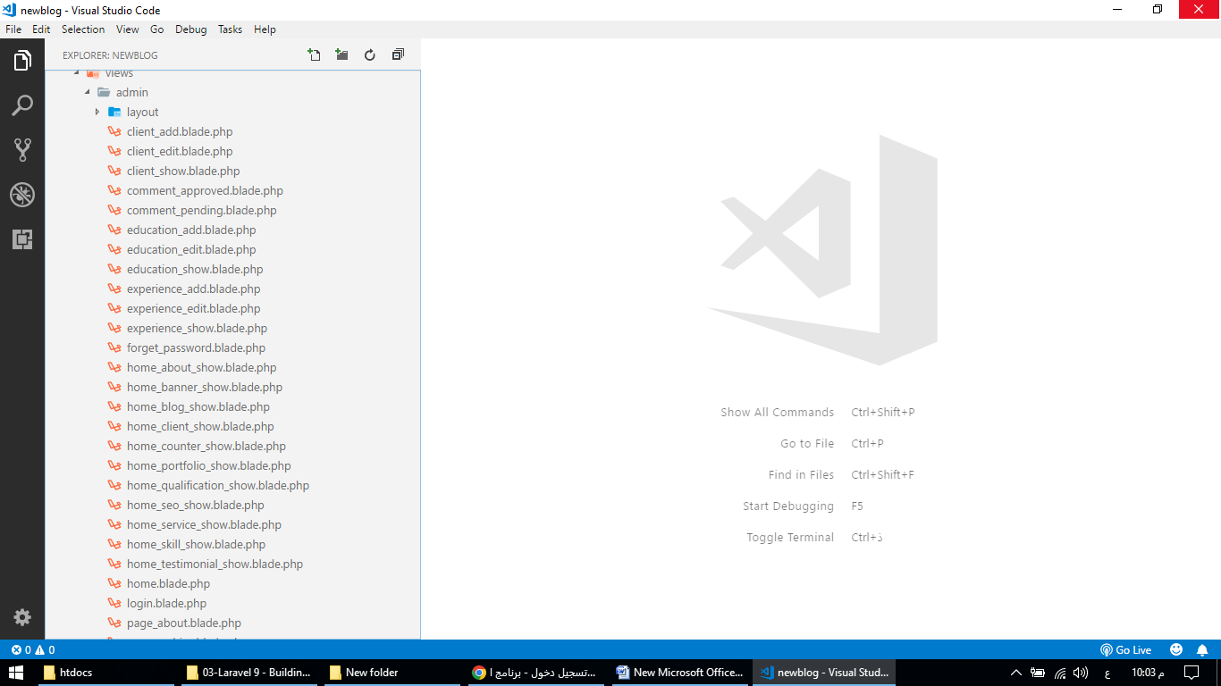

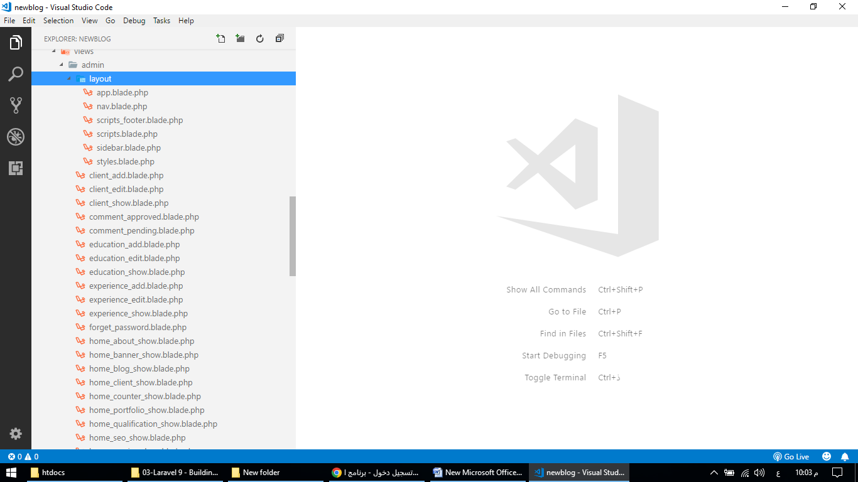

Layout

app.blade.php

<!DOCTYPE html>

<html lang="en">

<head>

<meta charset="UTF-8">

<meta content="width=device-width, initial-scale=1, maximum-scale=1, shrink-to-fit=no" name="viewport">

<link rel="icon" type="image/png" href="{{ asset('uploads/favicon.png') }}">

<title>Admin Panel</title>

<link href="https://fonts.googleapis.com/css2?family=Source+Sans+Pro:wght@400;600;700&display=swap" rel="stylesheet">

@include('admin.layout.styles')

@include('admin.layout.scripts')

</head>

<body>

<div id="app">

<div class="main-wrapper">

@include('admin.layout.nav')

@include('admin.layout.sidebar')

<div class="main-content">

<section class="section">

<div class="section-header justify-content-between">

<h1>@yield('heading')</h1>

<div>

@yield('rightside_button')

</div>

</div>

@yield('main_content')

</section>

</div>

</div>

</div>

@include('admin.layout.scripts_footer')

@if($errors->any())

@foreach($errors->all() as $error)

<script>

iziToast.error({

title: '',

position: 'topRight',

message: '{{ $error }}',

});

</script>

@endforeach

@endif

@if(session()->get('error'))

<script>

iziToast.error({

title: '',

position: 'topRight',

message: '{{ session()->get('error') }}',

});

</script>

@endif

@if(session()->get('success'))

<script>

iziToast.success({

title: '',

position: 'topRight',

message: '{{ session()->get('success') }}',

});

</script>

@endif

</body>

</html>

nav.blade.php

<div class="navbar-bg"></div>

<nav class="navbar navbar-expand-lg main-navbar">

<form class="form-inline mr-auto">

<ul class="navbar-nav mr-3">

<li><a href="#" data-toggle="sidebar" class="nav-link nav-link-lg"><i class="fas fa-bars"></i></a></li>

<li><a href="#" data-toggle="search" class="nav-link nav-link-lg d-sm-none"><i class="fas fa-search"></i></a></li>

</ul>

</form>

<ul class="navbar-nav navbar-right w-100-p justify-content-end">

<li class="nav-link">

<a href="" target="_blank" class="btn btn-warning">Front End</a>

</li>

<li class="nav-item dropdown">

<a class="nav-link dropdown-toggle" href="#" role="button" data-bs-toggle="dropdown" aria-expanded="false">

<img alt="image" src="{{ asset('uploads/'.Auth::guard('admin')->user()->photo) }}" class="rounded-circle-custom">

<div class="d-sm-none d-lg-inline-block">{{ Auth::guard('admin')->user()->name }}</div>

</a>

<ul class="dropdown-menu">

<li><a class="dropdown-item" href="{{ route('admin_profile') }}"><i class="far fa-user"></i> Edit Profile</a></li>

<li><a class="dropdown-item" href="{{ route('admin_logout') }}"><i class="fas fa-sign-out-alt"></i> Logout</a></li>

</ul>

</li>

</ul>

</nav>

scripts_footer.blade.php

<script src="{{ asset('dist/js/scripts.js') }}"></script>

<script src="{{ asset('dist/js/custom.js') }}"></script>

scripts.blade.php

<script src="{{ asset('dist/js/jquery-3.6.0.min.js') }}"></script>

<script src="{{ asset('dist/js/popper.min.js') }}"></script>

<script src="{{ asset('dist/js/tooltip.js') }}"></script>

<script src="{{ asset('dist/js/bootstrap.min.js') }}"></script>

<script src="{{ asset('dist/js/jquery.nicescroll.min.js') }}"></script>

<script src="{{ asset('dist/js/moment.min.js') }}"></script>

<script src="{{ asset('dist/js/stisla.js') }}"></script>

<script src="{{ asset('dist/js/jscolor.js') }}"></script>

<script src="{{ asset('dist/js/bootstrap-datepicker.min.js') }}"></script>

<script src="{{ asset('dist/js/bootstrap-timepicker.min.js') }}"></script>

<script src="{{ asset('dist/js/bootstrap-tagsinput.min.js') }}"></script>

<script src="{{ asset('dist/js/select2.full.min.js') }}"></script>

<script src="{{ asset('dist/js/jquery.dataTables.min.js') }}"></script>

<script src="{{ asset('dist/js/dataTables.bootstrap4.min.js') }}"></script>

<script src="{{ asset('dist/js/iziToast.min.js') }}"></script>

<script src="{{ asset('dist/js/fontawesome-iconpicker.js') }}"></script>

<script src="{{ asset('dist/js/bootstrap4-toggle.min.js') }}"></script>

<script src="{{ asset('dist/js/ckeditor.js') }}"></script>

sidebar.blade.php

<div class="main-sidebar">

<aside id="sidebar-wrapper">

<div class="sidebar-brand">

<a href="{{ route('admin_home') }}">Admin Panel</a>

</div>

<div class="sidebar-brand sidebar-brand-sm">

<a href="{{ route('admin_home') }}"></a>

</div>

<ul class="sidebar-menu">

<li class="{{ Request::is('admin/home') ? "active" : "" }}"><a class="nav-link" href="{{ route('admin_home') }}" data-bs-toggle="tooltip" data-bs-placement="right" data-bs-title="Dashboard"><i class="fas fa-hand-point-right"></i> <span>Dashboard</span></a></li>

<li class="{{ Request::is('admin/setting') ? "active" : "" }}"><a class="nav-link" href="{{ route('admin_setting') }}" data-bs-toggle="tooltip" data-bs-placement="right" data-bs-title="Settings"><i class="fas fa-hand-point-right"></i> <span>Settings</span></a></li>

<li class="nav-item dropdown {{ Request::is('admin/home-banner')||Request::is('admin/home-about')||Request::is('admin/home-skill')||Request::is('admin/home-qualification')||Request::is('admin/home-counter')||Request::is('admin/home-testimonial')||Request::is('admin/home-client')||Request::is('admin/home-service')||Request::is('admin/home-portfolio')||Request::is('admin/home-blog')||Request::is('admin/home-seo') ? "active" : "" }}">

<a href="#" class="nav-link has-dropdown"><i class="fas fa-hand-point-right"></i><span>Home Page</span></a>

<ul class="dropdown-menu">

<li class="{{ Request::is('admin/home-banner') ? "active" : "" }}"><a class="nav-link" href="{{ route('admin_home_banner') }}"><i class="fas fa-angle-right"></i> Banner Section</a></li>

<li class="{{ Request::is('admin/home-about') ? "active" : "" }}"><a class="nav-link" href="{{ route('admin_home_about') }}"><i class="fas fa-angle-right"></i> About Section</a></li>

<li class="{{ Request::is('admin/home-skill') ? "active" : "" }}"><a class="nav-link" href="{{ route('admin_home_skill') }}"><i class="fas fa-angle-right"></i> Skill Section</a></li>

<li class="{{ Request::is('admin/home-qualification') ? "active" : "" }}"><a class="nav-link" href="{{ route('admin_home_qualification') }}"><i class="fas fa-angle-right"></i> Qualification Section</a></li>

<li class="{{ Request::is('admin/home-counter') ? "active" : "" }}"><a class="nav-link" href="{{ route('admin_home_counter') }}"><i class="fas fa-angle-right"></i> Counter Section</a></li>

<li class="{{ Request::is('admin/home-testimonial') ? "active" : "" }}"><a class="nav-link" href="{{ route('admin_home_testimonial') }}"><i class="fas fa-angle-right"></i> Testimonial Section</a></li>

<li class="{{ Request::is('admin/home-client') ? "active" : "" }}"><a class="nav-link" href="{{ route('admin_home_client') }}"><i class="fas fa-angle-right"></i> Client Section</a></li>

<li class="{{ Request::is('admin/home-service') ? "active" : "" }}"><a class="nav-link" href="{{ route('admin_home_service') }}"><i class="fas fa-angle-right"></i> Service Section</a></li>

<li class="{{ Request::is('admin/home-portfolio') ? "active" : "" }}"><a class="nav-link" href="{{ route('admin_home_portfolio') }}"><i class="fas fa-angle-right"></i> Porfolio Section</a></li>

<li class="{{ Request::is('admin/home-blog') ? "active" : "" }}"><a class="nav-link" href="{{ route('admin_home_blog') }}"><i class="fas fa-angle-right"></i> Blog Section</a></li>

<li class="{{ Request::is('admin/home-seo') ? "active" : "" }}"><a class="nav-link" href="{{ route('admin_home_seo') }}"><i class="fas fa-angle-right"></i> SEO Section</a></li>

</ul>

</li>

<li class="nav-item dropdown {{ Request::is('admin/page/services')||Request::is('admin/page/portfolios')||Request::is('admin/page/about')||Request::is('admin/page/contact')||Request::is('admin/page/blog')||Request::is('admin/page/category')||Request::is('admin/page/archive')||Request::is('admin/page/search') ? "active" : "" }}">

<a href="#" class="nav-link has-dropdown"><i class="fas fa-hand-point-right"></i><span>Other Pages</span></a>

<ul class="dropdown-menu">

<li class="{{ Request::is('admin/page/services') ? "active" : "" }}"><a class="nav-link" href="{{ route('admin_page_services') }}"><i class="fas fa-angle-right"></i> Services Page</a></li>

<li class="{{ Request::is('admin/page/portfolios') ? "active" : "" }}"><a class="nav-link" href="{{ route('admin_page_portfolios') }}"><i class="fas fa-angle-right"></i> Portfolios Page</a></li>

<li class="{{ Request::is('admin/page/about') ? "active" : "" }}"><a class="nav-link" href="{{ route('admin_page_about') }}"><i class="fas fa-angle-right"></i> About Page</a></li>

<li class="{{ Request::is('admin/page/contact') ? "active" : "" }}"><a class="nav-link" href="{{ route('admin_page_contact') }}"><i class="fas fa-angle-right"></i> Contact Page</a></li>

<li class="{{ Request::is('admin/page/blog') ? "active" : "" }}"><a class="nav-link" href="{{ route('admin_page_blog') }}"><i class="fas fa-angle-right"></i> Blog Page</a></li>

<li class="{{ Request::is('admin/page/category') ? "active" : "" }}"><a class="nav-link" href="{{ route('admin_page_category') }}"><i class="fas fa-angle-right"></i> Category Page</a></li>

<li class="{{ Request::is('admin/page/archive') ? "active" : "" }}"><a class="nav-link" href="{{ route('admin_page_archive') }}"><i class="fas fa-angle-right"></i> Archive Page</a></li>

<li class="{{ Request::is('admin/page/search') ? "active" : "" }}"><a class="nav-link" href="{{ route('admin_page_search') }}"><i class="fas fa-angle-right"></i> Search Page</a></li>

</ul>

</li>

<li class="{{ Request::is('admin/skill/*') ? "active" : "" }}"><a class="nav-link" href="{{ route('admin_skill_show') }}" data-bs-toggle="tooltip" data-bs-placement="right" data-bs-title="Skills"><i class="fas fa-hand-point-right"></i> <span>Skills</span></a></li>

<li class="{{ Request::is('admin/education/*') ? "active" : "" }}"><a class="nav-link" href="{{ route('admin_education_show') }}" data-bs-toggle="tooltip" data-bs-placement="right" data-bs-title="Education"><i class="fas fa-hand-point-right"></i> <span>Education</span></a></li>

<li class="{{ Request::is('admin/experience/*') ? "active" : "" }}"><a class="nav-link" href="{{ route('admin_experience_show') }}" data-bs-toggle="tooltip" data-bs-placement="right" data-bs-title="Experience"><i class="fas fa-hand-point-right"></i> <span>Experience</span></a></li>

<li class="{{ Request::is('admin/testimonial/*') ? "active" : "" }}"><a class="nav-link" href="{{ route('admin_testimonial_show') }}" data-bs-toggle="tooltip" data-bs-placement="right" data-bs-title="Testimonial"><i class="fas fa-hand-point-right"></i> <span>Testimonial</span></a></li>

<li class="{{ Request::is('admin/client/*') ? "active" : "" }}"><a class="nav-link" href="{{ route('admin_client_show') }}" data-bs-toggle="tooltip" data-bs-placement="right" data-bs-title="Client"><i class="fas fa-hand-point-right"></i> <span>Client</span></a></li>

<li class="{{ Request::is('admin/service/*') ? "active" : "" }}"><a class="nav-link" href="{{ route('admin_service_show') }}" data-bs-toggle="tooltip" data-bs-placement="right" data-bs-title="Service"><i class="fas fa-hand-point-right"></i> <span>Service</span></a></li>

<li class="nav-item dropdown {{ Request::is('admin/portfolio-category/*')||Request::is('admin/portfolio/*') ? "active" : "" }}">

<a href="#" class="nav-link has-dropdown"><i class="fas fa-hand-point-right"></i><span>Portfolios</span></a>

<ul class="dropdown-menu">

<li class="{{ Request::is('admin/portfolio-category/*') ? "active" : "" }}"><a class="nav-link" href="{{ route('admin_portfolio_category_show') }}"><i class="fas fa-angle-right"></i> Category</a></li>

<li class="{{ Request::is('admin/portfolio/*') ? "active" : "" }}"><a class="nav-link" href="{{ route('admin_portfolio_show') }}"><i class="fas fa-angle-right"></i> Portfolio</a></li>

</ul>

</li>

<li class="nav-item dropdown {{ Request::is('admin/post-category/*')||Request::is('admin/post/*')||Request::is('admin/comment/*')||Request::is('admin/reply/*') ? "active" : "" }}">

<a href="#" class="nav-link has-dropdown"><i class="fas fa-hand-point-right"></i><span>Blog</span></a>

<ul class="dropdown-menu">

<li class="{{ Request::is('admin/post-category/*') ? "active" : "" }}"><a class="nav-link" href="{{ route('admin_post_category_show') }}"><i class="fas fa-angle-right"></i> Category</a></li>

<li class="{{ Request::is('admin/post/*') ? "active" : "" }}"><a class="nav-link" href="{{ route('admin_post_show') }}"><i class="fas fa-angle-right"></i> Post</a></li>

<li class="{{ Request::is('admin/comment/pending') ? "active" : "" }}"><a class="nav-link" href="{{ route('admin_comment_pending') }}"><i class="fas fa-angle-right"></i> Pending Comments</a></li>

<li class="{{ Request::is('admin/comment/approved') ? "active" : "" }}"><a class="nav-link" href="{{ route('admin_comment_approved') }}"><i class="fas fa-angle-right"></i> Approved Comments</a></li>

<li class="{{ Request::is('admin/reply/pending') ? "active" : "" }}"><a class="nav-link" href="{{ route('admin_reply_pending') }}"><i class="fas fa-angle-right"></i> Pending Replies</a></li>

<li class="{{ Request::is('admin/reply/approved') ? "active" : "" }}"><a class="nav-link" href="{{ route('admin_reply_approved') }}"><i class="fas fa-angle-right"></i> Approved Replies</a></li>

</ul>

</li>

</ul>

</aside>

</div>

styles.blade.php

<link rel="stylesheet" href="{{ asset('dist/css/bootstrap.min.css') }}">

<link rel="stylesheet" href="{{ asset('dist/css/font_awesome_5_free.min.css') }}">

<link rel="stylesheet" href="{{ asset('dist/css/select2.min.css') }}">

<link rel="stylesheet" href="{{ asset('dist/css/bootstrap-datepicker.min.css') }}">

<link rel="stylesheet" href="{{ asset('dist/css/bootstrap-timepicker.min.css') }}">

<link rel="stylesheet" href="{{ asset('dist/css/bootstrap-tagsinput.css') }}">

<link rel="stylesheet" href="{{ asset('dist/css/duotone-dark.css') }}">

<link rel="stylesheet" href="{{ asset('dist/css/dataTables.bootstrap4.min.css') }}">

<link rel="stylesheet" href="{{ asset('dist/css/iziToast.min.css') }}">

<link rel="stylesheet" href="{{ asset('dist/css/fontawesome-iconpicker.min.css') }}">

<link rel="stylesheet" href="{{ asset('dist/css/bootstrap4-toggle.min.css') }}">

<link rel="stylesheet" href="{{ asset('dist/css/style.css') }}">

<link rel="stylesheet" href="{{ asset('dist/css/components.css') }}">

<link rel="stylesheet" href="{{ asset('dist/css/spacing.css') }}">

<link rel="stylesheet" href="{{ asset('dist/css/custom.css') }}">

Admin

client_add.blade.php

@extends('admin.layout.app')

@section('heading', 'Add Client')

@section('rightside_button')

<a href="{{ route('admin_client_show') }}" class="btn btn-primary"><i class="fas fa-plus"></i> View All</a>

@endsection

@section('main_content')

<div class="section-body">

<div class="row">

<div class="col-12">

<div class="card">

<div class="card-body">

<form action="{{ route('admin_client_submit') }}" method="post" enctype="multipart/form-data">

@csrf

<div class="row">

<div class="col-md-12">

<div class="mb-4">

<label class="form-label">Photo *</label>

<div>

<input type="file" name="photo">

</div>

</div>

<div class="mb-4">

<label class="form-label">URL</label>

<input type="text" class="form-control" name="url">

</div>

<div class="mb-4">

<label class="form-label"></label>

<button type="submit" class="btn btn-primary">Submit</button>

</div>

</div>

</div>

</form>

</div>

</div>

</div>

</div>

</div>

@endsection

client_edit.blade.php

@extends('admin.layout.app')

@section('heading', 'Edit Client')

@section('rightside_button')

<a href="{{ route('admin_client_show') }}" class="btn btn-primary"><i class="fas fa-plus"></i> View All</a>

@endsection

@section('main_content')

<div class="section-body">

<div class="row">

<div class="col-12">

<div class="card">

<div class="card-body">

<form action="{{ route('admin_client_update',$row_data->id) }}" method="post" enctype="multipart/form-data">

@csrf

<div class="row">

<div class="col-md-12">

<div class="mb-4">

<label class="form-label">Existing Photo</label>

<div>

<img src="{{ asset('uploads/'.$row_data->photo) }}" alt="" class="w_100">

</div>

</div>

<div class="mb-4">

<label class="form-label">Change Photo</label>

<div>

<input type="file" name="photo">

</div>

</div>

<div class="mb-4">

<label class="form-label">URL</label>

<input type="text" class="form-control" name="url" value="{{ $row_data->url }}">

</div>

<div class="mb-4">

<label class="form-label"></label>

<button type="submit" class="btn btn-primary">Update</button>

</div>

</div>

</div>

</form>

</div>

</div>

</div>

</div>

</div>

@endsection

client_show.blade.php

@extends('admin.layout.app')

@section('heading', 'View Clients')

@section('rightside_button')

<a href="{{ route('admin_client_add') }}" class="btn btn-primary"><i class="fas fa-plus"></i> Add New</a>

@endsection

@section('main_content')

<div class="section-body">

<div class="row">

<div class="col-12">

<div class="card">

<div class="card-body">

<div class="table-responsive">

<table class="table table-bordered" id="example1">

<thead>

<tr>

<th>SL</th>

<th>Photo</th>

<th>URL</th>

<th>Action</th>

</tr>

</thead>

<tbody>

@foreach($all_data as $item)

<tr>

<td>{{ $loop->iteration }}</td>

<td>

<img src="{{ asset('uploads/'.$item->photo) }}" alt="" class="w_100">

</td>

<td>{{ $item->url }}</td>

<td class="pt_10 pb_10">

<a href="{{ route('admin_client_edit',$item->id) }}" class="btn btn-primary">Edit</a>

<a href="{{ route('admin_client_delete',$item->id) }}" class="btn btn-danger" onClick="return confirm('Are you sure?');">Delete</a>

</td>

</tr>

@endforeach

</tbody>

</table>

</div>

</div>

</div>

</div>

</div>

</div>

@endsection

comment_approved.blade.php

@extends('admin.layout.app')

@section('heading', 'View Approved Comments')

@section('rightside_button')

@endsection

@section('main_content')

<div class="section-body">

<div class="row">

<div class="col-12">

<div class="card">

<div class="card-body">

<div class="table-responsive">

<table class="table table-bordered" id="example1">

<thead>

<tr>

<th>SL</th>

<th>Post</th>

<th>Name</th>

<th>Email</th>

<th>Comment</th>

<th>Action</th>

</tr>

</thead>

<tbody>

@foreach($approved_comments as $item)

<tr>

<td>{{ $loop->iteration }}</td>

<td>

<a href="{{ route('post',$item->rPost->slug) }}" target="_blank">{{ $item->rPost->title }}</a>

</td>

<td>{{ $item->person_name }}</td>

<td>{{ $item->person_email }}</td>

<td>{{ $item->person_comment }}</td>

<td class="pt_10 pb_10">

<a href="{{ route('admin_comment_make_pending',$item->id) }}" class="btn btn-primary btn-sm w_100_p mb_10">Make Pending</a>

<a href="{{ route('admin_comment_delete',$item->id) }}" class="btn btn-danger btn-sm w_100_p" onClick="return confirm('Are you sure?');">Delete</a>

</td>

</tr>

@endforeach

</tbody>

</table>

</div>

</div>

</div>

</div>

</div>

</div>

@endsection

comment_pending.blade.php

@extends('admin.layout.app')

@section('heading', 'View Pending Comments')

@section('rightside_button')

@endsection

@section('main_content')

<div class="section-body">

<div class="row">

<div class="col-12">

<div class="card">

<div class="card-body">

<div class="table-responsive">

<table class="table table-bordered" id="example1">

<thead>

<tr>

<th>SL</th>

<th>Post</th>

<th>Name</th>

<th>Email</th>

<th>Comment</th>

<th>Action</th>

</tr>

</thead>

<tbody>

@foreach($pending_comments as $item)

<tr>

<td>{{ $loop->iteration }}</td>

<td>

<a href="{{ route('post',$item->rPost->slug) }}" target="_blank">{{ $item->rPost->title }}</a>

</td>

<td>{{ $item->person_name }}</td>

<td>{{ $item->person_email }}</td>

<td>{{ $item->person_comment }}</td>

<td class="pt_10 pb_10">

<a href="{{ route('admin_comment_make_approved',$item->id) }}" class="btn btn-primary btn-sm w_100_p mb_10">Make Approved</a>

<a href="{{ route('admin_comment_delete',$item->id) }}" class="btn btn-danger btn-sm w_100_p" onClick="return confirm('Are you sure?');">Delete</a>

</td>

</tr>

@endforeach

</tbody>

</table>

</div>

</div>

</div>

</div>

</div>

</div>

@endsection

education_add.blade.php

@extends('admin.layout.app')

@section('heading', 'Add Education')

@section('rightside_button')

<a href="{{ route('admin_education_show') }}" class="btn btn-primary"><i class="fas fa-plus"></i> View All</a>

@endsection

@section('main_content')

<div class="section-body">

<div class="row">

<div class="col-12">

<div class="card">

<div class="card-body">

<form action="{{ route('admin_education_submit') }}" method="post">

@csrf

<div class="row">

<div class="col-md-12">

<div class="mb-4">

<label class="form-label">Degree *</label>

<input type="text" class="form-control" name="degree">

</div>

<div class="mb-4">

<label class="form-label">Institute *</label>

<input type="text" class="form-control" name="institute">

</div>

<div class="mb-4">

<label class="form-label">Time *</label>

<input type="text" class="form-control" name="time">

</div>

<div class="mb-4">

<label class="form-label">Order *</label>

<input type="text" class="form-control" name="item_order">

</div>

<div class="mb-4">

<label class="form-label"></label>

<button type="submit" class="btn btn-primary">Submit</button>

</div>

</div>

</div>

</form>

</div>

</div>

</div>

</div>

</div>

@endsection

education_edit.blade.php

@extends('admin.layout.app')

@section('heading', 'Edit Education')

@section('rightside_button')

<a href="{{ route('admin_education_show') }}" class="btn btn-primary"><i class="fas fa-plus"></i> View All</a>

@endsection

@section('main_content')

<div class="section-body">

<div class="row">

<div class="col-12">

<div class="card">

<div class="card-body">

<form action="{{ route('admin_education_update',$row_data->id) }}" method="post">

@csrf

<div class="row">

<div class="col-md-12">

<div class="mb-4">

<label class="form-label">Degree *</label>

<input type="text" class="form-control" name="degree" value="{{ $row_data->degree }}">

</div>

<div class="mb-4">

<label class="form-label">Institute *</label>

<input type="text" class="form-control" name="institute" value="{{ $row_data->institute }}">

</div>

<div class="mb-4">

<label class="form-label">Time *</label>

<input type="text" class="form-control" name="time" value="{{ $row_data->time }}">

</div>

<div class="mb-4">

<label class="form-label">Order *</label>

<input type="text" class="form-control" name="item_order" value="{{ $row_data->item_order }}">

</div>

<div class="mb-4">

<label class="form-label"></label>

<button type="submit" class="btn btn-primary">Update</button>

</div>

</div>

</div>

</form>

</div>

</div>

</div>

</div>

</div>

@endsection

education_show.blade.php

@extends('admin.layout.app')

@section('heading', 'View Educations')

@section('rightside_button')

<a href="{{ route('admin_education_add') }}" class="btn btn-primary"><i class="fas fa-plus"></i> Add New</a>

@endsection

@section('main_content')

<div class="section-body">

<div class="row">

<div class="col-12">

<div class="card">

<div class="card-body">

<div class="table-responsive">

<table class="table table-bordered" id="example1">

<thead>

<tr>

<th>SL</th>

<th>Degree</th>

<th>Institute</th>

<th>Time</th>

<th>Order</th>

<th>Action</th>

</tr>

</thead>

<tbody>

@foreach($all_data as $item)

<tr>

<td>{{ $loop->iteration }}</td>

<td>{{ $item->degree }}</td>

<td>{{ $item->institute }}</td>

<td>{{ $item->time }}</td>

<td>{{ $item->item_order }}</td>

<td class="pt_10 pb_10">

<a href="{{ route('admin_education_edit',$item->id) }}" class="btn btn-primary">Edit</a>

<a href="{{ route('admin_education_delete',$item->id) }}" class="btn btn-danger" onClick="return confirm('Are you sure?');">Delete</a>

</td>

</tr>

@endforeach

</tbody>

</table>

</div>

</div>

</div>

</div>

</div>

</div>

@endsection

experience_add.blade.php.

@extends('admin.layout.app')

@section('heading', 'Add Experience')

@section('rightside_button')

<a href="{{ route('admin_experience_show') }}" class="btn btn-primary"><i class="fas fa-plus"></i> View All</a>

@endsection

@section('main_content')

<div class="section-body">

<div class="row">

<div class="col-12">

<div class="card">

<div class="card-body">

<form action="{{ route('admin_experience_submit') }}" method="post">

@csrf

<div class="row">

<div class="col-md-12">

<div class="mb-4">

<label class="form-label">Company *</label>

<input type="text" class="form-control" name="company">

</div>

<div class="mb-4">

<label class="form-label">Designation *</label>

<input type="text" class="form-control" name="designation">

</div>

<div class="mb-4">

<label class="form-label">Time *</label>

<input type="text" class="form-control" name="time">

</div>

<div class="mb-4">

<label class="form-label">Order *</label>

<input type="text" class="form-control" name="item_order">

</div>

<div class="mb-4">

<label class="form-label"></label>

<button type="submit" class="btn btn-primary">Submit</button>

</div>

</div>

</div>

</form>

</div>

</div>

</div>

</div>

</div>

@endsection

experience_edit.blade.php

@extends('admin.layout.app')

@section('heading', 'Edit Experience')

@section('rightside_button')

<a href="{{ route('admin_experience_show') }}" class="btn btn-primary"><i class="fas fa-plus"></i> View All</a>

@endsection

@section('main_content')

<div class="section-body">

<div class="row">

<div class="col-12">

<div class="card">

<div class="card-body">

<form action="{{ route('admin_experience_update',$row_data->id) }}" method="post">

@csrf

<div class="row">

<div class="col-md-12">

<div class="mb-4">

<label class="form-label">Company *</label>

<input type="text" class="form-control" name="company" value="{{ $row_data->company }}">

</div>

<div class="mb-4">

<label class="form-label">Designation *</label>

<input type="text" class="form-control" name="designation" value="{{ $row_data->designation }}">

</div>

<div class="mb-4">

<label class="form-label">Time *</label>

<input type="text" class="form-control" name="time" value="{{ $row_data->time }}">

</div>

<div class="mb-4">

<label class="form-label">Order *</label>

<input type="text" class="form-control" name="item_order" value="{{ $row_data->item_order }}">

</div>

<div class="mb-4">

<label class="form-label"></label>

<button type="submit" class="btn btn-primary">Update</button>

</div>

</div>

</div>

</form>

</div>

</div>

</div>

</div>

</div>

@endsection

experience_show.blade.php

@extends('admin.layout.app')

@section('heading', 'View Experience')

@section('rightside_button')

<a href="{{ route('admin_experience_add') }}" class="btn btn-primary"><i class="fas fa-plus"></i> Add New</a>

@endsection

@section('main_content')

<div class="section-body">

<div class="row">

<div class="col-12">

<div class="card">

<div class="card-body">

<div class="table-responsive">

<table class="table table-bordered" id="example1">

<thead>

<tr>

<th>SL</th>

<th>Company</th>

<th>Designation</th>

<th>Time</th>

<th>Order</th>

<th>Action</th>

</tr>

</thead>

<tbody>

@foreach($all_data as $item)

<tr>

<td>{{ $loop->iteration }}</td>

<td>{{ $item->company }}</td>

<td>{{ $item->designation }}</td>

<td>{{ $item->time }}</td>

<td>{{ $item->item_order }}</td>

<td class="pt_10 pb_10">

<a href="{{ route('admin_experience_edit',$item->id) }}" class="btn btn-primary">Edit</a>

<a href="{{ route('admin_experience_delete',$item->id) }}" class="btn btn-danger" onClick="return confirm('Are you sure?');">Delete</a>

</td>

</tr>

@endforeach

</tbody>

</table>

</div>

</div>

</div>

</div>

</div>

</div>

@endsection

forget_password.blade.php

<!DOCTYPE html>

<html lang="en">

<head>

<meta charset="UTF-8">

<meta content="width=device-width, initial-scale=1, maximum-scale=1, shrink-to-fit=no" name="viewport">

<link rel="icon" type="image/png" href="uploads/favicon.png">

<title>Admin Panel</title>

<link href="https://fonts.googleapis.com/css2?family=Source+Sans+Pro:wght@400;600;700&display=swap" rel="stylesheet">

@include('admin.layout.styles')

@include('admin.layout.scripts')

</head>

<body>

<div id="app">

<div class="main-wrapper">

<section class="section">

<div class="container container-login">

<div class="row">

<div class="col-12 col-sm-8 offset-sm-2 col-md-6 offset-md-3 col-lg-6 offset-lg-3 col-xl-4 offset-xl-4">

<div class="card card-primary border-box">

<div class="card-header card-header-auth">

<h4 class="text-center">Reset Password</h4>

</div>

<div class="card-body card-body-auth">

<form method="POST" action="{{ route('admin_forget_password_submit') }}">

@csrf

<div class="form-group">

<input type="text" class="form-control @error('email') is-invalid @enderror" name="email" placeholder="Email Address" value="" autofocus>

@error('email')

<div class="text-danger">{{ $message }}</div>

@enderror

@if(session()->get('error'))

<div class="text-danger">{{ session()->get('error') }}</div>

@endif

</div>

<div class="form-group">

<button type="submit" class="btn btn-primary btn-lg btn-block">

Send Password Reset Link

</button>

</div>

<div class="form-group">

<div>

<a href="{{ route('admin_login') }}">

Back to login page

</a>

</div>

</div>

</form>

</div>

</div>

</div>

</div>

</div>

</section>

</div>

</div>

@include('admin.layout.scripts_footer')

</body>

</html>

home_about_show.blade.php

@extends('admin.layout.app')

@section('heading', 'Edit Home Page About')

@section('main_content')

<div class="section-body">

<div class="row">

<div class="col-12">

<div class="card">

<div class="card-body">

<form action="{{ route('admin_home_about_update') }}" method="post" enctype="multipart/form-data">

@csrf

<div class="row">

<div class="col-md-3">

<img src="{{ asset('uploads/'.$page_data->about_photo) }}" alt="" class="profile-photo w_100_p">

<input type="file" class="form-control mt_10" name="about_photo">

</div>

<div class="col-md-9">

<div class="mb-4">

<label class="form-label">Subtitle</label>

<input type="text" class="form-control" name="about_subtitle" value="{{ $page_data->about_subtitle }}">

</div>

<div class="mb-4">

<label class="form-label">Title *</label>

<input type="text" class="form-control" name="about_title" value="{{ $page_data->about_title }}">

</div>

<div class="mb-4">

<label class="form-label">Description</label>

<textarea name="about_description" class="form-control h_100" cols="30" rows="10">{{ $page_data->about_description }}</textarea>

</div>

<div class="mb-4">

<label class="form-label">Person Name</label>

<input type="text" class="form-control" name="about_person_name" value="{{ $page_data->about_person_name }}">

</div>

<div class="mb-4">

<label class="form-label">Person Phone</label>

<input type="text" class="form-control" name="about_person_phone" value="{{ $page_data->about_person_phone }}">

</div>

<div class="mb-4">

<label class="form-label">Person Email</label>

<input type="text" class="form-control" name="about_person_email" value="{{ $page_data->about_person_email }}">

</div>

<div class="mb-4">

<label class="form-label">Icon 1</label>

<input type="text" class="form-control" name="about_icon1" value="{{ $page_data->about_icon1 }}">

</div>

<div class="mb-4">

<label class="form-label">Icon 1 URL</label>

<input type="text" class="form-control" name="about_icon1_url" value="{{ $page_data->about_icon1_url }}">

</div>

<div class="mb-4">

<label class="form-label">Icon 2</label>

<input type="text" class="form-control" name="about_icon2" value="{{ $page_data->about_icon2 }}">

</div>

<div class="mb-4">

<label class="form-label">Icon 2 URL</label>

<input type="text" class="form-control" name="about_icon2_url" value="{{ $page_data->about_icon2_url }}">

</div>

<div class="mb-4">

<label class="form-label">Icon 3</label>

<input type="text" class="form-control" name="about_icon3" value="{{ $page_data->about_icon3 }}">

</div>

<div class="mb-4">

<label class="form-label">Icon 3 URL</label>

<input type="text" class="form-control" name="about_icon3_url" value="{{ $page_data->about_icon3_url }}">

</div>

<div class="mb-4">

<label class="form-label">Icon 4</label>

<input type="text" class="form-control" name="about_icon4" value="{{ $page_data->about_icon4 }}">

</div>

<div class="mb-4">

<label class="form-label">Icon 4 URL</label>

<input type="text" class="form-control" name="about_icon4_url" value="{{ $page_data->about_icon4_url }}">

</div>

<div class="mb-4">

<label class="form-label">Icon 5</label>

<input type="text" class="form-control" name="about_icon5" value="{{ $page_data->about_icon5 }}">

</div>

<div class="mb-4">

<label class="form-label">Icon 5 URL</label>

<input type="text" class="form-control" name="about_icon5_url" value="{{ $page_data->about_icon5_url }}">

</div>

<div class="mb-4">

<label class="form-label">Status</label>

<select name="about_status" class="form-control">

<option value="Show" @if($page_data->about_status == 'Show') selected @endif>Show</option>

<option value="Hide" @if($page_data->about_status == 'Hide') selected @endif>Hide</option>

</select>

</div>

<div class="mb-4">

<label class="form-label"></label>

<button type="submit" class="btn btn-primary">Update</button>

</div>

</div>

</div>

</form>

</div>

</div>

</div>

</div>

</div>

@endsection

home_banner_show.blade.php

@extends('admin.layout.app')

@section('heading', 'Edit Home Page Banner')

@section('main_content')

<div class="section-body">

<div class="row">

<div class="col-12">

<div class="card">

<div class="card-body">

<form action="{{ route('admin_home_banner_update') }}" method="post" enctype="multipart/form-data">

@csrf

<div class="row">

<div class="col-md-3">

<img src="{{ asset('uploads/'.$page_data->banner_photo) }}" alt="" class="profile-photo w_100_p">

<input type="file" class="form-control mt_10" name="banner_photo">

</div>

<div class="col-md-9">

<div class="mb-4">

<label class="form-label">Title</label>

<input type="text" class="form-control" name="banner_title" value="{{ $page_data->banner_title }}">

</div>

<div class="mb-4">

<label class="form-label">Name *</label>

<input type="text" class="form-control" name="banner_person_name" value="{{ $page_data->banner_person_name }}">

</div>

<div class="mb-4">

<label class="form-label">Designation</label>

<input type="text" class="form-control" name="banner_person_designation" value="{{ $page_data->banner_person_designation }}">

</div>

<div class="mb-4">

<label class="form-label">Description</label>

<textarea name="banner_description" class="form-control h_100" cols="30" rows="10">{{ $page_data->banner_description }}</textarea>

</div>

<div class="mb-4">

<label class="form-label">Button Text</label>

<input type="text" class="form-control" name="banner_button_text" value="{{ $page_data->banner_button_text }}">

</div>

<div class="mb-4">

<label class="form-label">Button URL</label>

<input type="text" class="form-control" name="banner_button_url" value="{{ $page_data->banner_button_url }}">

</div>

<div class="mb-4">

<label class="form-label"></label>

<button type="submit" class="btn btn-primary">Update</button>

</div>

</div>

</div>

</form>

</div>

</div>

</div>

</div>

</div>

@endsection

home_blog_show.blade.php

@extends('admin.layout.app')

@section('heading', 'Edit Home Page Blog')

@section('main_content')

<div class="section-body">

<div class="row">

<div class="col-12">

<div class="card">

<div class="card-body">

<form action="{{ route('admin_home_blog_update') }}" method="post">

@csrf

<div class="row">

<div class="col-md-12">

<div class="mb-4">

<label class="form-label">SubTitle</label>

<input type="text" class="form-control" name="blog_subtitle" value="{{ $page_data->blog_subtitle }}">

</div>

<div class="mb-4">

<label class="form-label">Title</label>

<input type="text" class="form-control" name="blog_title" value="{{ $page_data->blog_title }}">

</div>

<div class="mb-4">

<label class="form-label">Status</label>

<select name="blog_status" class="form-control">

<option value="Show" @if($page_data->blog_status == 'Show') selected @endif>Show</option>

<option value="Hide" @if($page_data->blog_status == 'Hide') selected @endif>Hide</option>

</select>

</div>

<div class="mb-4">

<label class="form-label"></label>

<button type="submit" class="btn btn-primary">Update</button>

</div>

</div>

</div>

</form>

</div>

</div>

</div>

</div>

</div>

@endsection

home_client_show.blade.php

@extends('admin.layout.app')

@section('heading', 'Edit Home Page Client')

@section('main_content')

<div class="section-body">

<div class="row">

<div class="col-12">

<div class="card">

<div class="card-body">

<form action="{{ route('admin_home_client_update') }}" method="post">

@csrf

<div class="row">

<div class="col-md-12">

<div class="mb-4">

<label class="form-label">SubTitle</label>

<input type="text" class="form-control" name="client_subtitle" value="{{ $page_data->client_subtitle }}">

</div>

<div class="mb-4">

<label class="form-label">Title</label>

<input type="text" class="form-control" name="client_title" value="{{ $page_data->client_title }}">

</div>

<div class="mb-4">

<label class="form-label">Status</label>

<select name="client_status" class="form-control">

<option value="Show" @if($page_data->client_status == 'Show') selected @endif>Show</option>

<option value="Hide" @if($page_data->client_status == 'Hide') selected @endif>Hide</option>

</select>

</div>

<div class="mb-4">

<label class="form-label"></label>

<button type="submit" class="btn btn-primary">Update</button>

</div>

</div>

</div>

</form>

</div>

</div>

</div>

</div>

</div>

@endsection

home_counter_show.blade.php

@extends('admin.layout.app')

@section('heading', 'Edit Home Page Counter')

@section('main_content')

<div class="section-body">

<div class="row">

<div class="col-12">

<div class="card">

<div class="card-body">

<form action="{{ route('admin_home_counter_update') }}" method="post" enctype="multipart/form-data">

@csrf

<div class="row">

<div class="col-md-12">

<div class="mb-4">

<label class="form-label">Counter 1 - Number *</label>

<input type="text" class="form-control" name="counter1_number" value="{{ $page_data->counter1_number }}">

</div>

<div class="mb-4">

<label class="form-label">Counter 1 - Name *</label>

<input type="text" class="form-control" name="counter1_name" value="{{ $page_data->counter1_name }}">

</div>

<div class="mb-4">

<label class="form-label">Counter 2 - Number *</label>

<input type="text" class="form-control" name="counter2_number" value="{{ $page_data->counter2_number }}">

</div>

<div class="mb-4">

<label class="form-label">Counter 2 - Name *</label>

<input type="text" class="form-control" name="counter2_name" value="{{ $page_data->counter2_name }}">

</div>

<div class="mb-4">

<label class="form-label">Counter 3 - Number *</label>

<input type="text" class="form-control" name="counter3_number" value="{{ $page_data->counter3_number }}">

</div>

<div class="mb-4">

<label class="form-label">Counter 3 - Name *</label>

<input type="text" class="form-control" name="counter3_name" value="{{ $page_data->counter3_name }}">

</div>

<div class="mb-4">

<label class="form-label">Counter 4 - Number *</label>

<input type="text" class="form-control" name="counter4_number" value="{{ $page_data->counter4_number }}">

</div>

<div class="mb-4">

<label class="form-label">Counter 4 - Name *</label>

<input type="text" class="form-control" name="counter4_name" value="{{ $page_data->counter4_name }}">

</div>

<div class="mb-4">

<label class="form-label">Existing Background</label>

<div>

<img src="{{ asset('uploads/'.$page_data->counter_background) }}" alt="" class="w_200">

</div>

</div>

<div class="mb-4">

<label class="form-label">Change Background</label>

<div><input type="file" name="counter_background"></div>

</div>

<div class="mb-4">

<label class="form-label">Counter Status</label>

<select name="counter_status" class="form-control">

<option value="Show" @if($page_data->counter_status == 'Show') selected @endif>Show</option>

<option value="Hide" @if($page_data->counter_status == 'Hide') selected @endif>Hide</option>

</select>

</div>

<div class="mb-4">

<label class="form-label"></label>

<button type="submit" class="btn btn-primary">Update</button>

</div>

</div>

</div>

</form>

</div>

</div>

</div>

</div>

</div>

@endsection

home_portfolio_show.blade.php

@extends('admin.layout.app')

@section('heading', 'Edit Home Page Portfolio')

@section('main_content')

<div class="section-body">

<div class="row">

<div class="col-12">

<div class="card">

<div class="card-body">

<form action="{{ route('admin_home_portfolio_update') }}" method="post">

@csrf

<div class="row">

<div class="col-md-12">

<div class="mb-4">

<label class="form-label">SubTitle</label>

<input type="text" class="form-control" name="portfolio_subtitle" value="{{ $page_data->portfolio_subtitle }}">

</div>

<div class="mb-4">

<label class="form-label">Title</label>

<input type="text" class="form-control" name="portfolio_title" value="{{ $page_data->portfolio_title }}">

</div>

<div class="mb-4">

<label class="form-label">Status</label>

<select name="portfolio_status" class="form-control">

<option value="Show" @if($page_data->portfolio_status == 'Show') selected @endif>Show</option>

<option value="Hide" @if($page_data->portfolio_status == 'Hide') selected @endif>Hide</option>

</select>

</div>

<div class="mb-4">

<label class="form-label"></label>

<button type="submit" class="btn btn-primary">Update</button>

</div>

</div>

</div>

</form>

</div>

</div>

</div>

</div>

</div>

@endsection

home_qualification_show.blade.php

@extends('admin.layout.app')

@section('heading', 'Edit Home Page Qualification')

@section('main_content')

<div class="section-body">

<div class="row">

<div class="col-12">

<div class="card">

<div class="card-body">

<form action="{{ route('admin_home_qualification_update') }}" method="post">

@csrf

<div class="row">

<div class="col-md-12">

<div class="mb-4">

<label class="form-label">Qualification Subtitle</label>

<input type="text" class="form-control" name="qualification_subtitle" value="{{ $page_data->qualification_subtitle }}">

</div>

<div class="mb-4">

<label class="form-label">Qualification Title</label>

<input type="text" class="form-control" name="qualification_title" value="{{ $page_data->qualification_title }}">

</div>

<div class="mb-4">

<label class="form-label">Qualification Status</label>

<select name="qualification_status" class="form-control">

<option value="Show" @if($page_data->qualification_status == 'Show') selected @endif>Show</option>

<option value="Hide" @if($page_data->qualification_status == 'Hide') selected @endif>Hide</option>

</select>

</div>

<div class="mb-4">

<label class="form-label">Education Title</label>

<input type="text" class="form-control" name="education_title" value="{{ $page_data->education_title }}">

</div>

<div class="mb-4">

<label class="form-label">Experience Title</label>

<input type="text" class="form-control" name="experience_title" value="{{ $page_data->experience_title }}">

</div>

<div class="mb-4">

<label class="form-label"></label>

<button type="submit" class="btn btn-primary">Update</button>

</div>

</div>

</div>

</form>

</div>

</div>

</div>

</div>

</div>

@endsection

home_seo_show.blade.php

@extends('admin.layout.app')

@section('heading', 'Edit Home Page SEO')

@section('main_content')

<div class="section-body">

<div class="row">

<div class="col-12">

<div class="card">

<div class="card-body">

<form action="{{ route('admin_home_seo_update') }}" method="post">

@csrf

<div class="row">

<div class="col-md-12">

<div class="mb-4">

<label class="form-label">SEO Title</label>

<input type="text" class="form-control" name="seo_title" value="{{ $page_data->seo_title }}">

</div>

<div class="mb-4">

<label class="form-label">SEO Meta Description</label>

<textarea name="seo_meta_description" class="form-control" cols="30" rows="10">{{ $page_data->seo_meta_description }}</textarea>

</div>

<div class="mb-4">

<label class="form-label"></label>

<button type="submit" class="btn btn-primary">Update</button>

</div>

</div>

</div>

</form>

</div>

</div>

</div>

</div>

</div>

@endsection

---

@extends('admin.layout.app')

@section('heading', 'Edit Home Page SEO')

@section('main_content')

<div class="section-body">

<div class="row">

<div class="col-12">

<div class="card">

<div class="card-body">

<form action="{{ route('admin_home_seo_update') }}" method="post">

@csrf

<div class="row">

<div class="col-md-12">

<div class="mb-4">

<label class="form-label">SEO Title</label>

<input type="text" class="form-control" name="seo_title" value="{{ $page_data->seo_title }}">

</div>

<div class="mb-4">

<label class="form-label">SEO Meta Description</label>

<textarea name="seo_meta_description" class="form-control" cols="30" rows="10">{{ $page_data->seo_meta_description }}</textarea>

</div>

<div class="mb-4">

<label class="form-label"></label>

<button type="submit" class="btn btn-primary">Update</button>

</div>

</div>

</div>

</form>

</div>

</div>

</div>

</div>

</div>

@endsection

home_service_show.blade.php

@extends('admin.layout.app')

@section('heading', 'Edit Home Page Service')

@section('main_content')

<div class="section-body">

<div class="row">

<div class="col-12">

<div class="card">

<div class="card-body">

<form action="{{ route('admin_home_service_update') }}" method="post">

@csrf

<div class="row">

<div class="col-md-12">

<div class="mb-4">

<label class="form-label">SubTitle</label>

<input type="text" class="form-control" name="service_subtitle" value="{{ $page_data->service_subtitle }}">

</div>

<div class="mb-4">

<label class="form-label">Title</label>

<input type="text" class="form-control" name="service_title" value="{{ $page_data->service_title }}">

</div>

<div class="mb-4">

<label class="form-label">Total Items *</label>

<input type="text" class="form-control" name="service_total" value="{{ $page_data->service_total }}">

</div>

<div class="mb-4">

<label class="form-label">Status</label>

<select name="service_status" class="form-control">

<option value="Show" @if($page_data->service_status == 'Show') selected @endif>Show</option>

<option value="Hide" @if($page_data->service_status == 'Hide') selected @endif>Hide</option>

</select>

</div>

<div class="mb-4">

<label class="form-label"></label>

<button type="submit" class="btn btn-primary">Update</button>

</div>

</div>

</div>

</form>

</div>

</div>

</div>

</div>

</div>

@endsection

home_skill_show.blade.php

@extends('admin.layout.app')

@section('heading', 'Edit Home Page Skill')

@section('main_content')

<div class="section-body">

<div class="row">

<div class="col-12">

<div class="card">

<div class="card-body">

<form action="{{ route('admin_home_skill_update') }}" method="post">

@csrf

<div class="row">

<div class="col-md-12">

<div class="mb-4">

<label class="form-label">SubTitle</label>

<input type="text" class="form-control" name="skill_subtitle" value="{{ $page_data->skill_subtitle }}">

</div>

<div class="mb-4">

<label class="form-label">Title</label>

<input type="text" class="form-control" name="skill_title" value="{{ $page_data->skill_title }}">

</div>

<div class="mb-4">

<label class="form-label">Status</label>

<select name="skill_status" class="form-control">

<option value="Show" @if($page_data->skill_status == 'Show') selected @endif>Show</option>

<option value="Hide" @if($page_data->skill_status == 'Hide') selected @endif>Hide</option>

</select>

</div>

<div class="mb-4">

<label class="form-label"></label>

<button type="submit" class="btn btn-primary">Update</button>

</div>

</div>

</div>

</form>

</div>

</div>

</div>

</div>

</div>

@endsection

home_testimonial_show.blade.php

@extends('admin.layout.app')

@section('heading', 'Edit Home Page Testimonial')

@section('main_content')

<div class="section-body">

<div class="row">

<div class="col-12">

<div class="card">

<div class="card-body">

<form action="{{ route('admin_home_testimonial_update') }}" method="post" enctype="multipart/form-data">

@csrf

<div class="row">

<div class="col-md-12">

<div class="mb-4">

<label class="form-label">Subtitle</label>

<input type="text" class="form-control" name="testimonial_subtitle" value="{{ $page_data->testimonial_subtitle }}">

</div>

<div class="mb-4">

<label class="form-label">Title</label>

<input type="text" class="form-control" name="testimonial_title" value="{{ $page_data->testimonial_title }}">

</div>

<div class="mb-4">

<label class="form-label">Existing Background</label>

<div>

<img src="{{ asset('uploads/'.$page_data->testimonial_background) }}" alt="" class="w_200">

</div>

</div>

<div class="mb-4">

<label class="form-label">Change Background</label>

<div><input type="file" name="testimonial_background"></div>

</div>

<div class="mb-4">

<label class="form-label">Status</label>

<select name="testimonial_status" class="form-control">

<option value="Show" @if($page_data->testimonial_status == 'Show') selected @endif>Show</option>

<option value="Hide" @if($page_data->testimonial_status == 'Hide') selected @endif>Hide</option>

</select>

</div>

<div class="mb-4">

<label class="form-label"></label>

<button type="submit" class="btn btn-primary">Update</button>

</div>

</div>

</div>

</form>

</div>

</div>

</div>

</div>

</div>

@endsection

[home.blade.php](http://home.blade.php)

@extends('admin.layout.app')

@section('heading', 'Dashboard')

@section('main_content')

<div class="row">

<div class="col-lg-4 col-md-6 col-sm-6 col-12">

<div class="card card-statistic-1">

<div class="card-icon bg-primary">

<i class="far fa-user"></i>

</div>

<div class="card-wrap">

<div class="card-header">

<h4>Total News Categories</h4>

</div>

<div class="card-body">

12

</div>

</div>

</div>

</div>

<div class="col-lg-4 col-md-6 col-sm-6 col-12">

<div class="card card-statistic-1">

<div class="card-icon bg-danger">

<i class="fas fa-book-open"></i>

</div>

<div class="card-wrap">

<div class="card-header">

<h4>Total News</h4>

</div>

<div class="card-body">

122

</div>

</div>

</div>

</div>

<div class="col-lg-4 col-md-6 col-sm-6 col-12">

<div class="card card-statistic-1">

<div class="card-icon bg-warning">

<i class="fas fa-bullhorn"></i>

</div>

<div class="card-wrap">

<div class="card-header">

<h4>Total Users</h4>

</div>

<div class="card-body">

45

</div>

</div>

</div>

</div>

</div>

@endsection

login.blade.php

<!DOCTYPE html>

<html lang="en">

<head>

<meta charset="UTF-8">

<meta content="width=device-width, initial-scale=1, maximum-scale=1, shrink-to-fit=no" name="viewport">

<link rel="icon" type="image/png" href="uploads/favicon.png">

<title>Admin Panel</title>

<link href="https://fonts.googleapis.com/css2?family=Source+Sans+Pro:wght@400;600;700&display=swap" rel="stylesheet">

@include('admin.layout.styles')

@include('admin.layout.scripts')

</head>

<body>

<div id="app">

<div class="main-wrapper">

<section class="section">

<div class="container container-login">

<div class="row">

<div class="col-12 col-sm-8 offset-sm-2 col-md-6 offset-md-3 col-lg-6 offset-lg-3 col-xl-4 offset-xl-4">

<div class="card card-primary border-box">

<div class="card-header card-header-auth">

<h4 class="text-center">Admin Panel Login</h4>

</div>

<div class="card-body card-body-auth">

@if(session()->get('success'))

<div class="text-success">{{ session()->get('success') }}</div>

@endif

<form method="POST" action="{{ route('admin_login_submit') }}">

@csrf

<div class="form-group">

<input type="text" class="form-control @error('email') is-invalid @enderror" name="email" placeholder="Email Address" value="{{ old('email') }}" autofocus>

@error('email')

<div class="text-danger">{{ $message }}</div>

@enderror

@if(session()->get('error'))

<div class="text-danger">{{ session()->get('error') }}</div>

@endif

</div>

<div class="form-group">

<input type="password" class="form-control @error('password') is-invalid @enderror" name="password" placeholder="Password">

@error('password')

<div class="text-danger">{{ $message }}</div>

@enderror

</div>

<div class="form-group">

<button type="submit" class="btn btn-primary btn-lg btn-block">

Login

</button>

</div>

<div class="form-group">

<div>

<a href="{{ route('admin_forget_password') }}">

Forget Password?

</a>

</div>

</div>

</form>

</div>

</div>

</div>

</div>

</div>

</section>

</div>

</div>

@include('admin.layout.scripts_footer')

</body>

</html>

page_about.blade.php

@extends('admin.layout.app')

@section('heading', 'Edit About Page Content')

@section('main_content')

<div class="section-body">

<div class="row">

<div class="col-12">

<div class="card">

<div class="card-body">

<form action="{{ route('admin_page_about_update') }}" method="post" enctype="multipart/form-data">

@csrf

<div class="row">

<div class="col-md-12">

<div class="mb-4">

<label class="form-label">Heading *</label>

<input type="text" class="form-control" name="about_heading" value="{{ $page_data->about_heading }}">

</div>

<div class="mb-4">

<label class="form-label">Description *</label>

<textarea name="about_description" class="form-control editor" cols="30" rows="10">{{ $page_data->about_description }}</textarea>

</div>

<div class="mb-4">

<label class="form-label">Existing Photo</label>

<div>

@if($page_data->about_photo == '')

<span class="text-danger">No photo found</span>

@else

<img src="{{ asset('uploads/'.$page_data->about_photo) }}" alt="" class="w_200"><br>

<a href="{{ route('admin_page_about_photo_delete') }}">Remove</a>

@endif

</div>

</div>

<div class="mb-4">

<label class="form-label">Change Photo</label>

<div><input type="file" name="about_photo"></div>

</div>

<div class="mb-4">

<label class="form-label">Existing Banner</label>

<div>

<img src="{{ asset('uploads/'.$page_data->about_banner) }}" alt="" class="w_200">

</div>

</div>

<div class="mb-4">

<label class="form-label">Change Banner</label>

<div><input type="file" name="about_banner"></div>

</div>

<div class="mb-4">

<label class="form-label">SEO Title</label>

<input type="text" class="form-control" name="about_seo_title" value="{{ $page_data->about_seo_title }}">

</div>

<div class="mb-4">

<label class="form-label">SEO Meta Desription</label>

<textarea name="about_seo_meta_description" class="form-control h_100" cols="30" rows="10">{{ $page_data->about_seo_meta_description }}</textarea>

</div>

<div class="mb-4">

<label class="form-label"></label>

<button type="submit" class="btn btn-primary">Update</button>

</div>

</div>

</div>

</form>

</div>

</div>

</div>

</div>

</div>

@endsection

page_archive.blade.php

@extends('admin.layout.app')

@section('heading', 'Edit Archive Page Content')

@section('main_content')

<div class="section-body">

<div class="row">

<div class="col-12">

<div class="card">

<div class="card-body">

<form action="{{ route('admin_page_archive_update') }}" method="post" enctype="multipart/form-data">

@csrf

<div class="row">

<div class="col-md-12">

<div class="mb-4">

<label class="form-label">Existing Banner</label>

<div>

<img src="{{ asset('uploads/'.$page_data->archive_banner) }}" alt="" class="w_200">

</div>

</div>

<div class="mb-4">

<label class="form-label">Change Banner</label>

<div><input type="file" name="archive_banner"></div>

</div>

<div class="mb-4">

<label class="form-label">SEO Title</label>

<input type="text" class="form-control" name="archive_seo_title" value="{{ $page_data->archive_seo_title }}">

</div>

<div class="mb-4">

<label class="form-label">SEO Meta Desription</label>

<textarea name="archive_seo_meta_description" class="form-control h_100" cols="30" rows="10">{{ $page_data->archive_seo_meta_description }}</textarea>

</div>

<div class="mb-4">

<label class="form-label"></label>

<button type="submit" class="btn btn-primary">Update</button>

</div>

</div>

</div>

</form>

</div>

</div>

</div>

</div>

</div>

@endsection

page_blog.blade.php

@extends('admin.layout.app')

@section('heading', 'Edit Blog Page Content')

@section('main_content')

<div class="section-body">

<div class="row">

<div class="col-12">

<div class="card">

<div class="card-body">

<form action="{{ route('admin_page_blog_update') }}" method="post" enctype="multipart/form-data">

@csrf

<div class="row">

<div class="col-md-12">

<div class="mb-4">

<label class="form-label">Heading *</label>

<input type="text" class="form-control" name="blog_heading" value="{{ $page_data->blog_heading }}">

</div>

<div class="mb-4">

<label class="form-label">Existing Banner</label>

<div>

<img src="{{ asset('uploads/'.$page_data->blog_banner) }}" alt="" class="w_200">

</div>

</div>

<div class="mb-4">

<label class="form-label">Change Banner</label>

<div><input type="file" name="blog_banner"></div>

</div>

<div class="mb-4">

<label class="form-label">SEO Title</label>

<input type="text" class="form-control" name="blog_seo_title" value="{{ $page_data->blog_seo_title }}">

</div>

<div class="mb-4">

<label class="form-label">SEO Meta Desription</label>

<textarea name="blog_seo_meta_description" class="form-control h_100" cols="30" rows="10">{{ $page_data->blog_seo_meta_description }}</textarea>

</div>

<div class="mb-4">

<label class="form-label"></label>

<button type="submit" class="btn btn-primary">Update</button>

</div>

</div>

</div>

</form>

</div>

</div>

</div>

</div>

</div>

@endsection

page_category.blade.php

@extends('admin.layout.app')

@section('heading', 'Edit Category Page Content')

@section('main_content')

<div class="section-body">

<div class="row">

<div class="col-12">

<div class="card">

<div class="card-body">

<form action="{{ route('admin_page_category_update') }}" method="post" enctype="multipart/form-data">

@csrf

<div class="row">

<div class="col-md-12">

<div class="mb-4">

<label class="form-label">Existing Banner</label>

<div>

<img src="{{ asset('uploads/'.$page_data->category_banner) }}" alt="" class="w_200">

</div>

</div>

<div class="mb-4">

<label class="form-label">Change Banner</label>

<div><input type="file" name="category_banner"></div>

</div>

<div class="mb-4">

<label class="form-label"></label>

<button type="submit" class="btn btn-primary">Update</button>

</div>

</div>

</div>

</form>

</div>

</div>

</div>

</div>

</div>

@endsection

page_contact.blade.php

@extends('admin.layout.app')

@section('heading', 'Edit Contact Page Content')

@section('main_content')

<div class="section-body">

<div class="row">

<div class="col-12">

<div class="card">

<div class="card-body">

<form action="{{ route('admin_page_contact_update') }}" method="post" enctype="multipart/form-data">

@csrf

<div class="row">

<div class="col-md-12">

<div class="mb-4">

<label class="form-label">Heading *</label>

<input type="text" class="form-control" name="contact_heading" value="{{ $page_data->contact_heading }}">

</div>

<div class="mb-4">

<label class="form-label">Existing Banner</label>

<div>

<img src="{{ asset('uploads/'.$page_data->contact_banner) }}" alt="" class="w_200">

</div>

</div>

<div class="mb-4">

<label class="form-label">Change Banner</label>

<div><input type="file" name="contact_banner"></div>

</div>

<div class="mb-4">

<label class="form-label">Address *</label>

<textarea name="contact_address" class="form-control h_100" cols="30" rows="10">{{ $page_data->contact_address }}</textarea>

</div>

<div class="mb-4">

<label class="form-label">Email *</label>

<textarea name="contact_email" class="form-control h_100" cols="30" rows="10">{{ $page_data->contact_email }}</textarea>

</div>

<div class="mb-4">

<label class="form-label">Phone *</label>

<textarea name="contact_phone" class="form-control h_100" cols="30" rows="10">{{ $page_data->contact_phone }}</textarea>

</div>

<div class="mb-4">

<label class="form-label">Map (iframe code) *</label>

<textarea name="contact_map_iframe" class="form-control h_100" cols="30" rows="10">{{ $page_data->contact_map_iframe }}</textarea>

</div>

<div class="mb-4">

<label class="form-label">SEO Title</label>

<input type="text" class="form-control" name="contact_seo_title" value="{{ $page_data->contact_seo_title }}">

</div>

<div class="mb-4">

<label class="form-label">SEO Meta Desription</label>

<textarea name="contact_seo_meta_description" class="form-control h_100" cols="30" rows="10">{{ $page_data->contact_seo_meta_description }}</textarea>

</div>

<div class="mb-4">

<label class="form-label"></label>

<button type="submit" class="btn btn-primary">Update</button>

</div>

</div>

</div>

</form>

</div>

</div>

</div>

</div>

</div>

@endsection

page_portfolios.blade.php

@extends('admin.layout.app')

@section('heading', 'Edit Portfolios Page Content')

@section('main_content')

<div class="section-body">

<div class="row">

<div class="col-12">

<div class="card">

<div class="card-body">

<form action="{{ route('admin_page_portfolios_update') }}" method="post" enctype="multipart/form-data">

@csrf

<div class="row">

<div class="col-md-12">

<div class="mb-4">

<label class="form-label">Heading</label>

<input type="text" class="form-control" name="portfolios_heading" value="{{ $page_data->portfolios_heading }}">

</div>

<div class="mb-4">

<label class="form-label">Existing Banner</label>

<div>

<img src="{{ asset('uploads/'.$page_data->portfolios_banner) }}" alt="" class="w_200">

</div>

</div>

<div class="mb-4">

<label class="form-label">Change Banner</label>

<div><input type="file" name="portfolios_banner"></div>

</div>

<div class="mb-4">

<label class="form-label">SEO Title</label>

<input type="text" class="form-control" name="portfolios_seo_title" value="{{ $page_data->portfolios_seo_title }}">

</div>

<div class="mb-4">

<label class="form-label">SEO Meta Desription</label>

<textarea name="portfolios_seo_meta_description" class="form-control h_100" cols="30" rows="10">{{ $page_data->portfolios_seo_meta_description }}</textarea>

</div>

<div class="mb-4">

<label class="form-label"></label>

<button type="submit" class="btn btn-primary">Update</button>

</div>

</div>

</div>

</form>

</div>

</div>

</div>

</div>

</div>

@endsection

page_search.blade.php

@extends('admin.layout.app')

@section('heading', 'Edit Search Page Content')

@section('main_content')

<div class="section-body">

<div class="row">

<div class="col-12">

<div class="card">

<div class="card-body">

<form action="{{ route('admin_page_search_update') }}" method="post" enctype="multipart/form-data">

@csrf

<div class="row">

<div class="col-md-12">

<div class="mb-4">

<label class="form-label">Existing Banner</label>

<div>

<img src="{{ asset('uploads/'.$page_data->search_banner) }}" alt="" class="w_200">

</div>

</div>

<div class="mb-4">

<label class="form-label">Change Banner</label>

<div><input type="file" name="search_banner"></div>

</div>

<div class="mb-4">

<label class="form-label">SEO Title</label>

<input type="text" class="form-control" name="search_seo_title" value="{{ $page_data->search_seo_title }}">

</div>

<div class="mb-4">

<label class="form-label">SEO Meta Desription</label>

<textarea name="search_seo_meta_description" class="form-control h_100" cols="30" rows="10">{{ $page_data->search_seo_meta_description }}</textarea>

</div>

<div class="mb-4">

<label class="form-label"></label>

<button type="submit" class="btn btn-primary">Update</button>

</div>

</div>

</div>

</form>

</div>

</div>

</div>

</div>

</div>

@endsection

page_services.blade.php

@extends('admin.layout.app')

@section('heading', 'Edit Services Page Content')

@section('main_content')

<div class="section-body">

<div class="row">

<div class="col-12">

<div class="card">

<div class="card-body">

<form action="{{ route('admin_page_services_update') }}" method="post" enctype="multipart/form-data">

@csrf

<div class="row">

<div class="col-md-12">

<div class="mb-4">

<label class="form-label">Heading</label>

<input type="text" class="form-control" name="services_heading" value="{{ $page_data->services_heading }}">

</div>

<div class="mb-4">

<label class="form-label">Existing Banner</label>

<div>

<img src="{{ asset('uploads/'.$page_data->services_banner) }}" alt="" class="w_200">

</div>

</div>

<div class="mb-4">

<label class="form-label">Change Banner</label>

<div><input type="file" name="services_banner"></div>

</div>

<div class="mb-4">

<label class="form-label">SEO Title</label>

<input type="text" class="form-control" name="services_seo_title" value="{{ $page_data->services_seo_title }}">

</div>

<div class="mb-4">

<label class="form-label">SEO Meta Desription</label>

<textarea name="services_seo_meta_description" class="form-control h_100" cols="30" rows="10">{{ $page_data->services_seo_meta_description }}</textarea>

</div>

<div class="mb-4">

<label class="form-label"></label>

<button type="submit" class="btn btn-primary">Update</button>

</div>

</div>

</div>

</form>

</div>

</div>

</div>

</div>

</div>

@endsection

portfolio_add.blade.php

@extends('admin.layout.app')

@section('heading', 'Add Portfolio')

@section('rightside_button')

<a href="{{ route('admin_portfolio_show') }}" class="btn btn-primary"><i class="fas fa-plus"></i> View All</a>

@endsection

@section('main_content')

<div class="section-body">

<div class="row">

<div class="col-12">

<div class="card">

<div class="card-body">

<form action="{{ route('admin_portfolio_submit') }}" method="post" enctype="multipart/form-data">

@csrf

<div class="row">

<div class="col-md-12">

<div class="mb-4">

<label class="form-label">Photo *</label>

<div>

<input type="file" name="photo">

</div>

</div>

<div class="mb-4">

<label class="form-label">Banner *</label>

<div>

<input type="file" name="banner">

</div>

</div>

<div class="mb-4">

<label class="form-label">Select Category *</label>

<select name="portfolio_category_id" class="form-control select2">

@foreach($portfolio_categories as $item)

<option value="{{ $item->id }}">{{ $item->category_name }}</option>

@endforeach

</select>

</div>

<div class="mb-4">

<label class="form-label">Name *</label>

<input type="text" class="form-control" name="name" value="{{ old('name') }}">

</div>

<div class="mb-4">

<label class="form-label">Slug *</label>

<input type="text" class="form-control" name="slug" value="{{ old('slug') }}">

</div>

<div class="mb-4">

<label class="form-label">Description *</label>

<textarea name="description" class="form-control editor" cols="30" rows="10">{{ old('description') }}</textarea>

</div>

<div class="mb-4">

<label class="form-label">Client Name</label>

<input type="text" class="form-control" name="project_client" value="{{ old('project_client') }}">

</div>

<div class="mb-4">

<label class="form-label">Company Name</label>

<input type="text" class="form-control" name="project_company" value="{{ old('project_company') }}">

</div>

<div class="mb-4">

<label class="form-label">Start Date</label>

<input type="text" class="form-control" name="project_start_date" value="{{ old('project_start_date') }}">

</div>

<div class="mb-4">

<label class="form-label">End Date</label>

<input type="text" class="form-control" name="project_end_date" value="{{ old('project_end_date') }}">

</div>

<div class="mb-4">

<label class="form-label">Cost</label>

<input type="text" class="form-control" name="project_cost" value="{{ old('project_cost') }}">

</div>

<div class="mb-4">

<label class="form-label">Website</label>

<input type="text" class="form-control" name="project_website" value="{{ old('project_website') }}">

</div>

<div class="mb-4">

<label class="form-label">SEO Title</label>

<input type="text" class="form-control" name="seo_title" value="{{ old('seo_title') }}">

</div>

<div class="mb-4">

<label class="form-label">SEO Meta Description</label>

<textarea name="seo_meta_description" class="form-control h_100" cols="30" rows="10">{{ old('seo_meta_description') }}</textarea>

</div>

<div class="mb-4">

<label class="form-label"></label>

<button type="submit" class="btn btn-primary">Submit</button>

</div>

</div>

</div>

</form>

</div>

</div>

</div>

</div>

</div>

@endsection

portfolio_category_add.blade.php

@extends('admin.layout.app')

@section('heading', 'Add Portfolio Category')

@section('rightside_button')

<a href="{{ route('admin_portfolio_category_show') }}" class="btn btn-primary"><i class="fas fa-plus"></i> View All</a>

@endsection

@section('main_content')

<div class="section-body">

<div class="row">

<div class="col-12">

<div class="card">

<div class="card-body">

<form action="{{ route('admin_portfolio_category_submit') }}" method="post">

@csrf

<div class="row">

<div class="col-md-12">

<div class="mb-4">

<label class="form-label">Category Name *</label>

<input type="text" class="form-control" name="category_name">

</div>

<div class="mb-4">

<label class="form-label"></label>

<button type="submit" class="btn btn-primary">Submit</button>

</div>

</div>

</div>

</form>

</div>

</div>

</div>

</div>

</div>

@endsection

portfolio_category_edit.blade.php

@extends('admin.layout.app')

@section('heading', 'Edit Portfolio Category')

@section('rightside_button')

<a href="{{ route('admin_portfolio_category_show') }}" class="btn btn-primary"><i class="fas fa-plus"></i> View All</a>

@endsection

@section('main_content')

<div class="section-body">

<div class="row">

<div class="col-12">

<div class="card">

<div class="card-body">

<form action="{{ route('admin_portfolio_category_update',$row_data->id) }}" method="post">

@csrf

<div class="row">

<div class="col-md-12">

<div class="mb-4">

<label class="form-label">Category Name *</label>

<input type="text" class="form-control" name="category_name" value="{{ $row_data->category_name }}">

</div>

<div class="mb-4">

<label class="form-label"></label>

<button type="submit" class="btn btn-primary">Update</button>

</div>

</div>

</div>

</form>

</div>

</div>

</div>

</div>

</div>

@endsection

portfolio_category_show.blade.php

@extends('admin.layout.app')

@section('heading', 'View Portfolio Categories')

@section('rightside_button')

<a href="{{ route('admin_portfolio_category_add') }}" class="btn btn-primary"><i class="fas fa-plus"></i> Add New</a>

@endsection

@section('main_content')

<div class="section-body">

<div class="row">

<div class="col-12">

<div class="card">

<div class="card-body">

<div class="table-responsive">

<table class="table table-bordered" id="example1">

<thead>

<tr>

<th>SL</th>

<th>Category Name</th>

<th>Action</th>

</tr>

</thead>

<tbody>

@foreach($all_data as $item)

<tr>

<td>{{ $loop->iteration }}</td>

<td>{{ $item->category_name }}</td>

<td class="pt_10 pb_10">

<a href="{{ route('admin_portfolio_category_edit',$item->id) }}" class="btn btn-primary">Edit</a>

<a href="{{ route('admin_portfolio_category_delete',$item->id) }}" class="btn btn-danger" onClick="return confirm('Are you sure?');">Delete</a>

</td>

</tr>

@endforeach

</tbody>

</table>

</div>

</div>

</div>

</div>

</div>

</div>

@endsection

portfolio_edit.blade.php

@extends('admin.layout.app')

@section('heading', 'Edit Portfolio')

@section('rightside_button')

<a href="{{ route('admin_portfolio_show') }}" class="btn btn-primary"><i class="fas fa-plus"></i> View All</a>

@endsection

@section('main_content')

<div class="section-body">

<div class="row">

<div class="col-12">

<div class="card">

<div class="card-body">

<form action="{{ route('admin_portfolio_update',$row_data->id) }}" method="post" enctype="multipart/form-data">

@csrf

<div class="row">

<div class="col-md-12">

<div class="mb-4">

<label class="form-label">Existing Photo</label>

<div>

<img src="{{ asset('uploads/'.$row_data->photo) }}" alt="" class="w_200">

</div>

</div>

<div class="mb-4">

<label class="form-label">Change Photo</label>

<div>

<input type="file" name="photo">

</div>

</div>

<div class="mb-4">

<label class="form-label">Existing Banner</label>

<div>

<img src="{{ asset('uploads/'.$row_data->banner) }}" alt="" class="w_200">

</div>

</div>

<div class="mb-4">

<label class="form-label">Change Banner</label>

<div>

<input type="file" name="banner">

</div>

</div>

<div class="mb-4">

<label class="form-label">Select Category *</label>

<select name="portfolio_category_id" class="form-control select2">

@foreach($portfolio_categories as $item)

<option value="{{ $item->id }}" @if($item->id == $row_data->portfolio_category_id) selected @endif>{{ $item->category_name }}</option>

@endforeach

</select>

</div>

<div class="mb-4">

<label class="form-label">Name *</label>

<input type="text" class="form-control" name="name" value="{{ $row_data->name }}">

</div>

<div class="mb-4">

<label class="form-label">Slug *</label>

<input type="text" class="form-control" name="slug" value="{{ $row_data->slug }}">

</div>

<div class="mb-4">

<label class="form-label">Description *</label>

<textarea name="description" class="form-control editor" cols="30" rows="10">{{ $row_data->description }}</textarea>

</div>

<div class="mb-4">

<label class="form-label">Client Name</label>

<input type="text" class="form-control" name="project_client" value="{{ $row_data->project_client }}">

</div>

<div class="mb-4">

<label class="form-label">Company Name</label>

<input type="text" class="form-control" name="project_company" value="{{ $row_data->project_company }}">

</div>

<div class="mb-4">

<label class="form-label">Start Date</label>

<input type="text" class="form-control" name="project_start_date" value="{{ $row_data->project_start_date }}">

</div>

<div class="mb-4">

<label class="form-label">End Date</label>

<input type="text" class="form-control" name="project_end_date" value="{{ $row_data->project_end_date }}">

</div>

<div class="mb-4">

<label class="form-label">Cost</label>

<input type="text" class="form-control" name="project_cost" value="{{ $row_data->project_cost }}">

</div>

<div class="mb-4">

<label class="form-label">Website</label>

<input type="text" class="form-control" name="project_website" value="{{ $row_data->project_website }}">

</div>

<div class="mb-4">

<label class="form-label">SEO Title</label>

<input type="text" class="form-control" name="seo_title" value="{{ $row_data->seo_title }}">

</div>

<div class="mb-4">

<label class="form-label">SEO Meta Description</label>

<textarea name="seo_meta_description" class="form-control h_100" cols="30" rows="10">{{ $row_data->seo_meta_description }}</textarea>

</div>

<div class="mb-4">

<label class="form-label"></label>

<button type="submit" class="btn btn-primary">Update</button>

</div>

</div>

</div>

</form>

</div>

</div>

</div>

</div>

</div>

@endsection

portfolio_photo_gallery_show.blade.php

@extends('admin.layout.app')

@section('heading', 'Photo Gallery for "'.$single_portfolio->name.'"')

@section('rightside_button')

<a href="{{ route('admin_portfolio_show') }}" class="btn btn-primary"><i class="fas fa-plus"></i> Back to previous</a>

@endsection

@section('main_content')

<div class="section-body">

<div class="row">

<div class="col-8">

<h5>All Photos</h5>

<div class="card">

<div class="card-body">

<div class="table-responsive">

<table class="table table-bordered" id="example1">

<thead>

<tr>

<th>SL</th>

<th>Photo</th>

<th>Action</th>

</tr>

</thead>

<tbody>

@foreach($photo_gallery_items as $item)

<tr>

<td>{{ $loop->iteration }}</td>

<td>

<img src="{{ asset('uploads/'.$item->photo) }}" alt="" class="w_100">

</td>

<td class="pt_10 pb_10">

<a href="{{ route('admin_portfolio_photo_gallery_delete',$item->id) }}" class="btn btn-danger btn-sm" onClick="return confirm('Are you sure?');">Delete</a>

</td>

</tr>

@endforeach

</tbody>

</table>

</div>

</div>

</div>

</div>

<div class="col-4">

<h5>Add Photo</h5>

<div class="card">

<div class="card-body">

<form action="{{ route('admin_portfolio_photo_gallery_submit') }}" method="post" enctype="multipart/form-data">

@csrf

<input type="hidden" name="portfolio_id" value="{{ $single_portfolio->id }}">

<div class="row">

<div class="col-md-12">

<div class="mb-4">

<label class="form-label">Photo *</label>

<div>

<input type="file" name="photo">

</div>

</div>

<div class="mb-4">

<label class="form-label"></label>

<button type="submit" class="btn btn-primary">Submit</button>

</div>

</div>

</div>

</form>

</div>

</div>

</div>

</div>

</div>

@endsection

portfolio_show.blade.php

@extends('admin.layout.app')

@section('heading', 'View Portfolios')

@section('rightside_button')

<a href="{{ route('admin_portfolio_add') }}" class="btn btn-primary"><i class="fas fa-plus"></i> Add New</a>

@endsection

@section('main_content')

<div class="section-body">

<div class="row">

<div class="col-12">

<div class="card">

<div class="card-body">

<div class="table-responsive">

<table class="table table-bordered" id="example1">

<thead>

<tr>

<th>SL</th>

<th>Photo</th>

<th>Banner</th>

<th>Name</th>

<th>Category</th>

<th>

Gallery

</th>

<th>Action</th>

</tr>

</thead>

<tbody>

@foreach($all_data as $item)

<tr>

<td>{{ $loop->iteration }}</td>

<td>

<img src="{{ asset('uploads/'.$item->photo) }}" alt="" class="w_100">

</td>

<td>

<img src="{{ asset('uploads/'.$item->banner) }}" alt="" class="w_100">

</td>

<td>{{ $item->name }}</td>

<td>

{{ $item->rPortfolioCategory->category_name }}

</td>

<td>

<a href="{{ route('admin_portfolio_photo_gallery',$item->id) }}" class="btn btn-success btn-sm w-100-p mb_10">Photo Gallery</a>

<a href="{{ route('admin_portfolio_video_gallery',$item->id) }}" class="btn btn-success btn-sm w-100-p">Video Gallery</a>

</td>

<td class="pt_10 pb_10">

<a href="{{ route('admin_portfolio_edit',$item->id) }}" class="btn btn-primary btn-sm">Edit</a>

<a href="{{ route('admin_portfolio_delete',$item->id) }}" class="btn btn-danger btn-sm" onClick="return confirm('Are you sure?');">Delete</a>

</td>

</tr>

@endforeach

</tbody>

</table>

</div>

</div>

</div>

</div>

</div>

</div>

@endsection

portfolio_video_gallery_show.blade.php

@extends('admin.layout.app')

@section('heading', 'Video Gallery for "'.$single_portfolio->name.'"')

@section('rightside_button')

<a href="{{ route('admin_portfolio_show') }}" class="btn btn-primary"><i class="fas fa-plus"></i> Back to previous</a>

@endsection

@section('main_content')

<div class="section-body">

<div class="row">

<div class="col-8">

<h5>All Photos</h5>

<div class="card">

<div class="card-body">

<div class="table-responsive">

<table class="table table-bordered" id="example1">

<thead>

<tr>

<th>SL</th>

<th>Video Preview</th>

<th>Caption</th>

<th>Action</th>

</tr>

</thead>

<tbody>

@foreach($video_gallery_items as $item)

<tr>

<td>{{ $loop->iteration }}</td>

<td>

<div class="video-iframe-container1">

<iframe width="560" height="315" src="https://www.youtube.com/embed/{{ $item->video_id }}" title="YouTube video player" frameborder="0" allow="accelerometer; autoplay; clipboard-write; encrypted-media; gyroscope; picture-in-picture" allowfullscreen></iframe>

</div>

</td>

<td>{{ $item->caption }}</td>

<td class="pt_10 pb_10">

<a href="{{ route('admin_portfolio_video_gallery_delete',$item->id) }}" class="btn btn-danger btn-sm" onClick="return confirm('Are you sure?');">Delete</a>

</td>

</tr>

@endforeach

</tbody>

</table>

</div>

</div>

</div>

</div>

<div class="col-4">

<h5>Add Photo</h5>

<div class="card">

<div class="card-body">

<form action="{{ route('admin_portfolio_video_gallery_submit') }}" method="post">

@csrf

<input type="hidden" name="portfolio_id" value="{{ $single_portfolio->id }}">

<div class="row">

<div class="col-md-12">

<div class="mb-4">

<label class="form-label">Caption *</label>

<input type="text" class="form-control" name="caption" value="{{ old('caption') }}">

</div>

<div class="mb-4">

<label class="form-label">Video Id *</label>

<input type="text" class="form-control" name="video_id" value="{{ old('video_id') }}">

</div>

<div class="mb-4">

<label class="form-label"></label>

<button type="submit" class="btn btn-primary">Submit</button>

</div>

</div>

</div>

</form>

</div>

</div>

</div>

</div>

</div>

@endsection

post_add.blade.php

@extends('admin.layout.app')

@section('heading', 'Add Post')

@section('rightside_button')

<a href="{{ route('admin_post_show') }}" class="btn btn-primary"><i class="fas fa-plus"></i> View All</a>

@endsection

@section('main_content')

<div class="section-body">

<div class="row">

<div class="col-12">

<div class="card">

<div class="card-body">

<form action="{{ route('admin_post_submit') }}" method="post" enctype="multipart/form-data">

@csrf

<div class="row">

<div class="col-md-12">

<div class="mb-4">

<label class="form-label">Photo *</label>

<div>

<input type="file" name="photo">

</div>

</div>

<div class="mb-4">

<label class="form-label">Banner *</label>

<div>

<input type="file" name="banner">

</div>

</div>

<div class="mb-4">

<label class="form-label">Select Category *</label>

<select name="post_category_id" class="form-control select2">

@foreach($post_categories as $item)

<option value="{{ $item->id }}">{{ $item->category_name }}</option>

@endforeach

</select>

</div>

<div class="mb-4">

<label class="form-label">Title *</label>

<input type="text" class="form-control" name="title" value="{{ old('title') }}">

</div>

<div class="mb-4">

<label class="form-label">Slug *</label>

<input type="text" class="form-control" name="slug" value="{{ old('slug') }}">

</div>

<div class="mb-4">

<label class="form-label">Short Description *</label>

<textarea name="short_description" class="form-control h_100" cols="30" rows="10">{{ old('short_description') }}</textarea>

</div>

<div class="mb-4">

<label class="form-label">Description *</label>

<textarea name="description" class="form-control editor" cols="30" rows="10">{{ old('description') }}</textarea>

</div>

<div class="mb-4">

<label class="form-label">Show Comment? *</label>

<select name="show_comment" class="form-control select2">

<option value="Yes">Yes</option>

<option value="No">No</option>

</select>

</div>

<div class="mb-4">

<label class="form-label">SEO Title</label>

<input type="text" class="form-control" name="seo_title" value="{{ old('seo_title') }}">

</div>

<div class="mb-4">

<label class="form-label">SEO Meta Description</label>

<textarea name="seo_meta_description" class="form-control h_100" cols="30" rows="10">{{ old('seo_meta_description') }}</textarea>

</div>

<div class="mb-4">

<label class="form-label"></label>

<button type="submit" class="btn btn-primary">Submit</button>

</div>

</div>

</div>

</form>

</div>

</div>

</div>

</div>

</div>

@endsection

post_category_add.blade.php

@extends('admin.layout.app')

@section('heading', 'Add Post Category')

@section('rightside_button')

<a href="{{ route('admin_post_category_show') }}" class="btn btn-primary"><i class="fas fa-plus"></i> View All</a>

@endsection

@section('main_content')

<div class="section-body">

<div class="row">

<div class="col-12">

<div class="card">

<div class="card-body">

<form action="{{ route('admin_post_category_submit') }}" method="post">

@csrf

<div class="row">

<div class="col-md-12">

<div class="mb-4">

<label class="form-label">Name *</label>

<input type="text" class="form-control" name="category_name">

</div>

<div class="mb-4">

<label class="form-label">Slug *</label>

<input type="text" class="form-control" name="category_slug">

</div>

<div class="mb-4">

<label class="form-label">SEO Title</label>

<input type="text" class="form-control" name="category_seo_title" value="{{ old('category_seo_title') }}">

</div>

<div class="mb-4">

<label class="form-label">SEO Meta Description</label>

<textarea name="category_seo_meta_description" class="form-control h_100" cols="30" rows="10">{{ old('category_seo_meta_description') }}</textarea>

</div>

<div class="mb-4">

<label class="form-label"></label>

<button type="submit" class="btn btn-primary">Submit</button>

</div>

</div>

</div>

</form>

</div>

</div>

</div>

</div>

</div>

@endsection

post_category_edit.blade.php

@extends('admin.layout.app')

@section('heading', 'Edit Post Category')

@section('rightside_button')

<a href="{{ route('admin_post_category_show') }}" class="btn btn-primary"><i class="fas fa-plus"></i> View All</a>

@endsection

@section('main_content')

<div class="section-body">

<div class="row">

<div class="col-12">

<div class="card">

<div class="card-body">

<form action="{{ route('admin_post_category_update',$row_data->id) }}" method="post">

@csrf

<div class="row">

<div class="col-md-12">

<div class="mb-4">

<label class="form-label">Name *</label>

<input type="text" class="form-control" name="category_name" value="{{ $row_data->category_name }}">

</div>

<div class="mb-4">

<label class="form-label">Slug *</label>

<input type="text" class="form-control" name="category_slug" value="{{ $row_data->category_slug }}">

</div>

<div class="mb-4">

<label class="form-label">SEO Title</label>

<input type="text" class="form-control" name="category_seo_title" value="{{ $row_data->category_seo_title }}">

</div>

<div class="mb-4">

<label class="form-label">SEO Meta Description</label>

<textarea name="category_seo_meta_description" class="form-control h_100" cols="30" rows="10">{{ $row_data->category_seo_meta_description }}</textarea>

</div>

<div class="mb-4">

<label class="form-label"></label>

<button type="submit" class="btn btn-primary">Update</button>

</div>

</div>

</div>

</form>

</div>

</div>

</div>

</div>

</div>

@endsection

post_category_show.blade.php

@extends('admin.layout.app')

@section('heading', 'View Post Categories')

@section('rightside_button')

<a href="{{ route('admin_post_category_add') }}" class="btn btn-primary"><i class="fas fa-plus"></i> Add New</a>

@endsection

@section('main_content')

<div class="section-body">

<div class="row">

<div class="col-12">

<div class="card">

<div class="card-body">

<div class="table-responsive">

<table class="table table-bordered" id="example1">

<thead>

<tr>

<th>SL</th>

<th>Category Name</th>

<th>Category Slug</th>

<th>Action</th>

</tr>

</thead>

<tbody>

@foreach($all_data as $item)

<tr>

<td>{{ $loop->iteration }}</td>

<td>{{ $item->category_name }}</td>

<td>{{ $item->category_slug }}</td>

<td class="pt_10 pb_10">

<a href="{{ route('admin_post_category_edit',$item->id) }}" class="btn btn-primary">Edit</a>

<a href="{{ route('admin_post_category_delete',$item->id) }}" class="btn btn-danger" onClick="return confirm('Are you sure?');">Delete</a>

</td>

</tr>

@endforeach

</tbody>

</table>

</div>

</div>

</div>

</div>

</div>

</div>

@endsection

post_edit.blade.php

@extends('admin.layout.app')

@section('heading', 'Edit Post')

@section('rightside_button')

<a href="{{ route('admin_post_show') }}" class="btn btn-primary"><i class="fas fa-plus"></i> View All</a>

@endsection

@section('main_content')

<div class="section-body">

<div class="row">

<div class="col-12">

<div class="card">

<div class="card-body">

<form action="{{ route('admin_post_update',$row_data->id) }}" method="post" enctype="multipart/form-data">

@csrf

<div class="row">

<div class="col-md-12">

<div class="mb-4">

<label class="form-label">Existing Photo</label>

<div>

<img src="{{ asset('uploads/'.$row_data->photo) }}" alt="" class="w_200">

</div>

</div>

<div class="mb-4">

<label class="form-label">Change Photo</label>

<div>

<input type="file" name="photo">

</div>

</div>

<div class="mb-4">

<label class="form-label">Existing Banner</label>

<div>

<img src="{{ asset('uploads/'.$row_data->banner) }}" alt="" class="w_200">

</div>

</div>

<div class="mb-4">

<label class="form-label">Change Banner</label>

<div>

<input type="file" name="banner">

</div>

</div>

<div class="mb-4">

<label class="form-label">Select Category *</label>

<select name="post_category_id" class="form-control select2">

@foreach($post_categories as $item)

<option value="{{ $item->id }}" @if($item->id == $row_data->post_category_id) selected @endif>{{ $item->category_name }}</option>

@endforeach

</select>

</div>

<div class="mb-4">

<label class="form-label">Title *</label>

<input type="text" class="form-control" name="title" value="{{ $row_data->title }}">

</div>

<div class="mb-4">

<label class="form-label">Slug *</label>

<input type="text" class="form-control" name="slug" value="{{ $row_data->slug }}">

</div>

<div class="mb-4">

<label class="form-label">Short Description *</label>

<textarea name="short_description" class="form-control h_100" cols="30" rows="10">{{ $row_data->short_description }}</textarea>

</div>

<div class="mb-4">

<label class="form-label">Description *</label>

<textarea name="description" class="form-control editor" cols="30" rows="10">{{ $row_data->description }}</textarea>

</div>

<div class="mb-4">

<label class="form-label">Show Comment? *</label>

<select name="show_comment" class="form-control select2">

<option value="Yes" @if($row_data->show_comment == 'Yes') selected @endif>Yes</option>

<option value="No" @if($row_data->show_comment == 'No') selected @endif>No</option>

</select>

</div>

<div class="mb-4">

<label class="form-label">SEO Title</label>

<input type="text" class="form-control" name="seo_title" value="{{ $row_data->seo_title }}">

</div>

<div class="mb-4">

<label class="form-label">SEO Meta Description</label>

<textarea name="seo_meta_description" class="form-control h_100" cols="30" rows="10">{{ $row_data->seo_meta_description }}</textarea>

</div>

<div class="mb-4">

<label class="form-label"></label>

<button type="submit" class="btn btn-primary">Update</button>

</div>

</div>

</div>

</form>

</div>

</div>

</div>

</div>

</div>

@endsection

post_show.blade.php

@extends('admin.layout.app')

@section('heading', 'View Posts')

@section('rightside_button')

<a href="{{ route('admin_post_add') }}" class="btn btn-primary"><i class="fas fa-plus"></i> Add New</a>

@endsection

@section('main_content')

<div class="section-body">

<div class="row">

<div class="col-12">

<div class="card">

<div class="card-body">

<div class="table-responsive">

<table class="table table-bordered" id="example1">

<thead>

<tr>

<th>SL</th>

<th>Photo</th>

<th>Banner</th>

<th>Title</th>

<th>Category</th>

<th>Action</th>

</tr>

</thead>

<tbody>

@foreach($all_data as $item)

<tr>

<td>{{ $loop->iteration }}</td>

<td>

<img src="{{ asset('uploads/'.$item->photo) }}" alt="" class="w_100">

</td>

<td>

<img src="{{ asset('uploads/'.$item->banner) }}" alt="" class="w_100">

</td>

<td>{{ $item->title }}</td>

<td>

{{ $item->rPostCategory->category_name }}

</td>

<td class="pt_10 pb_10">

<a href="{{ route('admin_post_edit',$item->id) }}" class="btn btn-primary btn-sm">Edit</a>

<a href="{{ route('admin_post_delete',$item->id) }}" class="btn btn-danger btn-sm" onClick="return confirm('Are you sure?');">Delete</a>

</td>

</tr>

@endforeach

</tbody>

</table>

</div>

</div>

</div>

</div>

</div>

</div>

@endsection

profile.blade.php.

@extends('admin.layout.app')

@section('heading', 'Edit Profile')

@section('main_content')

<div class="section-body">

<div class="row">

<div class="col-12">

<div class="card">

<div class="card-body">

<form action="{{ route('admin_profile_submit') }}" method="post" enctype="multipart/form-data">

@csrf

<div class="row">

<div class="col-md-3">

<img src="{{ asset('uploads/'.Auth::guard('admin')->user()->photo) }}" alt="" class="profile-photo w_100_p">

<input type="file" class="form-control mt_10" name="photo">

</div>

<div class="col-md-9">

<div class="mb-4">

<label class="form-label">Name *</label>

<input type="text" class="form-control" name="name" value="{{ Auth::guard('admin')->user()->name }}">

</div>

<div class="mb-4">

<label class="form-label">Email *</label>

<input type="text" class="form-control" name="email" value="{{ Auth::guard('admin')->user()->email }}">

</div>

<div class="mb-4">

<label class="form-label">Password</label>

<input type="password" class="form-control" name="password">

</div>

<div class="mb-4">

<label class="form-label">Retype Password</label>

<input type="password" class="form-control" name="retype_password">

</div>

<div class="mb-4">

<label class="form-label"></label>

<button type="submit" class="btn btn-primary">Update</button>

</div>

</div>

</div>

</form>

</div>

</div>

</div>

</div>

</div>

@endsection

reply_approved.blade.php.

@extends('admin.layout.app')

@section('heading', 'View Approved Replies')

@section('rightside_button')

@endsection

@section('main_content')

<div class="section-body">

<div class="row">

<div class="col-12">

<div class="card">

<div class="card-body">

<div class="table-responsive">

<table class="table table-bordered" id="example1">

<thead>

<tr>

<th>SL</th>

<th>Post</th>

<th>Comment</th>

<th>Name</th>

<th>Email</th>

<th>Comment</th>

<th>Action</th>

</tr>

</thead>

<tbody>

@foreach($approved_replies as $item)

<tr>

<td>{{ $loop->iteration }}</td>

<td>

<a href="{{ route('post',$item->rPost->slug) }}" target="_blank">{{ $item->rPost->title }}</a>

</td>

<td>

{{ $item->rComment->person_name }}<br>

{{ $item->rComment->person_email }}<br>

{{ $item->rComment->person_comment }}

</td>

<td>{{ $item->person_name }}</td>

<td>{{ $item->person_email }}</td>

<td>{{ $item->person_comment }}</td>

<td class="pt_10 pb_10">

<a href="{{ route('admin_reply_make_pending',$item->id) }}" class="btn btn-primary btn-sm w_100_p mb_10">Make Pending</a>

<a href="{{ route('admin_reply_delete',$item->id) }}" class="btn btn-danger btn-sm w_100_p" onClick="return confirm('Are you sure?');">Delete</a>

</td>

</tr>

@endforeach

</tbody>

</table>

</div>

</div>

</div>

</div>

</div>

</div>

@endsection

reply_pending.blade.php

@extends('admin.layout.app')

@section('heading', 'View Pending Replies')

@section('rightside_button')

@endsection

@section('main_content')

<div class="section-body">

<div class="row">

<div class="col-12">

<div class="card">

<div class="card-body">

<div class="table-responsive">

<table class="table table-bordered" id="example1">

<thead>

<tr>

<th>SL</th>

<th>Post</th>

<th>Comment</th>

<th>Name</th>

<th>Email</th>

<th>Comment</th>

<th>Action</th>

</tr>

</thead>

<tbody>

@foreach($pending_replies as $item)

<tr>

<td>{{ $loop->iteration }}</td>

<td>

<a href="{{ route('post',$item->rPost->slug) }}" target="_blank">{{ $item->rPost->title }}</a>

</td>

<td>

{{ $item->rComment->person_name }}<br>

{{ $item->rComment->person_email }}<br>

{{ $item->rComment->person_comment }}

</td>

<td>{{ $item->person_name }}</td>

<td>{{ $item->person_email }}</td>

<td>{{ $item->person_comment }}</td>

<td class="pt_10 pb_10">

<a href="{{ route('admin_reply_make_approved',$item->id) }}" class="btn btn-primary btn-sm w_100_p mb_10">Make Approved</a>

<a href="{{ route('admin_reply_delete',$item->id) }}" class="btn btn-danger btn-sm w_100_p" onClick="return confirm('Are you sure?');">Delete</a>

</td>

</tr>

@endforeach

</tbody>

</table>

</div>

</div>

</div>

</div>

</div>

</div>

@endsection

reset_password.blade.php

<!DOCTYPE html>

<html lang="en">

<head>

<meta charset="UTF-8">

<meta content="width=device-width, initial-scale=1, maximum-scale=1, shrink-to-fit=no" name="viewport">

<link rel="icon" type="image/png" href="uploads/favicon.png">

<title>Admin Panel</title>

<link href="https://fonts.googleapis.com/css2?family=Source+Sans+Pro:wght@400;600;700&display=swap" rel="stylesheet">

@include('admin.layout.styles')

@include('admin.layout.scripts')

</head>

<body>

<div id="app">

<div class="main-wrapper">

<section class="section">

<div class="container container-login">

<div class="row">

<div class="col-12 col-sm-8 offset-sm-2 col-md-6 offset-md-3 col-lg-6 offset-lg-3 col-xl-4 offset-xl-4">

<div class="card card-primary border-box">

<div class="card-header card-header-auth">

<h4 class="text-center">Reset Password</h4>

</div>

<div class="card-body card-body-auth">

<form method="POST" action="{{ route('admin_reset_password_submit') }}">

@csrf

<input type="hidden" name="token" value="{{ $token }}">

<input type="hidden" name="email" value="{{ $email }}">

<div class="form-group">

<input type="password" class="form-control @error('password') is-invalid @enderror" name="password" placeholder="Password" autofocus>

@error('password')

<div class="text-danger">{{ $message }}</div>

@enderror

</div>

<div class="form-group">

<input type="password" class="form-control @error('retype_password') is-invalid @enderror" name="retype_password" placeholder="Retype Password">

@error('retype_password')

<div class="text-danger">{{ $message }}</div>

@enderror

</div>

<div class="form-group">

<button type="submit" class="btn btn-primary btn-lg btn-block">

Update

</button>

</div>

</form>

</div>

</div>

</div>

</div>

</div>

</section>

</div>

</div>

@include('admin.layout.scripts_footer')

</body>

</html>

service_add.blade.php

@extends('admin.layout.app')

@section('heading', 'Add Service')

@section('rightside_button')

<a href="{{ route('admin_service_show') }}" class="btn btn-primary"><i class="fas fa-plus"></i> View All</a>

@endsection

@section('main_content')

<div class="section-body">

<div class="row">

<div class="col-12">

<div class="card">

<div class="card-body">

<form action="{{ route('admin_service_submit') }}" method="post" enctype="multipart/form-data">

@csrf

<div class="row">

<div class="col-md-12">

<div class="mb-4">

<label class="form-label">Photo *</label>

<div>

<input type="file" name="photo">

</div>

</div>

<div class="mb-4">

<label class="form-label">Banner *</label>

<div>

<input type="file" name="banner">

</div>

</div>

<div class="mb-4">

<label class="form-label">Name *</label>

<input type="text" class="form-control" name="name">

</div>

<div class="mb-4">

<label class="form-label">Slug *</label>

<input type="text" class="form-control" name="slug">

</div>

<div class="mb-4">

<label class="form-label">Short Description *</label>

<textarea name="short_description" class="form-control h_100" cols="30" rows="10"></textarea>

</div>

<div class="mb-4">

<label class="form-label">Description *</label>

<textarea name="description" class="form-control editor" cols="30" rows="10"></textarea>

</div>

<div class="mb-4">

<label class="form-label">Icon *</label>

<input type="text" class="form-control" name="icon">

</div>

<div class="mb-4">

<label class="form-label">SEO Title</label>

<input type="text" class="form-control" name="seo_title">

</div>

<div class="mb-4">

<label class="form-label">SEO Meta Description</label>

<textarea name="seo_meta_description" class="form-control h_100" cols="30" rows="10"></textarea>

</div>

<div class="mb-4">

<label class="form-label">Order *</label>

<input type="text" class="form-control" name="item_order">

</div>

<div class="mb-4">

<label class="form-label"></label>

<button type="submit" class="btn btn-primary">Submit</button>

</div>

</div>

</div>

</form>

</div>

</div>

</div>

</div>

</div>

@endsection

service_edit.blade.php

@extends('admin.layout.app')

@section('heading', 'Edit Service')

@section('rightside_button')

<a href="{{ route('admin_service_show') }}" class="btn btn-primary"><i class="fas fa-plus"></i> View All</a>

@endsection

@section('main_content')

<div class="section-body">

<div class="row">

<div class="col-12">

<div class="card">

<div class="card-body">

<form action="{{ route('admin_service_update',$row_data->id) }}" method="post" enctype="multipart/form-data">

@csrf

<div class="row">

<div class="col-md-12">

<div class="mb-4">

<label class="form-label">Existing Photo</label>

<div>

<img src="{{ asset('uploads/'.$row_data->photo) }}" alt="" class="w_200">

</div>

</div>

<div class="mb-4">

<label class="form-label">Change Photo</label>

<div>

<input type="file" name="photo">

</div>

</div>

<div class="mb-4">

<label class="form-label">Existing Banner</label>

<div>

<img src="{{ asset('uploads/'.$row_data->banner) }}" alt="" class="w_200">

</div>

</div>

<div class="mb-4">

<label class="form-label">Change Banner</label>

<div>

<input type="file" name="banner">

</div>

</div>

<div class="mb-4">

<label class="form-label">Name *</label>

<input type="text" class="form-control" name="name" value="{{ $row_data->name }}">

</div>

<div class="mb-4">

<label class="form-label">Slug *</label>

<input type="text" class="form-control" name="slug" value="{{ $row_data->slug }}">

</div>

<div class="mb-4">

<label class="form-label">Short Description *</label>

<textarea name="short_description" class="form-control h_100" cols="30" rows="10">{{ $row_data->short_description }}</textarea>

</div>

<div class="mb-4">

<label class="form-label">Description *</label>

<textarea name="description" class="form-control editor" cols="30" rows="10">{{ $row_data->description }}</textarea>

</div>

<div class="mb-4">

<label class="form-label">Icon *</label>

<input type="text" class="form-control" name="icon" value="{{ $row_data->icon }}">

</div>

<div class="mb-4">

<label class="form-label">SEO Title</label>

<input type="text" class="form-control" name="seo_title" value="{{ $row_data->seo_title }}">

</div>

<div class="mb-4">

<label class="form-label">SEO Meta Description</label>

<textarea name="seo_meta_description" class="form-control h_100" cols="30" rows="10">{{ $row_data->seo_meta_description }}</textarea>

</div>

<div class="mb-4">

<label class="form-label">Order *</label>

<input type="text" class="form-control" name="item_order" value="{{ $row_data->item_order }}">

</div>

<div class="mb-4">

<label class="form-label"></label>

<button type="submit" class="btn btn-primary">Update</button>

</div>

</div>

</div>

</form>

</div>

</div>

</div>

</div>

</div>

@endsection

service_show.blade.php

@extends('admin.layout.app')

@section('heading', 'View Services')

@section('rightside_button')

<a href="{{ route('admin_service_add') }}" class="btn btn-primary"><i class="fas fa-plus"></i> Add New</a>

@endsection

@section('main_content')

<div class="section-body">

<div class="row">

<div class="col-12">

<div class="card">

<div class="card-body">

<div class="table-responsive">

<table class="table table-bordered" id="example1">

<thead>

<tr>

<th>SL</th>

<th>Photo</th>

<th>Banner</th>

<th>Name</th>

<th>Action</th>

</tr>

</thead>

<tbody>

@foreach($all_data as $item)

<tr>

<td>{{ $loop->iteration }}</td>

<td>

<img src="{{ asset('uploads/'.$item->photo) }}" alt="" class="w_150">

</td>

<td>

<img src="{{ asset('uploads/'.$item->banner) }}" alt="" class="w_150">

</td>

<td>{{ $item->name }}</td>

<td class="pt_10 pb_10">

<a href="{{ route('admin_service_edit',$item->id) }}" class="btn btn-primary">Edit</a>

<a href="{{ route('admin_service_delete',$item->id) }}" class="btn btn-danger" onClick="return confirm('Are you sure?');">Delete</a>

</td>

</tr>

@endforeach

</tbody>

</table>

</div>

</div>

</div>

</div>

</div>

</div>

@endsection

setting.blade.php

@extends('admin.layout.app')

@section('heading', 'Settings')

@section('rightside_button')

@endsection

@section('main_content')

<div class="section-body">

<div class="row">

<div class="col-12">

<div class="card">

<div class="card-body">

<form action="{{ route('admin_setting_update') }}" method="post" enctype="multipart/form-data">

@csrf

<div class="row">

<div class="col-md-12">

<div class="mb-4">

<label class="form-label">Existing Logo</label>

<div>

<img src="{{ asset('uploads/'.$setting_data->logo) }}" alt="" class="w_100">

</div>

</div>

<div class="mb-4">

<label class="form-label">Change Logo</label>

<div>

<input type="file" name="logo">

</div>

</div>

<div class="mb-4">

<label class="form-label">Existing Favicon</label>

<div>

<img src="{{ asset('uploads/'.$setting_data->favicon) }}" alt="" class="w_100">

</div>

</div>

<div class="mb-4">

<label class="form-label">Change Favicon</label>

<div>

<input type="file" name="favicon">

</div>

</div>

<div class="mb-4">

<label class="form-label">Existing Footer Logo</label>

<div style="background:#e1e1e1;">

<img src="{{ asset('uploads/'.$setting_data->logo_footer) }}" alt="" class="w_100">

</div>

</div>

<div class="mb-4">

<label class="form-label">Change Footer Logo</label>

<div>

<input type="file" name="logo_footer">

</div>

</div>

<div class="mb-4">

<label class="form-label">Footer Text</label>

<textarea name="footer_text" class="form-control h_100" cols="30" rows="10">{{ $setting_data->footer_text }}</textarea>

</div>

<div class="mb-4">

<label class="form-label">Footer - Icon 1</label>

<input type="text" class="form-control" name="footer_icon_1" value="{{ $setting_data->footer_icon_1 }}">

</div>

<div class="mb-4">

<label class="form-label">Footer - Icon 1 - URL</label>

<input type="text" class="form-control" name="footer_icon_1_url" value="{{ $setting_data->footer_icon_1_url }}">

</div>

<div class="mb-4">

<label class="form-label">Footer - Icon 2</label>

<input type="text" class="form-control" name="footer_icon_2" value="{{ $setting_data->footer_icon_2 }}">

</div>

<div class="mb-4">

<label class="form-label">Footer - Icon 2 - URL</label>

<input type="text" class="form-control" name="footer_icon_2_url" value="{{ $setting_data->footer_icon_2_url }}">

</div>

<div class="mb-4">

<label class="form-label">Footer - Icon 3</label>

<input type="text" class="form-control" name="footer_icon_3" value="{{ $setting_data->footer_icon_3 }}">

</div>

<div class="mb-4">

<label class="form-label">Footer - Icon 3 - URL</label>

<input type="text" class="form-control" name="footer_icon_3_url" value="{{ $setting_data->footer_icon_3_url }}">

</div>

<div class="mb-4">

<label class="form-label">Footer - Icon 4</label>

<input type="text" class="form-control" name="footer_icon_4" value="{{ $setting_data->footer_icon_4 }}">

</div>

<div class="mb-4">

<label class="form-label">Footer - Icon 4 - URL</label>

<input type="text" class="form-control" name="footer_icon_4_url" value="{{ $setting_data->footer_icon_4_url }}">

</div>

<div class="mb-4">

<label class="form-label">Footer Copyright</label>

<input type="text" class="form-control" name="footer_copyright" value="{{ $setting_data->footer_copyright }}">

</div>

<div class="mb-4">

<label class="form-label">Preloader Status</label>

<select name="preloader_status" class="form-control">

<option value="Show" @if($setting_data->preloader_status == 'Show') selected @endif>Show</option>

<option value="Hide" @if($setting_data->preloader_status == 'Hide') selected @endif>Hide</option>

</select>

</div>

<div class="mb-4">

<label class="form-label">Color</label>

<input type="text" class="form-control" name="theme_color" data-jscolor="{}" value="{{ $setting_data->theme_color }}">

</div>

<div class="mb-4">

<label class="form-label"></label>

<button type="submit" class="btn btn-primary">Update</button>

</div>

</div>

</div>

</form>

</div>

</div>

</div>

</div>

</div>

@endsection

skill_add.blade.php

@extends('admin.layout.app')

@section('heading', 'Add Skill')

@section('rightside_button')

<a href="{{ route('admin_skill_show') }}" class="btn btn-primary"><i class="fas fa-plus"></i> View All</a>

@endsection

@section('main_content')

<div class="section-body">

<div class="row">

<div class="col-12">

<div class="card">

<div class="card-body">

<form action="{{ route('admin_skill_submit') }}" method="post">

@csrf

<div class="row">

<div class="col-md-12">

<div class="mb-4">

<label class="form-label">Name *</label>

<input type="text" class="form-control" name="name">

</div>

<div class="mb-4">

<label class="form-label">Percentage *</label>

<input type="text" class="form-control" name="percentage">

</div>

<div class="mb-4">

<label class="form-label">Select Side</label>

<select name="side" class="form-control">

<option value="Left">Left</option>

<option value="Right">Right</option>

</select>

</div>

<div class="mb-4">

<label class="form-label"></label>

<button type="submit" class="btn btn-primary">Submit</button>

</div>

</div>

</div>

</form>

</div>

</div>

</div>

</div>

</div>

@endsection

skill_edit.blade.php

@extends('admin.layout.app')

@section('heading', 'Edit Skill')

@section('rightside_button')

<a href="{{ route('admin_skill_show') }}" class="btn btn-primary"><i class="fas fa-plus"></i> View All</a>

@endsection

@section('main_content')

<div class="section-body">

<div class="row">

<div class="col-12">

<div class="card">

<div class="card-body">

<form action="{{ route('admin_skill_update',$row_data->id) }}" method="post">

@csrf

<div class="row">

<div class="col-md-12">

<div class="mb-4">

<label class="form-label">Name *</label>

<input type="text" class="form-control" name="name" value="{{ $row_data->name }}">

</div>

<div class="mb-4">

<label class="form-label">Percentage *</label>

<input type="text" class="form-control" name="percentage" value="{{ $row_data->percentage }}">

</div>

<div class="mb-4">

<label class="form-label">Select Side</label>

<select name="side" class="form-control">

<option value="Left" @if($row_data->side == 'Left') selected @endif>Left</option>

<option value="Right" @if($row_data->side == 'Right') selected @endif>Right</option>

</select>

</div>

<div class="mb-4">

<label class="form-label"></label>

<button type="submit" class="btn btn-primary">Update</button>

</div>

</div>

</div>

</form>

</div>

</div>

</div>

</div>

</div>

@endsection

skill_show.blade.php

@extends('admin.layout.app')

@section('heading', 'View Skills')

@section('rightside_button')

<a href="{{ route('admin_skill_add') }}" class="btn btn-primary"><i class="fas fa-plus"></i> Add New</a>

@endsection

@section('main_content')

<div class="section-body">

<div class="row">

<div class="col-12">

<div class="card">

<div class="card-body">

<div class="table-responsive">

<table class="table table-bordered" id="example1">

<thead>

<tr>

<th>SL</th>

<th>Name</th>

<th>Percentage</th>

<th>Side</th>

<th>Action</th>

</tr>

</thead>

<tbody>

@foreach($all_data as $item)

<tr>

<td>{{ $loop->iteration }}</td>

<td>{{ $item->name }}</td>

<td>{{ $item->percentage }}</td>

<td>{{ $item->side }}</td>

<td class="pt_10 pb_10">

<a href="{{ route('admin_skill_edit',$item->id) }}" class="btn btn-primary">Edit</a>

<a href="{{ route('admin_skill_delete',$item->id) }}" class="btn btn-danger" onClick="return confirm('Are you sure?');">Delete</a>

</td>

</tr>

@endforeach

</tbody>

</table>

</div>

</div>

</div>

</div>

</div>

</div>

@endsection

testimonial_add.blade.php

@extends('admin.layout.app')

@section('heading', 'Add Testimonial')

@section('rightside_button')

<a href="{{ route('admin_testimonial_show') }}" class="btn btn-primary"><i class="fas fa-plus"></i> View All</a>

@endsection

@section('main_content')

<div class="section-body">

<div class="row">

<div class="col-12">

<div class="card">

<div class="card-body">

<form action="{{ route('admin_testimonial_submit') }}" method="post" enctype="multipart/form-data">

@csrf

<div class="row">

<div class="col-md-12">

<div class="mb-4">

<label class="form-label">Photo *</label>

<div>

<input type="file" name="photo">

</div>

</div>

<div class="mb-4">

<label class="form-label">Name *</label>

<input type="text" class="form-control" name="name">

</div>

<div class="mb-4">

<label class="form-label">Designation *</label>

<input type="text" class="form-control" name="designation">

</div>

<div class="mb-4">

<label class="form-label">Comment *</label>

<textarea name="comment" class="form-control h_100" cols="30" rows="10"></textarea>

</div>

<div class="mb-4">

<label class="form-label"></label>

<button type="submit" class="btn btn-primary">Submit</button>

</div>

</div>

</div>

</form>

</div>

</div>

</div>

</div>

</div>

@endsection

testimonial_edit.blade.php

@extends('admin.layout.app')

@section('heading', 'Edit Testimonial')

@section('rightside_button')

<a href="{{ route('admin_testimonial_show') }}" class="btn btn-primary"><i class="fas fa-plus"></i> View All</a>

@endsection

@section('main_content')

<div class="section-body">

<div class="row">

<div class="col-12">

<div class="card">

<div class="card-body">

<form action="{{ route('admin_testimonial_update',$row_data->id) }}" method="post" enctype="multipart/form-data">

@csrf

<div class="row">

<div class="col-md-12">

<div class="mb-4">

<label class="form-label">Existing Photo</label>

<div>

<img src="{{ asset('uploads/'.$row_data->photo) }}" alt="" class="w_100">

</div>

</div>

<div class="mb-4">

<label class="form-label">Change Photo</label>

<div>

<input type="file" name="photo">

</div>

</div>

<div class="mb-4">

<label class="form-label">Name *</label>

<input type="text" class="form-control" name="name" value="{{ $row_data->name }}">

</div>

<div class="mb-4">

<label class="form-label">Designation *</label>

<input type="text" class="form-control" name="designation" value="{{ $row_data->designation }}">

</div>

<div class="mb-4">

<label class="form-label">Comment *</label>

<textarea name="comment" class="form-control h_100" cols="30" rows="10">{{ $row_data->comment }}</textarea>

</div>

<div class="mb-4">

<label class="form-label"></label>

<button type="submit" class="btn btn-primary">Update</button>

</div>

</div>

</div>

</form>

</div>

</div>

</div>

</div>

</div>

@endsection

testimonial_show.blade.php

@extends('admin.layout.app')

@section('heading', 'View Testimonials')

@section('rightside_button')

<a href="{{ route('admin_testimonial_add') }}" class="btn btn-primary"><i class="fas fa-plus"></i> Add New</a>

@endsection

@section('main_content')

<div class="section-body">

<div class="row">

<div class="col-12">

<div class="card">

<div class="card-body">

<div class="table-responsive">

<table class="table table-bordered" id="example1">

<thead>

<tr>

<th>SL</th>

<th>Photo</th>

<th>Name</th>

<th>Designation</th>

<th>Action</th>

</tr>

</thead>

<tbody>

@foreach($all_data as $item)

<tr>

<td>{{ $loop->iteration }}</td>

<td>

<img src="{{ asset('uploads/'.$item->photo) }}" alt="" class="w_100">

</td>

<td>{{ $item->name }}</td>

<td>{{ $item->designation }}</td>

<td class="pt_10 pb_10">

<a href="{{ route('admin_testimonial_edit',$item->id) }}" class="btn btn-primary">Edit</a>

<a href="{{ route('admin_testimonial_delete',$item->id) }}" class="btn btn-danger" onClick="return confirm('Are you sure?');">Delete</a>

</td>

</tr>

@endforeach

</tbody>

</table>

</div>

</div>

</div>

</div>

</div>

</div>

@endsection

Email

email.blade.php

<!DOCTYPE html>

<html lang="en">

<head>

<title>Email</title>

</head>

<body>

<p>{!! $body !!}</p>

</body>

</html>

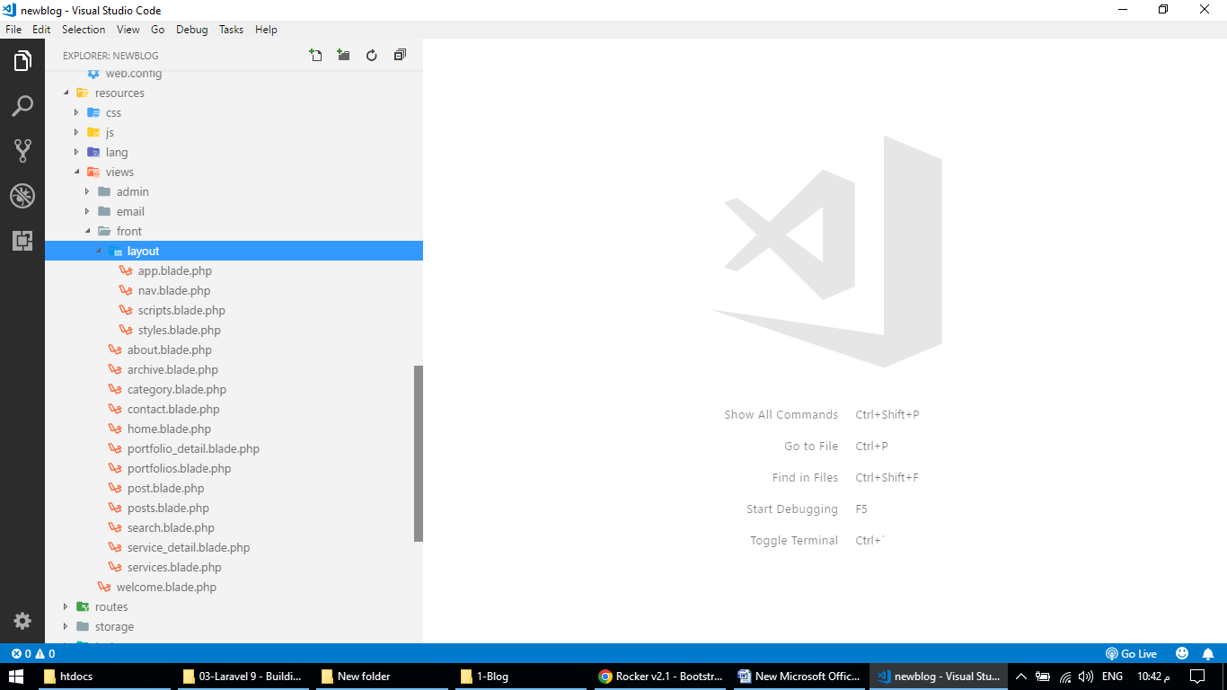

app.blade.php

<!DOCTYPE html>

<html lang="en">

<head>

<meta charset="UTF-8">

<meta http-equiv="X-UA-Compatible" content="IE=edge">

<meta name="viewport" content="width=device-width, initial-scale=1.0">

<title>@yield('seo_title')</title>

<meta name="description" value="@yield('seo_meta_description')">

@yield('open_graph_data')

@include('front.layout.styles')

<link rel="icon" type="image/png" href="{{ asset('uploads/'.$global_setting_data->favicon) }}">

<link href="https://fonts.googleapis.com/css2?family=Poppins:wght@400;500;600;700&display=swap" rel="stylesheet">

<style>

nav .nav-item .nav-link.active,

nav .nav-item .nav-link:hover,

.home-banner .left .button a,

.home-about .right h3,

.home-about .contact-info i,

.home-skill .heading h2,

.home-qualification .heading h2,

.home-qualification h2.title,

.home-qualification .item:before,

.service .heading h2,

.service .item .icon i,

.portfolio .heading h2,

.home-testimonial .heading h2,

.blog .heading h2,

.home-client .heading h2,

.footer .social ul li:hover a,

.sidebar .widget h2,

.sidebar .widget ul li a:hover,

.sidebar .widget ul li:hover:before,

.sidebar .widget .project-detail .item .name,

.blog-detail .sub .category a,

.comment h2,

.comment .comment-box .right .reply a,

.contact .item .icon {

color: {{ $global_setting_data->theme_color }};

}

.home-banner,

.home-about .social ul li,

.home-skill .progress-bar,

.home-qualification .item .v-line,

.service .item .button a,

.portfolio .filter ul li,

.blog .item .button a,

.footer .social ul li,

.scrollup i,

.sidebar .widget .search button,

.comment button,

.contact .form-map button {

background: {{ $global_setting_data->theme_color }};

}

.testimonial-carousel .owl-dot.active span,

.client-carousel .owl-dot.active span {

background: {{ $global_setting_data->theme_color }}!important;

}

.sidebar .widget .search button {

border-color: {{ $global_setting_data->theme_color }};

}

</style>

</head>

<body>

@if($global_setting_data->preloader_status == 'Show')

<div id="preloader">

<div id="preloader_inner"></div>

</div>

@endif

@include('front.layout.nav')

@yield('main_content')

<div class="footer">

<div class="container">

<div class="row">

<div class="col-md-12">

<div class="logo d-flex justify-content-center">

<img src="{{ asset('uploads/'.$global_setting_data->logo_footer) }}" alt="">

</div>

@if($global_setting_data->footer_text != '')

<div class="description">

{!! nl2br($global_setting_data->footer_text) !!}

</div>

@endif

@if($global_setting_data->footer_icon_1 != '' || $global_setting_data->footer_icon_2 != '' || $global_setting_data->footer_icon_3 != '' || $global_setting_data->footer_icon_4 != '')

<div class="social">

<ul>

@if($global_setting_data->footer_icon_1 != '')

<li><a href="{{ $global_setting_data->footer_icon_1_url }}" target="_blank"><i class="{{ $global_setting_data->footer_icon_1 }}"></i></a></li>

@endif

@if($global_setting_data->footer_icon_2 != '')

<li><a href="{{ $global_setting_data->footer_icon_2_url }}" target="_blank"><i class="{{ $global_setting_data->footer_icon_2 }}"></i></a></li>

@endif

@if($global_setting_data->footer_icon_3 != '')

<li><a href="{{ $global_setting_data->footer_icon_3_url }}" target="_blank"><i class="{{ $global_setting_data->footer_icon_3 }}"></i></a></li>

@endif

@if($global_setting_data->footer_icon_4 != '')

<li><a href="{{ $global_setting_data->footer_icon_4_url }}" target="_blank"><i class="{{ $global_setting_data->footer_icon_4 }}"></i></a></li>

@endif

</ul>

</div>

@endif

<div class="copyright">

{{ $global_setting_data->footer_copyright }}

</div>

</div>

</div>

</div>

</div>

<a href="" class="scrollup">

<i class="fas fa-chevron-up"></i>

</a>

@include('front.layout.scripts')

@if($errors->any())

@foreach($errors->all() as $error)

<script>

iziToast.error({

title: '',

position: 'topRight',

message: '{{ $error }}',

});

</script>

@endforeach

@endif

@if(session()->get('error'))

<script>

iziToast.error({

title: '',

position: 'topRight',

message: '{{ session()->get('error') }}',

});

</script>

@endif

@if(session()->get('success'))

<script>

iziToast.success({

title: '',

position: 'topRight',

message: '{{ session()->get('success') }}',

});

</script>

@endif

@yield('skill_animation')

</body>

</html>

nav.blade.php

<nav class="navbar navbar-expand-lg bg-light">

<div class="container">

<a class="navbar-brand logo" href="{{ route('home') }}">

<img src="{{ asset('uploads/'.$global_setting_data->logo) }}" alt="">

</a>

<button class="navbar-toggler" type="button" data-bs-toggle="collapse" data-bs-target="#navbarNavDropdown" aria-controls="navbarNavDropdown" aria-expanded="false" aria-label="Toggle navigation">

<span class="navbar-toggler-icon"></span>

</button>

<div class="collapse navbar-collapse justify-content-end" id="navbarNavDropdown">

<ul class="navbar-nav">

<li class="nav-item">

<a class="nav-link {{ Request::is('/') ? "active" : "" }}" href="{{ route('home') }}">Home</a>

</li>

<li class="nav-item">

<a class="nav-link {{ Request::is('about') ? "active" : "" }}" href="{{ route('about') }}">About</a>

</li>

<li class="nav-item">

<a class="nav-link {{ Request::is('services') ? "active" : "" }}" href="{{ route('services') }}">Services</a>

</li>

<li class="nav-item">

<a class="nav-link {{ Request::is('portfolios') ? "active" : "" }}" href="{{ route('portfolios') }}">Portfolios</a>

</li>

<li class="nav-item">

<a class="nav-link {{ Request::is('blog') ? "active" : "" }}" href="{{ route('blog') }}">Blog</a>

</li>

<li class="nav-item">

<a class="nav-link {{ Request::is('contact') ? "active" : "" }}" href="{{ route('contact') }}">Contact</a>

</li>

</ul>

</div>

</div>

</nav>

scripts.blade.php

<script src="{{ asset('dist_front/js/jquery-3.6.1.min.js') }}"></script>

<script src="{{ asset('dist_front/js/popper.min.js') }}"></script>

<script src="{{ asset('dist_front/js/bootstrap.min.js') }}"></script>

<script src="{{ asset('dist_front/js/jquery.waypoints.min.js') }}"></script>

<script src="{{ asset('dist_front/js/counterup.min.js') }}"></script>

<script src="{{ asset('dist_front/js/filter.min.js') }}"></script>

<script src="{{ asset('dist_front/js/owl.carousel.min.js') }}"></script>

<script src="{{ asset('dist_front/js/wow.min.js') }}"></script>

<script src="{{ asset('dist_front/js/iziToast.min.js') }}"></script>

<script src="{{ asset('dist_front/js/custom.js') }}"></script>

styles.blade.php

<link rel="stylesheet" href="{{ asset('dist_front/css/bootstrap.min.css') }}">

<link rel="stylesheet" href="{{ asset('dist_front/css/all.css') }}">

<link rel="stylesheet" href="{{ asset('dist_front/css/owl.carousel.min.css') }}">

<link rel="stylesheet" href="{{ asset('dist_front/css/owl.theme.default.min.css') }}">

<link rel="stylesheet" href="{{ asset('dist_front/css/animate.css') }}">

<link rel="stylesheet" href="{{ asset('dist_front/css/iziToast.min.css') }}">

<link rel="stylesheet" href="{{ asset('dist_front/css/custom.css') }}">

Front

about.blade.php

@extends('front.layout.app')

@section('seo_title'){{ $page_data->about_seo_title }}@endsection

@section('seo_meta_description'){{ $page_data->about_seo_meta_description }}@endsection

@section('main_content')

<div class="page-banner" style="background-image: url({{ asset('uploads/'.$page_data->about_banner) }})">

<div class="container">

<div class="row">

<div class="col-md-12">

<h1>{{ $page_data->about_heading }}</h1>

</div>

</div>

</div>

</div>

<div class="page-content">

<div class="container">

<div class="row">

<div class="col-md-12">

@if($page_data->about_photo!='')

<div class="about-photo d-flex justify-content-center">

<img src="{{ asset('uploads/'.$page_data->about_photo) }}" alt="">

</div>

@endif

<div class="about-content">

{!! nl2br($page_data->about_description) !!}

</div>

</div>

</div>

</div>

</div>

@endsection

archive.blade.php

@extends('front.layout.app')

@section('seo_title'){{ $page_data->archive_seo_title }}@endsection

@section('seo_meta_description'){{ $page_data->archive_seo_meta_description }}@endsection

@section('main_content')

<div class="page-banner" style="background-image: url({{ asset('uploads/'.$page_data->archive_banner) }})">

<div class="container">

<div class="row">

<div class="col-md-12">

@php

if($month == '01') {$month_full='January';}

elseif($month == '02') {$month_full='February';}

elseif($month == '03') {$month_full='March';}

elseif($month == '04') {$month_full='April';}

elseif($month == '05') {$month_full='May';}

elseif($month == '06') {$month_full='June';}

elseif($month == '07') {$month_full='July';}

elseif($month == '08') {$month_full='August';}

elseif($month == '09') {$month_full='September';}

elseif($month == '10') {$month_full='October';}

elseif($month == '11') {$month_full='November';}

elseif($month == '12') {$month_full='December';}

@endphp

<h1>All Posts of: {{ $month_full }} {{ $year }}</h1>

</div>

</div>

</div>

</div>

<div class="page-content blog">

<div class="container">

<div class="row">

@if(!$posts->count())

<span class="text-danger">No Post Found</span>

@else

@foreach($posts as $item)

@php

if($item->created_at->format('m') != $month) {

continue;

}

@endphp

<div class="col-md-4">

<div class="item">

<div class="photo">

<img src="{{ asset('uploads/'.$item->photo) }}" alt="">

</div>

<div class="text">

<h3>{{ $item->title }}</h3>

<p>

{!! nl2br($item->short_description) !!}

</p>

<div class="button">

<a href="{{ route('post',$item->slug) }}" class="btn btn-primary">Read More</a>

</div>

</div>

</div>

</div>

@endforeach

@endif

</div>

</div>

</div>

@endsection

category.blade.php

@extends('front.layout.app')

@section('seo_title'){{ $category_detail->category_seo_title }}@endsection

@section('seo_meta_description'){{ $category_detail->category_seo_meta_description }}@endsection

@section('main_content')

<div class="page-banner" style="background-image: url({{ asset('uploads/'.$page_data->category_banner) }})">

<div class="container">

<div class="row">

<div class="col-md-12">

<h1>Posts under: {{ $category_detail->category_name }}</h1>

</div>

</div>

</div>

</div>

<div class="page-content blog">

<div class="container">

<div class="row">

@if(!$posts->count())

<span class="text-danger">No Post Found</span>

@else

@foreach($posts as $item)

<div class="col-md-4">

<div class="item">

<div class="photo">

<img src="{{ asset('uploads/'.$item->photo) }}" alt="">

</div>

<div class="text">

<h3>{{ $item->title }}</h3>

<p>

{!! nl2br($item->short_description) !!}

</p>

<div class="button">

<a href="{{ route('post',$item->slug) }}" class="btn btn-primary">Read More</a>

</div>

</div>

</div>

</div>

@endforeach

@endif

</div>

<div class="row">

<div class="col-md-12">

{{ $posts->links() }}

</div>

</div>

</div>

</div>

@endsection

contact.blade.php

@extends('front.layout.app')

@section('seo_title'){{ $page_data->contact_seo_title }}@endsection

@section('seo_meta_description'){{ $page_data->contact_seo_meta_description }}@endsection

@section('main_content')

<div class="page-banner" style="background-image: url({{ asset('uploads/'.$page_data->contact_banner) }})">

<div class="container">

<div class="row">

<div class="col-md-12">

<h1>{{ $page_data->contact_heading }}</h1>

</div>

</div>

</div>

</div>

<div class="page-content contact">

<div class="container">

<div class="row">

<div class="col-md-4">

<div class="item">

<div class="icon"><i class="fas fa-map-marker-alt"></i></div>

<h2>My Location</h2>

<div class="text">

{!! nl2br($page_data->contact_address) !!}

</div>

</div>

</div>

<div class="col-md-4">

<div class="item">

<div class="icon"><i class="fas fa-phone-alt"></i></div>

<h2>Phone Number</h2>

<div class="text">

{!! nl2br($page_data->contact_phone) !!}

</div>

</div>

</div>

<div class="col-md-4">

<div class="item">

<div class="icon"><i class="fas fa-envelope"></i></div>

<h2>Email Address</h2>

<div class="text">

{!! nl2br($page_data->contact_email) !!}

</div>

</div>

</div>

</div>

<div class="row form-map">

<div class="col-lg-6 col-md-12">

<h2>Please contact via the following form:</h2>

<form action="{{ route('contact_send_email') }}" method="post">

@csrf

<div class="mb-3">

<input type="text" class="form-control" placeholder="Name (Required)" name="name">

</div>

<div class="mb-3">

<input type="text" class="form-control" placeholder="Email Address (Required)" name="email">

</div>

<div class="mb-3">

<input type="text" class="form-control" placeholder="Phone Number" name="phone">

</div>

<div class="mb-3">

<textarea class="form-control" placeholder="Message (Required)" rows="3" name="comment"></textarea>

</div>

<div class="mb-3">

<button type="submit" class="btn btn-primary">Send Message</button>

</div>

</form>

</div>

<div class="col-lg-6 col-md-12">

<h2>Find me on Map:</h2>

{!! nl2br($page_data->contact_map_iframe) !!}

</div>

</div>

</div>

</div>

@endsection

[home.blade.php](http://home.blade.php)

@extends('front.layout.app')

@section('seo_title'){{ $page_data->seo_title }}@endsection

@section('seo_meta_description'){{ $page_data->seo_meta_description }}@endsection

@section('main_content')

<div class="home-banner">

<div class="container">

<div class="row">

<div class="col-md-6 d-flex align-items-center">

<div class="left">

<h4>{{ $page_data->banner_title }}</h4>

<h2>{{ $page_data->banner_person_name }}</h2>

<h3>{{ $page_data->banner_person_designation }}</h3>

<p>

{!! $page_data->banner_description !!}

</p>

<div class="button">

<a href="{{ $page_data->banner_button_url }}" class="btn btn-primary">{{ $page_data->banner_button_text }}</a>

</div>

</div>

</div>

<div class="col-md-6">

<div class="right">

<img src="{{ asset('uploads/'.$page_data->banner_photo) }}" alt="">

</div>

</div>

</div>

</div>

</div>

@if($page_data->about_status == 'Show')

<div class="home-about">

<div class="container">

<div class="row">

<div class="col-md-4">

<div class="left wow fadeInLeft">

<img src="{{ asset('uploads/'.$page_data->about_photo) }}" alt="">

</div>

</div>

<div class="col-md-8">

<div class="right wow fadeInRight">

@if($page_data->about_subtitle != '')

<h3>{{ $page_data->about_subtitle }}</h3>

@endif

<h2>{{ $page_data->about_title }}</h2>

@if($page_data->about_description != '')

<p>{!! nl2br($page_data->about_description) !!}</p>

@endif

@if( $page_data->about_person_name!='' || $page_data->about_person_phone!='' || $page_data->about_person_email!='')

<div class="contact-info">

<div class="table-responsive">

<table class="table">

@if($page_data->about_person_name!='')

<tr>

<td><i class="far fa-user"></i></td>

<td>Name</td>

<td>:</td>

<td>{{ $page_data->about_person_name }}</td>

</tr>

@endif

@if($page_data->about_person_phone!='')

<tr>

<td><i class="fas fa-phone"></i></td>

<td>Phone</td>

<td>:</td>

<td>{{ $page_data->about_person_phone }}</td>

</tr>

@endif

@if($page_data->about_person_email!='')

<tr>

<td><i class="far fa-envelope"></i></td>

<td>Email</td>

<td>:</td>

<td>{{ $page_data->about_person_email }}</td>

</tr>

@endif

</table>

</div>

</div>

@endif

@if( $page_data->about_icon1!='' || $page_data->about_icon2!='' || $page_data->about_icon3!='' || $page_data->about_icon4!='' || $page_data->about_icon5!='')

<div class="social">

<h3>Find me on social media:</h3>

<ul>

@if($page_data->about_icon1!='')

<li><a href="{{ $page_data->about_icon1_url }}"><i class="{{ $page_data->about_icon1 }}"></i></a></li>

@endif

@if($page_data->about_icon2!='')

<li><a href="{{ $page_data->about_icon2_url }}"><i class="{{ $page_data->about_icon2 }}"></i></a></li>

@endif

@if($page_data->about_icon3!='')

<li><a href="{{ $page_data->about_icon3_url }}"><i class="{{ $page_data->about_icon3 }}"></i></a></li>

@endif

@if($page_data->about_icon4!='')

<li><a href="{{ $page_data->about_icon4_url }}"><i class="{{ $page_data->about_icon4 }}"></i></a></li>

@endif

@if($page_data->about_icon5!='')

<li><a href="{{ $page_data->about_icon5_url }}"><i class="{{ $page_data->about_icon5 }}"></i></a></li>

@endif

</ul>

</div>

@endif

</div>

</div>

</div>

</div>

</div>

@endif

@if($page_data->skill_status == 'Show')

<div class="home-skill">

<div class="container">

<div class="row">

<div class="col-md-12 heading">

@if($page_data->skill_subtitle!='')

<h2>{{ $page_data->skill_subtitle }}</h2>

@endif

@if($page_data->skill_title!='')

<h3>{{ $page_data->skill_title }}</h3>

@endif

</div>

<div class="col-md-6 wow fadeInLeft">

@php $i=0; @endphp

@foreach($left_skills as $item)

@php $i++; @endphp

<div class="progress-text">{{ $item->name }}</div>

<div class="progress">

<div class="progress-bar anim_left{{ $i }} w-0" role="progressbar" aria-label="Example with label" aria-valuenow="{{ $item->percentage }}" aria-valuemin="0" aria-valuemax="100">{{ $item->percentage }}%</div>

</div>

@endforeach

</div>

<div class="col-md-6 wow fadeInRight">

@php $i=0; @endphp

@foreach($right_skills as $item)

@php $i++; @endphp

<div class="progress-text">{{ $item->name }}</div>

<div class="progress">

<div class="progress-bar anim_right{{ $i }} w-0" role="progressbar" aria-label="Example with label" aria-valuenow="{{ $item->percentage }}" aria-valuemin="0" aria-valuemax="100">{{ $item->percentage }}%</div>

</div>

@endforeach

</div>

</div>

</div>

</div>

@endif

@if($page_data->qualification_status == 'Show')

<div class="home-qualification">

<div class="container">

<div class="row">

<div class="col-md-12 heading">

<h2>{{ $page_data->qualification_subtitle }}</h2>

<h3>{{ $page_data->qualification_title }}</h3>

</div>

<div class="col-md-6">

<h2 class="title"><i class="fas fa-graduation-cap"></i> {{ $page_data->education_title }}</h2>

<div class="inner">

@foreach($education as $item)

<div class="item wow fadeInUp">

<h3>{{ $item->degree }}</h3>

<h4>{{ $item->institute }}</h4>

<div class="time"><i class="far fa-clock"></i> {{ $item->time }}</div>

<div class="v-line"></div>

</div>

@endforeach

</div>

</div>

<div class="col-md-6">

<h2 class="title"><i class="fas fa-award"></i> {{ $page_data->experience_title }}</h2>

<div class="inner">

@foreach($experiences as $item)

<div class="item wow fadeInUp">

<h3>{{ $item->company }}</h3>

<h4>{{ $item->designation }}</h4>

<div class="time"><i class="far fa-clock"></i> {{ $item->time }}</div>

<div class="v-line"></div>

</div>

@endforeach

</div>

</div>

</div>

</div>

</div>

@endif

@if($page_data->service_status == 'Show')

<div class="service">

<div class="container">

<div class="row">

<div class="col-md-12 heading">

<h2>Services</h2>

<h3>What Services I Offer</h3>

</div>

@php $i=1; @endphp

@foreach($services as $item)

@php

if($i%3 == 1) {

$anim = 'fadeInLeft';

} elseif($i%3 == 2) {

$anim = 'fadeInUp';

} elseif($i%3 == 0) {

$anim = 'fadeInRight';

}

$i++;

@endphp

<div class="col-lg-4 col-md-6 wow {{ $anim }}">

<div class="item">

<div class="icon"><i class="{{ $item->icon }}"></i></div>

<h3>{{ $item->name }}</h3>

<p>

{!! nl2br($item->short_description) !!}

</p>

<div class="button">

<a href="{{ route('service_detail',$item->slug) }}" class="btn btn-primary">Read More</a>

</div>

</div>

</div>

@endforeach

</div>

</div>

</div>

@endif

@if($page_data->counter_status == 'Show')

<div class="home-counter" style="background-image:url({{ asset('uploads/'.$page_data->counter_background) }})">

<div class="container">

<div class="row counter-items">

<div class="col-md-3 counter-item">

<div class="counter">{{ $page_data->counter1_number }}</div>

<div class="text">{{ $page_data->counter1_name }}</div>

</div>

<div class="col-md-3 counter-item">

<div class="counter">{{ $page_data->counter2_number }}</div>

<div class="text">{{ $page_data->counter2_name }}</div>

</div>

<div class="col-md-3 counter-item">

<div class="counter">{{ $page_data->counter3_number }}</div>

<div class="text">{{ $page_data->counter3_name }}</div>

</div>

<div class="col-md-3 counter-item">

<div class="counter">{{ $page_data->counter4_number }}</div>

<div class="text">{{ $page_data->counter4_name }}</div>

</div>

</div>

</div>

</div>

@endif

@if($page_data->portfolio_status == 'Show')

<div class="portfolio">

<div class="container">

<div class="row">

<div class="col-md-12 heading">

@if($page_data->portfolio_subtitle != '')

<h2>{{ $page_data->portfolio_subtitle }}</h2>

@endif

@if($page_data->portfolio_title != '')

<h3>{{ $page_data->portfolio_title }}</h3>

@endif

</div>

<div class="col-md-12">

<div class="filter">

<ul>

<li data-filter="*">All</li>

@foreach($portfolio_categories as $item)

<li data-filter=".abc{{ $item->id }}">{{ $item->category_name }}</li>

@endforeach

</ul>

</div>

<div class="filter-items">

@foreach($portfolios as $item)

<div class="filter-item abc{{ $item->portfolio_category_id }}">

<div class="inner">

<div class="photo"><a href="{{ route('portfolio_detail',$item->slug) }}"><img src="{{ asset('uploads/'.$item->photo) }}" alt=""></a></div>

<div class="text">

<h2>{{ $item->name }}</h2>

</div>

</div>

</div>

@endforeach

</div>

</div>

</div>

</div>

</div>

@endif

@if($page_data->testimonial_status == 'Show')

<div class="home-testimonial" style="background-image:url({{ asset('uploads/'.$page_data->testimonial_background) }})">

<div class="container">

<div class="row">

<div class="col-md-12 heading">

@if($page_data->testimonial_subtitle!='')

<h2>{{ $page_data->testimonial_subtitle }}</h2>

@endif

@if($page_data->testimonial_title!='')

<h3>{{ $page_data->testimonial_title }}</h3>

@endif

</div>

<div class="col-md-12">

<div class="owl-carousel owl-theme testimonial-carousel">

@foreach($testimonials as $item)

<div class="item">

<div class="photo d-flex justify-content-center">

<img src="{{ asset('uploads/'.$item->photo) }}" alt="">

</div>

<div class="comment">

{!! nl2br($item->comment) !!}

</div>

<div class="person-detail">

<h3>{{ $item->name }}</h3>

<h4>{{ $item->designation }}</h4>

</div>

</div>

@endforeach

</div>

</div>

</div>

</div>

</div>

@endif

@if($page_data->blog_status == 'Show')

<div class="blog">

<div class="container">

<div class="row">

<div class="col-md-12 heading">

@if($page_data->blog_subtitle != '')

<h2>{{ $page_data->blog_subtitle }}</h2>

@endif

@if($page_data->blog_title != '')

<h3>{{ $page_data->blog_title }}</h3>

@endif

</div>

@foreach($posts as $item)

<div class="col-md-4 wow fadeInUp">

<div class="item">

<div class="photo">

<img src="{{ asset('uploads/'.$item->photo) }}" alt="">

</div>

<div class="text">

<h3>{{ $item->title }}</h3>

<p>

{!! nl2br($item->short_description) !!}

</p>

<div class="button">

<a href="" class="btn btn-primary">Read More</a>

</div>

</div>

</div>

</div>

@endforeach

</div>

</div>

</div>

@endif

@if($page_data->client_status == 'Show')

<div class="home-client">

<div class="container">

<div class="row">

<div class="col-md-12 heading">

@if($page_data->client_subtitle!='')

<h2>{{ $page_data->client_subtitle }}</h2>

@endif

@if($page_data->client_title!='')

<h3>{{ $page_data->client_title }}</h3>

@endif

</div>

<div class="col-md-12">

<div class="owl-carousel owl-theme client-carousel">

@foreach($clients as $item)

<div class="item">

@if($item->url!='')

<a href="{{ $item->url }}" target="_blank"><img src="{{ asset('uploads/'.$item->photo) }}" alt=""></a>

@else

<img src="{{ asset('uploads/'.$item->photo) }}" alt="">

@endif

</div>

@endforeach

</div>

</div>

</div>

</div>

</div>

@endif

@endsection

@section('skill_animation')

@php $i=0; @endphp

@foreach($left_skills as $item)

@php $i++; @endphp

<script>

$(".anim_left{{ $i }}").animate({width: "{{ $item->percentage }}%"}, 2500);

</script>

@endforeach

@php $i=0; @endphp

@foreach($right_skills as $item)

@php $i++; @endphp

<script>

$(".anim_right{{ $i }}").animate({width: "{{ $item->percentage }}%"}, 2500);

</script>

@endforeach

@endsection

portfolio_detail.blade.php

@extends('front.layout.app')

@section('seo_title'){{ $portfolio_detail->seo_title }}@endsection

@section('seo_meta_description'){{ $portfolio_detail->seo_meta_description }}@endsection

@section('main_content')

<div class="page-banner" style="background-image: url({{ asset('uploads/'.$portfolio_detail->banner) }})">

<div class="container">

<div class="row">

<div class="col-md-12">

<h1>{{ $portfolio_detail->name }}</h1>

</div>

</div>

</div>

</div>

<div class="page-content portfolio-detail">

<div class="container">

<div class="row">

<div class="col-md-8">

<div class="owl-carousel owl-theme photo-carousel">

<div class="item">

<div class="photo">

<img src="{{ asset('uploads/'.$portfolio_detail->photo) }}" alt="">

</div>

</div>

@foreach($portfolio_photos as $item)

<div class="item">

<div class="photo">

<img src="{{ asset('uploads/'.$item->photo) }}" alt="">

</div>

</div>

@endforeach

</div>

<div class="text">

<p>

{!! nl2br($portfolio_detail->description) !!}

</p>

</div>

@foreach($portfolio_videos as $item)

<div class="video">

<h3>{{ $item->caption }}</h3>

<iframe width="560" height="315" src="https://www.youtube.com/embed/{{ $item->video_id }}" title="YouTube video player" frameborder="0" allow="accelerometer; autoplay; clipboard-write; encrypted-media; gyroscope; picture-in-picture" allowfullscreen></iframe>

</div>

@endforeach

</div>

<div class="col-md-4">

<div class="sidebar">

<div class="widget">

<h2>All Work Portfolios</h2>

<ul>

@foreach($portfolios as $item)

<li><a href="{{ route('portfolio_detail',$item->slug) }}">{{ $item->name }}</a></li>

@endforeach

</ul>

</div>

@if($portfolio_detail->project_client != '' || $portfolio_detail->project_company != '' || $portfolio_detail->project_start_date != '' || $portfolio_detail->project_end_date != '' || $portfolio_detail->project_cost != '' || $portfolio_detail->project_website != '')

<div class="widget">

<h2>Project Detail</h2>

<div class="project-detail">

@if($portfolio_detail->project_client != '')

<div class="item">

<div class="name">Client Name</div>

<div class="value">{{ $portfolio_detail->project_client }}</div>

</div>

@endif

@if($portfolio_detail->project_company != '')

<div class="item">

<div class="name">Company Name</div>

<div class="value">{{ $portfolio_detail->project_company }}</div>

</div>

@endif

@if($portfolio_detail->project_start_date != '')

<div class="item">

<div class="name">Start Date</div>

<div class="value">{{ $portfolio_detail->project_start_date }}</div>

</div>

@endif

@if($portfolio_detail->project_end_date != '')

<div class="item">

<div class="name">End Date</div>

<div class="value">{{ $portfolio_detail->project_end_date }}</div>

</div>

@endif

@if($portfolio_detail->project_cost != '')

<div class="item">

<div class="name">Project Cost</div>

<div class="value">{{ $portfolio_detail->project_cost }}</div>

</div>

@endif

@if($portfolio_detail->project_website != '')

<div class="item">

<div class="name">Website URL</div>

<div class="value"><a href="{{ $portfolio_detail->project_website }}" target="_blank">{{ $portfolio_detail->project_website }}</a></div>

</div>

@endif

</div>

</div>

@endif

</div>

</div>

</div>

</div>

</div>

@endsection

portfolios.blade.php

@extends('front.layout.app')

@section('seo_title'){{ $page_data->portfolios_seo_title }}@endsection

@section('seo_meta_description'){{ $page_data->portfolios_seo_meta_description }}@endsection

@section('main_content')

<div class="page-banner" style="background-image: url({{ asset('uploads/'.$page_data->portfolios_banner) }})">

<div class="container">

<div class="row">

<div class="col-md-12">

<h1>{{ $page_data->portfolios_heading }}</h1>

</div>

</div>

</div>

</div>

<div class="page-content portfolio">

<div class="container">

<div class="row">

<div class="col-md-12">

<div class="filter">

<ul>

<li data-filter="*">All</li>

@foreach($portfolio_categories as $item)

<li data-filter=".abc{{ $item->id }}">{{ $item->category_name }}</li>

@endforeach

</ul>

</div>

<div class="filter-items">

@foreach($portfolios as $item)

<div class="filter-item abc{{ $item->portfolio_category_id }}">

<div class="inner">

<div class="photo"><a href="{{ route('portfolio_detail',$item->slug) }}"><img src="{{ asset('uploads/'.$item->photo) }}" alt=""></a></div>

<div class="text">

<h2>{{ $item->name }}</h2>

</div>

</div>

</div>

@endforeach

</div>

</div>

</div>

</div>

</div>

@endsection

post.blade.php

@extends('front.layout.app')

@section('seo_title'){{ $post_detail->seo_title }}@endsection

@section('seo_meta_description'){{ $post_detail->seo_meta_description }}@endsection

@section('open_graph_data')

<meta property="og:title" content="{{ $post_detail->title }}">

<meta property="og:url" content="{{ route('post',$post_detail->slug) }}">

<meta property="og:description" content="{{ $post_detail->short_description }}">

<meta property="og:image" content="{{ asset('uploads/'.$post_detail->photo) }}">

@endsection

@section('main_content')

<div class="page-banner" style="background-image: url({{ asset('uploads/'.$post_detail->banner) }})">

<div class="container">

<div class="row">

<div class="col-md-12">

<h1>{{ $post_detail->title }}</h1>

</div>

</div>

</div>

</div>

<div class="page-content blog-detail">

<div class="container">

<div class="row">

<div class="col-md-8">

<div class="photo">

<img src="{{ asset('uploads/'.$post_detail->photo) }}" alt="">

</div>

<div class="sub d-flex justify-content-start">

<div class="author"><span>By:</span> Admin</div>

<div class="dash"> - </div>

<div class="date"><span>On:</span> {{ $post_detail->created_at->format('M d, Y') }}</div>

<div class="dash"> - </div>

<div class="category"><span>Category:</span> <a href="{{ route('category',$post_detail->rPostCategory->category_slug) }}">{{ $post_detail->rPostCategory->category_name }}</a></div>

</div>

<div class="text">

{!! nl2br($post_detail->description) !!}

</div>

<div class="share">

<script type="text/javascript" src="https://platform-api.sharethis.com/js/sharethis.js#property=633263d3bfbc4500128cca2f&product=inline-share-buttons" async="async"></script>

<div class="sharethis-inline-share-buttons"></div>

</div>

@if($post_detail->show_comment == 'Yes')

<div class="comment">

<h2>{{ $total_comments }} Comments</h2>

@if($total_comments == 0)

<span class="text-danger">No Comment is Found!</span>

@endif

@foreach($comments as $item)

<div class="comment-section">

<div class="comment-box d-flex justify-content-start @if($item->person_type == 'Admin') comment-box-admin @endif">

<div class="left">

@php

$grav_url = "https://www.gravatar.com/avatar/" . md5( strtolower( trim( $item->person_email ) ) ) . "?s=128";

@endphp

<img src="{{ $grav_url }}" alt="">

</div>

<div class="right">

<div class="name">{{ $item->person_name }}</div>

<div class="date">

{{ $item->created_at->format('F').' '.$item->created_at->format('d').', '.$item->created_at->format('Y') }}

</div>

<div class="text">

{!! nl2br($item->person_comment) !!}

</div>

<div class="reply">

<a href="" data-bs-toggle="modal" data-bs-target="#exampleModal{{ $item->id }}"><i class="fas fa-reply"></i> Reply</a>

</div>

</div>

</div>

@foreach($item->rReply as $item2)

@if($item2->status == 0)

@continue

@endif

<div class="comment-box reply-box d-flex justify-content-start @if($item2->person_type == 'Admin') comment-box-admin @endif">

<div class="left">

@php

$grav_url = "https://www.gravatar.com/avatar/" . md5( strtolower( trim( $item2->person_email ) ) ) . "?s=128";

@endphp

<img src="{{ $grav_url }}" alt="">

</div>

<div class="right">

<div class="name">{{ $item2->person_name }}</div>

<div class="date">

{{ $item2->created_at->format('F').' '.$item2->created_at->format('d').', '.$item2->created_at->format('Y') }}

</div>

<div class="text">

{!! nl2br($item2->person_comment) !!}

</div>

</div>

</div>

@endforeach

</div>

<!-- Modal -->

<div class="modal fade" id="exampleModal{{ $item->id }}" tabindex="-1" aria-labelledby="exampleModalLabel" aria-hidden="true">

<div class="modal-dialog">

<div class="modal-content">

<div class="modal-header">

<h1 class="modal-title fs-5" id="exampleModalLabel">Reply Here</h1>

<button type="button" class="btn btn-close text-white" data-bs-dismiss="modal" aria-label="Close">X</button>

</div>

<div class="modal-body">

@if(Auth::guard('admin')->user())

<form action="{{ route('reply_submit_admin') }}" method="post">

@csrf

<input type="hidden" name="post_id" value="{{ $post_detail->id }}">

<input type="hidden" name="comment_id" value="{{ $item->id }}">

<div class="mb-3">

<textarea class="form-control" rows="3" placeholder="Comment" name="comment"></textarea>

</div>

<div class="mb-3">

<button type="submit" class="btn btn-primary">Submit</button>

</div>

</form>

@else

<form action="{{ route('reply_submit') }}" method="post">

@csrf

<input type="hidden" name="post_id" value="{{ $post_detail->id }}">

<input type="hidden" name="comment_id" value="{{ $item->id }}">

<div class="row">

<div class="col-md-6">

<div class="mb-3">

<input type="text" class="form-control" placeholder="Name" name="name">

</div>

</div>

<div class="col-md-6">

<div class="mb-3">

<input type="text" class="form-control" placeholder="Email Address" name="email">

</div>

</div>

</div>

<div class="mb-3">

<textarea class="form-control" rows="3" placeholder="Comment" name="comment"></textarea>

</div>

<div class="mb-3">

<button type="submit" class="btn btn-primary">Submit</button>

</div>

</form>

@endif

</div>

</div>

</div>

</div>

@endforeach

<div class="mt_40"></div>

<h2>Leave Your Comment</h2>

@if(Auth::guard('admin')->user())

<form action="{{ route('comment_submit_admin') }}" method="post">

@csrf

<input type="hidden" name="post_id" value="{{ $post_detail->id }}">

<div class="mb-3">

<textarea class="form-control" rows="3" placeholder="Comment" name="comment"></textarea>

</div>

<div class="mb-3">

<button type="submit" class="btn btn-primary">Submit</button>

</div>

</form>

@else

<form action="{{ route('comment_submit') }}" method="post">

@csrf

<input type="hidden" name="post_id" value="{{ $post_detail->id }}">

<div class="row">

<div class="col-md-6">

<div class="mb-3">

<input type="text" class="form-control" placeholder="Name" name="name">

</div>

</div>

<div class="col-md-6">

<div class="mb-3">

<input type="text" class="form-control" placeholder="Email Address" name="email">

</div>

</div>

</div>

<div class="mb-3">

<textarea class="form-control" rows="3" placeholder="Comment" name="comment"></textarea>

</div>

<div class="mb-3">

<button type="submit" class="btn btn-primary">Submit</button>

</div>

</form>

@endif

</div>

@endif

</div>

<div class="col-md-4">

<div class="sidebar">

<div class="widget">

<h2>Search</h2>

<div class="search">

<form class="row g-3" action="{{ route('search') }}" method="post">

@csrf

<div class="col-auto">

<input type="text" class="form-control" placeholder="Search Anything ..." name="search_text">

</div>

<div class="col-auto">

<button type="submit" class="btn btn-primary mb-3">Search</button>

</div>

</form>

</div>

</div>

<div class="widget">

<h2>Latest Post</h2>

<ul>

@foreach($posts as $item)

<li><a href="{{ route('post',$item->slug) }}">{{ $item->title }}</a></li>

@endforeach

</ul>

</div>

<div class="widget">

<h2>Categories</h2>

<ul>

@foreach($post_categories as $item)

<li><a href="{{ route('category',$item->category_slug) }}">{{ $item->category_name }}</a></li>

@endforeach

</ul>

</div>

<div class="widget">

<h2>Archives</h2>

<ul>

@foreach($archives as $item)

@php

if($item->month == '01') {$month='January';}

elseif($item->month == '02') {$month='February';}

elseif($item->month == '03') {$month='March';}

elseif($item->month == '04') {$month='April';}

elseif($item->month == '05') {$month='May';}

elseif($item->month == '06') {$month='June';}

elseif($item->month == '07') {$month='July';}

elseif($item->month == '08') {$month='August';}

elseif($item->month == '09') {$month='September';}

elseif($item->month == '10') {$month='October';}

elseif($item->month == '11') {$month='November';}

elseif($item->month == '12') {$month='December';}

@endphp

<li><a href="{{ route('archive',[$item->month,$item->year]) }}">{{ $month }} {{ $item->year }} ({{ $item->total_post }})</a></li>

@endforeach

</ul>

</div>

</div>

</div>

</div>

</div>

</div>

@endsection

posts.blade.php

@extends('front.layout.app')

@section('seo_title'){{ $page_data->blog_seo_title }}@endsection

@section('seo_meta_description'){{ $page_data->blog_seo_meta_description }}@endsection

@section('main_content')

<div class="page-banner" style="background-image: url({{ asset('uploads/'.$page_data->blog_banner) }})">

<div class="container">

<div class="row">

<div class="col-md-12">

<h1>{{ $page_data->blog_heading }}</h1>

</div>

</div>

</div>

</div>

<div class="page-content blog">

<div class="container">

<div class="row">

@foreach($posts as $item)

<div class="col-md-4">

<div class="item">

<div class="photo">

<img src="{{ asset('uploads/'.$item->photo) }}" alt="">

</div>

<div class="text">

<h3>{{ $item->title }}</h3>

<p>

{!! nl2br($item->short_description) !!}

</p>

<div class="button">

<a href="{{ route('post',$item->slug) }}" class="btn btn-primary">Read More</a>

</div>

</div>

</div>

</div>

@endforeach

</div>

<div class="row">

<div class="col-md-12">

{{ $posts->links() }}

</div>

</div>

</div>

</div>

@endsection

search.blade.php

@extends('front.layout.app')

@section('seo_title'){{ $page_data->search_seo_title }}@endsection

@section('seo_meta_description'){{ $page_data->search_seo_meta_description }}@endsection

@section('main_content')

<div class="page-banner" style="background-image: url({{ asset('uploads/'.$page_data->search_banner) }})">

<div class="container">

<div class="row">

<div class="col-md-12">

<h1>Search By: {{ $search_text }}</h1>

</div>

</div>

</div>

</div>

<div class="page-content blog">

<div class="container">

<div class="row">

@if(!$posts->count())

<span class="text-danger">No Post Found</span>

@else

@foreach($posts as $item)

<div class="col-md-4">

<div class="item">

<div class="photo">

<img src="{{ asset('uploads/'.$item->photo) }}" alt="">

</div>

<div class="text">

<h3>{{ $item->title }}</h3>

<p>

{!! nl2br($item->short_description) !!}

</p>

<div class="button">

<a href="{{ route('post',$item->slug) }}" class="btn btn-primary">Read More</a>

</div>

</div>

</div>

</div>

@endforeach

@endif

</div>

</div>

</div>

@endsection

service_detail.blade.php

@extends('front.layout.app')

@section('seo_title'){{ $service_detail->seo_title }}@endsection

@section('seo_meta_description'){{ $service_detail->seo_meta_description }}@endsection

@section('main_content')

<div class="page-banner" style="background-image: url({{ asset('uploads/'.$service_detail->banner) }})">

<div class="container">

<div class="row">

<div class="col-md-12">

<h1>{{ $service_detail->name }}</h1>

</div>

</div>

</div>

</div>

<div class="page-content service-detail">

<div class="container">

<div class="row">

<div class="col-md-8">

<div class="photo">

<img src="{{ asset('uploads/'.$service_detail->photo) }}" alt="">

</div>

<div class="text">

<p>

{!! nl2br($service_detail->description) !!}

</p>

</div>

</div>

<div class="col-md-4">

<div class="sidebar">

<div class="widget">

<h2>All Services</h2>

<ul>

@foreach($services as $item)

<li><a href="{{ route('service_detail',$item->slug) }}">{{ $item->name }}</a></li>

@endforeach

</ul>

</div>

</div>

</div>

</div>

</div>

</div>

@endsection

services.blade.php

@extends('front.layout.app')

@section('seo_title'){{ $page_data->services_seo_title }}@endsection

@section('seo_meta_description'){{ $page_data->services_seo_meta_description }}@endsection

@section('main_content')

<div class="page-banner" style="background-image: url({{ asset('uploads/'.$page_data->services_banner) }})">

<div class="container">

<div class="row">

<div class="col-md-12">

<h1>{{ $page_data->services_heading }}</h1>

</div>

</div>

</div>

</div>

<div class="page-content service">

<div class="container">

<div class="row">

@php $i=1; @endphp

@foreach($services as $item)

@php

if($i%3 == 1) {

$anim = 'fadeInLeft';

} elseif($i%3 == 2) {

$anim = 'fadeInUp';

} elseif($i%3 == 0) {

$anim = 'fadeInRight';

}

$i++;

@endphp

<div class="col-lg-4 col-md-6 wow {{ $anim }}">

<div class="item">

<div class="icon"><i class="{{ $item->icon }}"></i></div>

<h3>{{ $item->name }}</h3>

<p>

{!! nl2br($item->short_description) !!}

</p>

<div class="button">

<a href="{{ route('service_detail',$item->slug) }}" class="btn btn-primary">Read More</a>

</div>

</div>

</div>

@endforeach

</div>

<div class="row">

<div class="col-md-12">

{{ $services->links() }}

</div>

</div>

</div>

</div>

@endsection